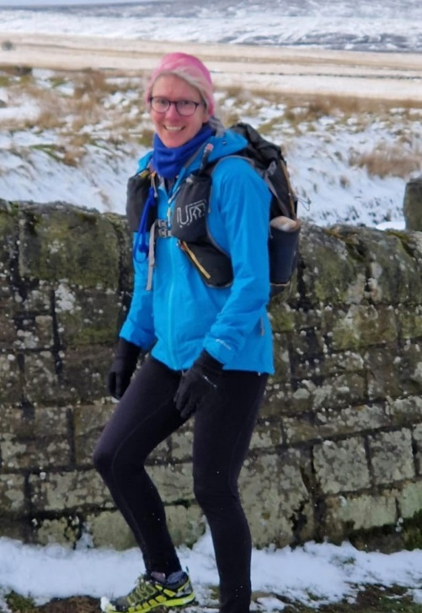
Padiham Parish Food Bank
From 5th April 2023, I will be tackling the Wild Horse 200 South to raise funding for Padiham Parish Food bank.
I’ll have 120 hours to complete a 200-mile trail run across South Wales. The route has 30,187 feet of climbing. The run is across the trails and mountains of South Wales including parts of Offas Dyke, the Beacons Way, the Heart of Wales Line, the Wales Coastal path to finish at Worm’s Head.
In early 2021, when Padiham Parish Foodbank was establishing itself within the community, we had just a few clients each week. Since then, through both increased need and growing knowledge of the resource, we now serve around 40 - 50 households on a weekly basis. Please help to support this by adding a donation to https://gofund.me/a73d3d8a or use the link on Padiham Parish Foodbank Facebook page.
Thank you
Bev Holmes
Headteacher at Padiham St Leonard’s Primary School
Wales Coast Path and finish line at Worm’s Head.

