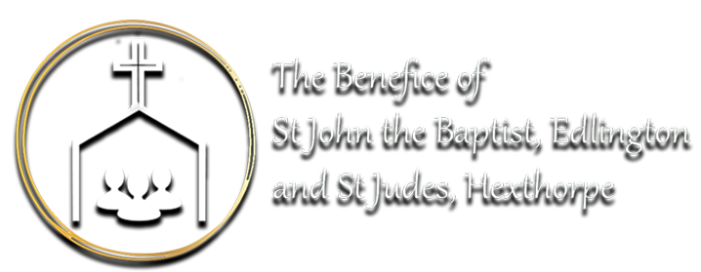

Lent, Holy Week and Easter 2023

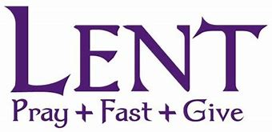
Ash Wednesday
10.15am St Judes- Hexthorpe
7pm St John’s-Edlington

Weekly Pattern
Tuesday
10am Mass St Johns
Wednesday
10.15am Mass St Judes
5pm Holy Hour/Vespers St Johns
6pm Lent Study Group St Johns
Friday
Noon Lent Study & lunch St Judes
6pm Stations of the Cross St Johns
Sunday
9.15am Parish Mass St Johns
11am Parish Mass St Judes

Holy Week
Monday
11.30am Chrism Mass St Peter’s -Barnsley
6pm Mass St Johns
Tuesday
10am Mass St Johns
Wednesday
10.15am Mass St Judes
Maundy Thursday
7pm Mass of the Last Supper St Johns
Good Friday
2pm Liturgy of the Passion St Judes
Saturday
8pm Vigil Mass St Judes
Easter Sunday
9.15am Parish Mass St Johns
11am Parish Mass St Judes

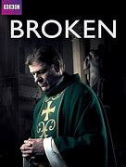
The TV series, Broken, written by Jimmy McGovern and starring Sean Bean is set in an estate parish somewhere in the UK. The series focuses on the life and ministry Father Michael Kerrigan, a Roman Catholic, priest who, despite past trauma and anxiety about his own inadequacies, attempts to bring the light of Christ into the lives of the people amongst whom he ministers. The series portrays real life at its most gritty and unvarnished, and in doing so raises many questions along the way about how to live faithfully when life is very hard.
Some of the themes are not for the faint hearted and the series does contain swearing and themes of suicide, abuse and violence etc. These are the sort of issues we see around us which we can either ignore or reflect upon as the people of God. Often there are far more questions raised than we will ever answer, the idea of the course is to provide space for us to pick up questions raised in the series and explore how we might want to answer them.
Each session will involve watching an episode (an hour long) followed by discussion. Depending on the discussion the session could last two hours but we will eat our food during the episode.

