The Parish Church of St Lawrence

FULSTOW

Historical information

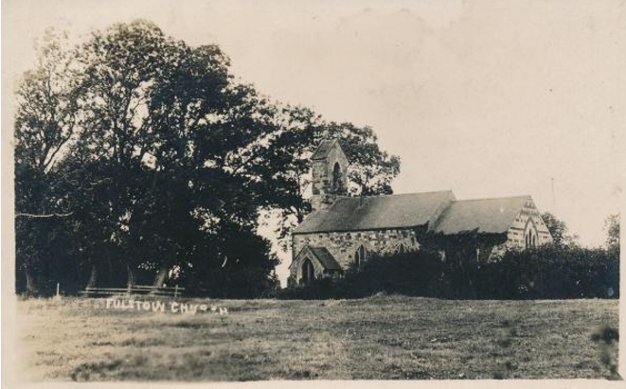

1086 Domesday Book | No mention of a church being in Fulstow in the Domesday Book.
1219 | First known mention of a church. Picot de Lascelles was the patron, and it is believed that he presented Roger Bacon as the incumbent.
Medieval period | Shaft of cross in churchyard.
13th century | North wall – early thirteenth century two bay blocked arcade. South wall of the nave is a blocked early thirteenth century three bay arcade, with single chamfered arches and annular abacii.  The inner doorway is thirteenth century, with clustered shafts, capitals and moulded hood. (This would have been the outer doorway before the addition of the porch.)  Located in the porch - late thirteenth century/early fourteenth century effigies, one a knight thought to be Sir Robert de Hilton, with mail hauberk, surcoat and greaves. His feet rest on a lion. He has a low sword belt and shield, and his head rests on a cushion. The other is of his lady, with head-dress, flowing gown and buttoned sleeves. Her feet rest on a lion, and her head rests on a pillow with angel supporters  Font – thirteenth century. Base thought to be older than the bowl.
1349 | There was a chantry chapel to the Blessed Virgin Mary in church.
c. 1558 | Bell – inscribed “God save our King”
1569 | Chalice and paten created, believed to be by Lincolnshire silversmith John Morley.
1595 | A drawing of the church on Haiwarde’s map of the village, shows a tower, chancel, nave and south aisles. On the drawing the church also appears to have had a small spire on top of the tower. It is believed it had eight large bells and a priest’s bell.
1615 | Repairs needed to the church were reported as being completed in a poor and wretched way.
1647 | William Bennett the Vicar. He baptised five of his children, buried four and officiated at the marriage one of his daughters.
1720’s | Tower crashed to the ground. It is thought that Robert Sourby was reaping corn near church when this happened.
1768 | Painted hatchment – George III period. The hatchment bears name of churchwarden William Ludlam.
1792 | The Reverend Robert Leek became Vicar of Fulstow.
1817 | The Rev Leek appeared in court on a charge of assaulting a parishioner.
1819 | A case of defamation against the Rev Leek was withdrawn at the Lincolnshire Assizes. The allegation had been that a farmer had said that the vicar was a “thief and a rogue”. Damages had been set at £1000!
1835 | Rev Leek died.
1847 | Rev John Holt was very keen on the temperance movement, and promised to marry a couple for no fee if they were both tee-totallers.
February 1863 | Thomas Orwell, a soldier, died on home leave. It is said he chose his grave-space to be near the road in order that when people kicked his gravestone they would remember him. At his funeral the church had not been so full for twenty seven years. The service was taken by the Rev C A Bourne.
1864 | A new Vicarage was built on the Thoresby Road, partly funded by Queen Anne’s Bounty.
1866 | The Churchwarden’s voluntary rate showed a deficiency of over three pounds. It was decided to abandon it.
1867 | Masonry and woodwork fell into the church, damaging some of the pews.  Part of church wall fell down. Services suspended. Held in the “National School” instead.
September 1867 | Church closed by order of the Archdeacon.
1st July 1868 | Restoration begun. Vicar Rev Cornelius Alexander Bourne laid foundation stone. Part of the funds (£333) was raised when the Churchwarden sold some lead at Hull. It is thought that the restoration cost five hundred pounds.  Chancel restoration at the expense of H. Allenby Esq.
16 October 1869 | Rev Cornelius Alexander Bourne died in Turin whilst on holiday, of typhoid. He had been the Vicar since 1861.
18 November 1869 | The household effects which had belonged to the Rev Bourne were sold by auction, at the Vicarage.
1882 | It is recorded that when the bell was tolled to mark the death of a male it was tolled three times four tolls. For a female it was tolled four times three tolls.
18 October 1884 | Rev Richard Young, who had become the Vicar of Fulstow in 1869, became the first Anglican Bishop to be consecrated in Western Canada, at St John’s Cathedral, Winnipeg. When he died he left an estate valued at £4796
1897 | There is a tune named "Fulstow". It was composed by the Reverend Timothy R Matthews. Matthews served as Curate (1853-59) and Curate-in-Charge (1859-69) of St. Mary’s Church, Nottingham. During this time he founded Nottingham’s Working Men’s Institute. In 1869, he became Rector at North Cotes, Lincolnshire. He retired in 1907 to live with his eldest son at Tetney vicarage. He died in 1910 and is buried at Tetney. The hymn tune was published in the "Presbyterian Book of Praise" in 1897.
19th century restoration | Gabled bellcote built.  North wall of nave – two windows. North wall of the chancel – two nineteenth century lancets. Chancel east wall – nineteenth century three light window with above it a reset thirteenth century projecting head (to the exterior). South wall of nave –two three light cusped headed windows.  Porch built to south wall. Corpus thought to be from medieval limestone cross in churchyard placed to exterior wall. Pews and commandment boards fitted.
1906 | The Reverend Alexander Johnson died. The net living of the Parish of Fulstow at that time was £120 plus a house. He had become the Vicar in 1876.
1942 | Rev Herbert Clement Jones died – communion rail installed in his memory. He had been the Vicar between 1906 and 1935.
1948 | Cost of insuring St Lawrence’s one pound and ten shillings.
1950’s | Organ built by Hawkins of Walsall Wood.
1954 | There were many broken windows in the church, needing repair. The wrought iron door handle was repaired by the blacksmith.
1960 | Gifts of fruit and flowers from the harvest festival were donated to St Margaret’s Home at Louth.
2005 | Memorial tablet to the fallen of the First and Second World Wars.
2011 | Roof completely restored.
2013 | Organ placed into church
1 July 2018 | Service held to commemorate one hundred and fifty years since restoration of the church in 1868.
5 June 2022 | Service held to commemorate the Platinum Jubilee of Her Majesty Queen Elizabeth II.

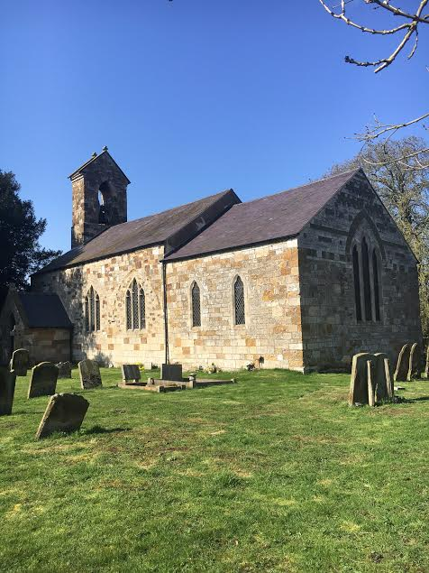

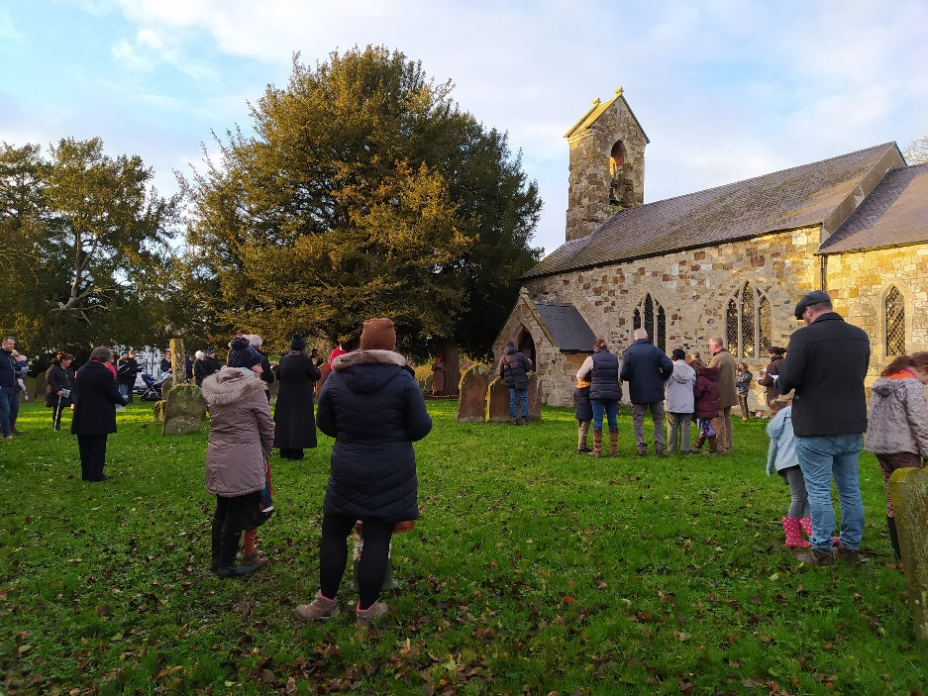

www.achurchnearyou.com/church/15094

Registers deposited in the Lincolnshire Archives:
FULSTOW PAR/1/1 | General register  1586 and 1730-33 damaged. | 1586-1733
FULSTOW PAR/1/2 | General register  Baptisms 1742-1790.  Marriages 1742-1782.  Burials 1742-1790. | 1742-1790
FULSTOW PAR/1/3 | Baptisms and burials | 1790-1812
FULSTOW PAR/1/4 | Marriages | 1755-1788
FULSTOW PAR/1/5 | Marriages | 1788-1818
FULSTOW PAR/1/6 | Baptisms | 1813-1865
FULSTOW PAR/1/7 | Burials | 1814-1890
FULSTOW PAR/1/8 | Marriages | 1813-1837
FULSTOW PAR/1/9 | Marriages | 1837-1990
FULSTOW PAR/1/10 | Baptisms  Includes notes at the front on the history of the church in 1867 and the cattle plague of 1865-7. | 1866-1992
FULSTOW PAR/1/11 | Marriages | 1990-2002
FULSTOW PAR/1/12 | Marriages | 2003-2018
Produced 23 August 2022

