APPLICATION FOR A WEDDING SERVICE
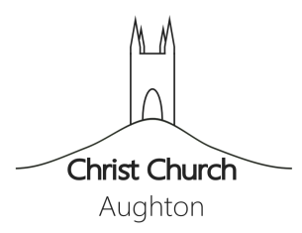
www.ChristChurchAughton.org

Groom’s details:
Full Name:
Surname:
First Name(s):
Address:
Street address:
Town/City:
County:
Postcode:
Email:
Tel No:
Years at above address:
Age on day of marriage (years):
Rank, profession, or occupation:
Are you related, or connected by marriage to the Bride. If so, how?
Church of England Parish you live in:
Are you on a church electoral roll? If so, where?
Marital status (Single/Widower/Previous marriage dissolved)
Father’s Full Name:
Surname:
First Names:
Father’s Rank, profession, or occupation:
If your father is deceased, state here:
Mother’s Full Name:
Surname:
First Names:
Mother’s Rank, profession, or occupation:
If your mother is deceased, indicate here:

Bride’s details:
Full Name:
Surname:
First Names:
Address:
Street address:
Town/City:
County:
Postcode:
Email:
Tel No:
Years at above address:
Age on day of marriage (years):
Rank, profession, or occupation:
Are you related, or connected by marriage to the Groom? If so, how?:
Church of England Parish you live in:
Are you on a church electoral roll? If so, where?
Marital status (Single/Widower/Previous marriage dissolved):
Father’s Full Name:
Surname:
First Names:
Father’s Rank, profession, or occupation:
If your father is deceased, indicate here:
Mother’s Full Name:
Surname:
First Names:
Mother’s Rank, profession, or occupation:
If your mother is deceased, indicate here:

Wedding details:
Proposed date of Wedding
Time
Day
Month
Year
Church and Parish
Organ Yes/No
Bells Yes/No
Choir Yes/No

We hereby certify that all particulars given and statements made in this form are correct.
Name:
email:
Date:
Address after marriage:

Instructions after completing the application:
- Please save this file (preferably with your name in the filename)
- Email the completed application to Rev’d Sarah O’Donoghue at revsarahodonoghue@gmail.com or post to Christ Church Ministry Centre, Long Lane, Aughton, L39 5AS

