Our history
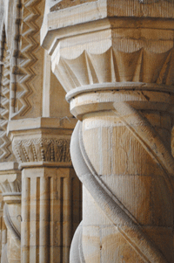Christians have worshipped here in this building, week by week from around 1100AD. It may well have been built on the site of an earlier wooden church. There has been a settlement here from early times; and it is even possible that St. Aidan came here during his extensive travels throughout Northumbria. Bede records that the Pope sent relics of St. Laurence (martyred in Rome 258AD) to Oswy, King of Northumbria in 667AD; this may give a hint as to the founding of an earlier church.
The Building
The oldest part of the present church is the westernmost part of the nave. If you stand in the North aisle and look up at the top of the nave wall above the arches, you can see what was the outside of the church in the 12thC. The two small windows and the corner stones of the original nave are a reminder of the simplicity of the early Norman building.
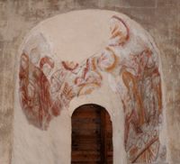These small windows were blocked by later builders and were only uncovered in the 19thC when the rare 12thC wall paintings, showing scenes from the life of St. Cuthbert, were discovered (19thC copies of the paintings can be examined at the back of the church). It is probable that much of the early Norman church was decorated in the same way.
The most spectacular feature of St. Laurence is the remarkable North arcade. About 1180, during the time of Bishop Pudsey (Hugh de Puiset) the church was extended considerably. An aisle was added to the original North wall, this was then pierced and the decorated pillars and arches were added. The first four arches date from this period, as do the large arch on the West wall and the lower part of the tower.
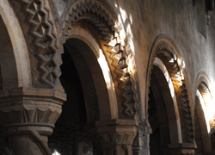Bishop Pudsey, responsible for the Galilee Chapel in Durham Cathedral and the Norman Gallery in the castle, had two great builders: Ricardus Ingenator (“Ingenator” is the description from which we take the modern word engineer) who was known as Pudsey’s architect, and Christian the Mason. They both had lands in Sherburn and Pittington, and almost certainly lived here. Near the pulpit you will find Christian’s grave cover; a massive slab of Frosterley marble. Christian is thought to have been responsible for both the Galilee Chapel and the North arcade here.
The development of the rest of the church in the 13th and 14th centuries becomes rather complex. The church was further extended and would have provided a grand complement to the Prior of Durham’s manor house which was on land to the North.
The most dramatic alterations, and those which largely determine the appearance of the church you see today, are due to enthusiastic Victorian “restoration” by Ignatius Bonomi in 1846-7. The chancel was extended again, and the aisle walls, porch and chancel were rebuilt almost completely. There were further changes in 1897 and 1905 when the chancel was extended again. One feature of note from the Bonomi building programme is the easternmost pillar of the North arcade. The two arches nearest the chancel were “restored” to make them appear contemporary with the original Norman arches in the arcade; the spiral pillar is carved from a single stone.
Other Features and Monuments
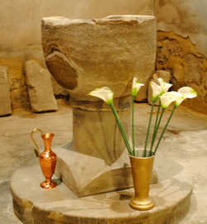Other features to look for include the Norman font. It was sold in 1805 and used as a cattle trough on a Belmont farm. For almost 90 years the church used a marble font from Durham Cathedral. When the original was rediscovered the marble font was returned to the Cathedral.
In the North aisle is a stone effigy of a knight. It dates from around 1280 and represents one of the Fitz Marmaduke lords of Horden. At the west end of the church are a number of medieval monuments and grave covers. The tower holds three pre-reformation bells, and on the outside of the church on the south wall is an early sundial, which may have belonged to the first church. The window in the west end of the church depicts St. Laurence who was martryed by being burned on an iron grid. This motif is echoed in the design of the oak table at that end of the church.
In recent years there have been major repairs to the fabric of the building. In 1977 the wall paintings were restored with the aid of a grant from the Pilgrim Trust, work was done on the North aisle, and the tower and bell frame were strengthened with partial funding from English Heritage. In the 80’s there was work on the South aisle, and in 1999-2000 a major renovation programme included replacing the timbers of the chancel roof, repairs to the exterior stone work, rewiring and new boilers. The English Heritage Lottery fund provided half, the rest was raised by the congregation from other sources.
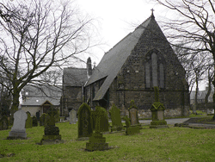
St Mary Magdalene, Belmont
The parish of Pittington is now part of the United Benefice of Belmont, St. Mary Magdalene and Pittington, St. Laurence.

