BAPTISM and THANKSGIVING SERVICE APPLICATION
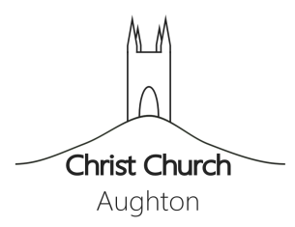

www.ChristChurchAughton.org

Please indicate which Service you would prefer: (please tick one)
- Baptism Service
- Thanksgiving Service

Date preferred:
Child's full name:
Date of birth:
Parent's full names (with occupation):
Father:
Mother:
Address:
Phone number:
Email address:
Names of Godparents:
............................................................................................
............................................................................................
............................................................................................
(Normally two godfathers and one godmother for a boy; Two godmothers and one godfather for a girl: Parents may also be godparents)

Instructions after completing the application:
- Please save this file (preferably with your name in the filename)
- Email the completed application to Rev’d Sarah O’Donoghue at revsarahodonoghue@gmail.com or post to Christ Church Ministry Centre, Long Lane, Aughton, L39 5AS

