We pray for peace for Ukraine.
God of love we pray for the leaders of the nations, that you will guide them in the ways of freedom, justice and truth.
Lord, in your mercy
hear our prayer.
We pray for those who bear arms on behalf of the nation,
that they may have discipline and discernment,
courage and compassion.
Lord, in your mercy
hear our prayer.
We pray for our enemies, and those who wish us harm,
that you will turn the hearts of all to kindness and friendship.
Lord, in your mercy
hear our prayer.
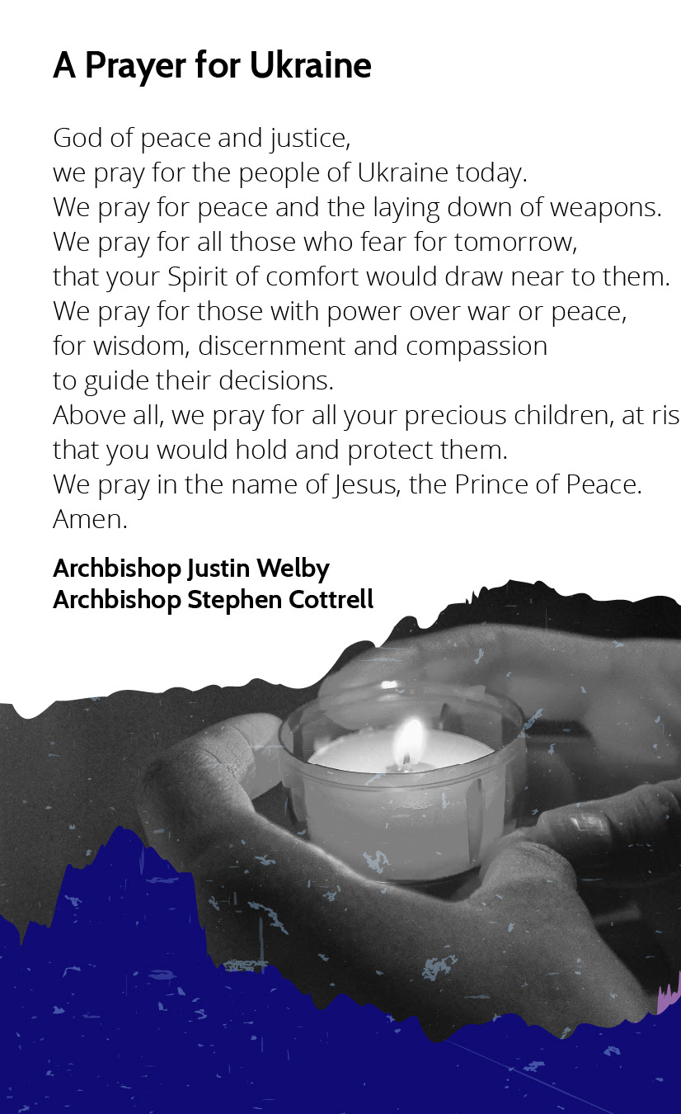
We pray for the wounded and the captive,
the grieving and the homeless, for all who are afraid;
that in all their trials they may know your love and support.
Lord, in your mercy
hear our prayer.
Most holy God and Father,
hear our prayers for all who strive for peace
and all who fight for justice.
Help us, who today remember the cost of war,
to work for a better tomorrow; and, as we commend to you lives lost in terror and conflict,
bring us all, in the end, to the peace of your presence;
through Christ our Lord.
Amen.
Introduction to the Peace
Jesus says: ‘Peace I leave with you; my peace I give to you.
Do not let your hearts be troubled, neither let them be afraid.’ John 14.27
Blessing
God grant to the living grace, to the departed rest,
to the Church, the Queen, the Commonwealth and all people,
unity, peace and concord,
and to us and all God’s servants, life everlasting;
and the blessing of God almighty,
the Father, the Son, and the Holy Spirit,
be among you and remain with you always.

