Considering a Church Wedding?
Let us be at Your Service

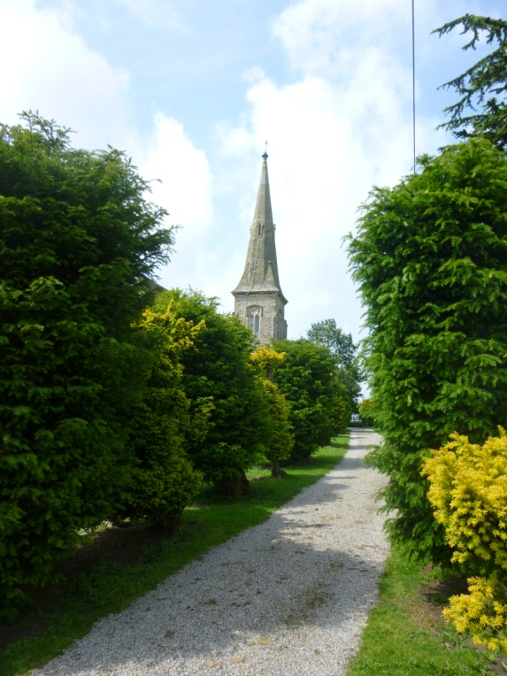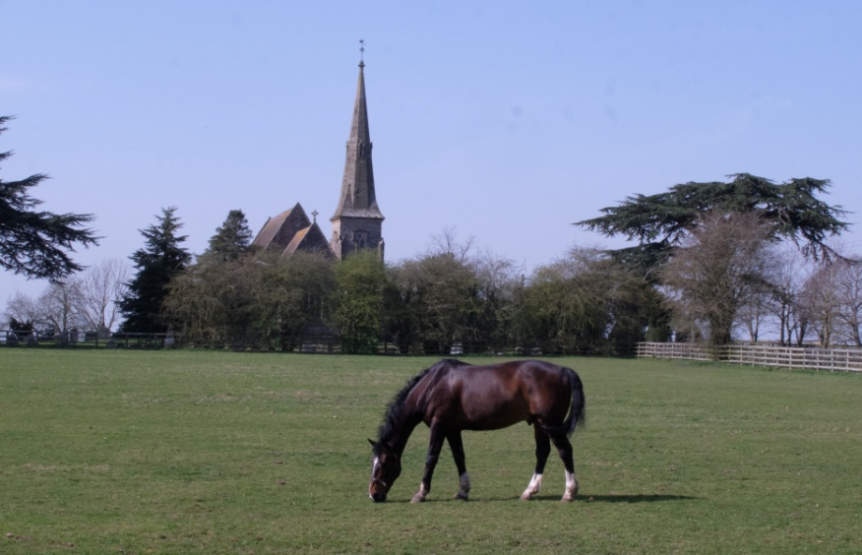

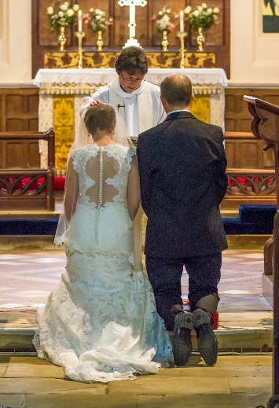
All Saints, Thirkleby is a very rural church in a secluded setting. It has a recently augmented ring of 6 bells and seats around 130 people. A most beautiful view greets the newly married couple as they exit the church!
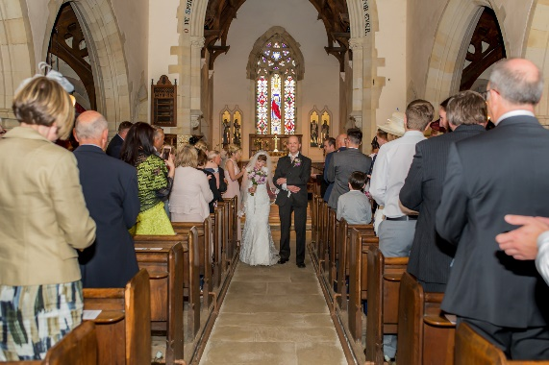
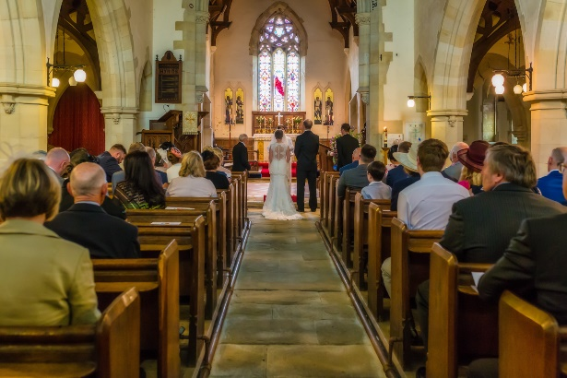

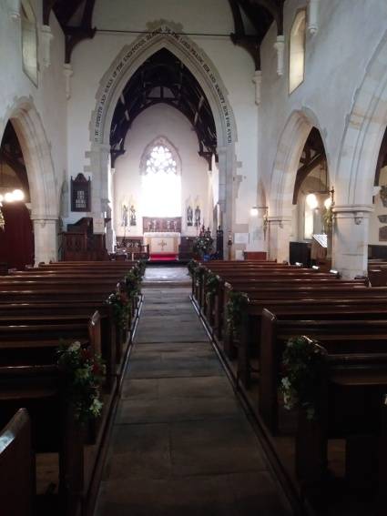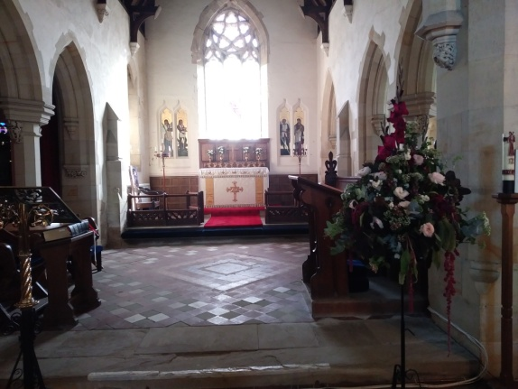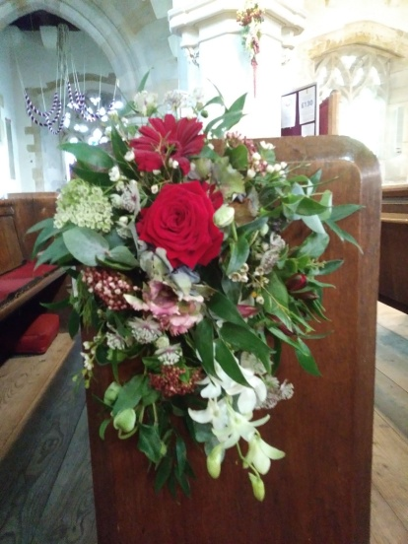

If you have decided to get married,

CONGRATULATIONS!

It's one of the most important events in your life and if we can help make it even more special, with a wedding in one of our five churches, then we will be delighted to welcome you.

More than a quarter of all marriages in England between a man and a woman take place in the traditional setting of a Church of England church. You're welcome to marry in church whatever your beliefs, whether or not you are baptised and whether or not you go to church. There are now options to be able to get married in churches where you may have a connection or can make one.

You can get married in a Church if one of you:
- lives in the parish
- is on the church’s electoral roll
- has at any time lived in the parish for a period of at least 6 months
- has habitually attended normal church services in the parish church for a period of at least 6 months
- was baptised in the parish
- was prepared for confirmation in the parish
or one of your parents; at any time after you were born:
- has lived in the parish for a period of at least 6 months
- has at any time habitually attended normal church services in the parish church for a period of at least 6 months
or 9 one of your parents or grandparents was married in the parish.
or 10 you have been granted a Special Licence.

We have also been granted greater flexibility by the Archbishop of York, so that if you qualify to be married in any one of our churches, then you automatically have the choice of any of the others.
Also, it is possible to have a second Marriage in Church. We would need to have a conversation about your previous marriage and see legal documents to ensure the marriage has legally ended. Please contact us.

But isn’t a Church Wedding more expensive?
Actually, no. A Church wedding will usually cost a lot less than a wedding service at your reception venue, where as well as hire of the room you will also have to pay for the Registrar to attend. The basic cost of a Church wedding is set nationally, but the Church you choose may have additional optional costs including organist, choir (if available) and bell ringers (if there are bells at your chosen church). All of this together will probably be less than a ceremony at your wedding venue, and the service will last longer.

Want to look around? The church at Thirkleby is open during the day, so please do come and look around. Alternatively, why not join us for a Sunday service? You would be very welcome. Details are on the church notice board.

If you are interested in a Church Wedding, we would be delighted to meet with you and discuss the possibilities:  Vicar: Rev David Biggs  Tel 01845 526736  rev.david@stoswaldsowerby.org.uk  Assistant Priest: Rev Pauline Percy  Tel 01347 868048  rev.pauline@stoswaldsowerby.org.uk | 