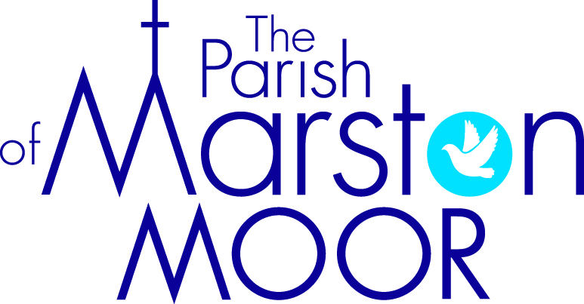
St Mary’s Church, Askham Richard; St James’ Church, Bilbrough
All Saints’ Church, Long Marston; All Saints’ Church, Rufforth
Church of the Epiphany Tockwith

CHURCH FEES 2022

Diocese PCC Verger Organist TOTAL
FUNERALS
Service in church £112 £94 £50 £75 £331

Service in church followed by cremation: same (£331) + £30 (Dioc fee) + £15 travel £376
Service in church followed by burial at Rufforth burial ground: £361
Service in church followed by burial requiring travel £348

Service in church plus
Burial in churchyard £127 (112+15) £410(94+316) £50 £75 £662

Burial only £ 44 £316 £25 -- £385

Cremation (service
at crematorium) £206 + £15 travel £221

Burial of ashes £ 44 £128 £25 -- £197

Extras: Heating - £50
All fees (including travel, and fees for retired clergy (which may include additional travel
expenses)) must be paid to the Parish of Marston Moor (i.e. no personal cheques).

No Diocesan or PCC fees are payable in respect of stillbirths or children under 16.

Funeral collection in church: all collections received in church must be put through the church accounts
before a cheque can be issued for any designated charity. __________________________________________________________________________________________
MONUMENTS
Wood cross £15 £34 -- -- £49
Cremation tablet/vase £15 £64 -- -- £79
Other monument £15 £135 -- -- £150
Additional inscription £15 £16 -- -- £31

MARRIAGES
Publication of Banns £32 -- -- )
Service £218 £262 £50 £100 ) _____ £218 £294 £50 £100 £662

Extras
Bells ~ Askham Richard £30 ~ Bilbrough £70 ~ Long Marston £50 ~ Rufforth £80 ~Tockwith £50
Heating ~ £50

BLESSING OF A MARRIAGE
Service £218 £262 £50 £100 £630
Extras (bells, heating) as for marriage service

Please ring the Vicar, The Revd Martin Otter, (07842 106044)
for an appointment to discuss arrangements for a marriage or blessing of a marriage.

Marriage taking place in another parish (please ring the Vicar to arrange calling of the banns)

Publication of Banns -- £ 32 -- -- )
Banns Certificate -- £ 16 -- -- ) £48

St Mary’s Church, Askham Richard; St James’ Church, Bilbrough
All Saints’ Church, Long Marston; All Saints’ Church, Rufforth
Church of the Epiphany Tockwith

CHURCH FEES 2022

FUNERALS

Diocese PCC Verger Organist TOTAL

FUNERALS
Service in church £112 £94 £50 £75 £331

Service in church followed by cremation: same (£331) + £30(Dioc fee) + £15 travel = £376

Service in church plus
burial in churchyard £127 (112+15) £410 (94+316) £50 £75 £662

Burial only £ 44 £316 £25 -- £385

Cremation (service
at crematorium) £206 + £15 travel £221

Burial of ashes £ 44 £128 £25 -- £197

Extras - Heating - £50

All fees (including travel, and fees for retired clergy (which may include additional travel
expenses) must be paid to the Parish PCC (i.e. no personal cheques).

No Diocesan or PCC fees are payable in respect of stillbirths or children under 16.

Funeral collection in church: all collections received in church must be put through the
church accounts before a cheque can be issued for any designated charity.

______________________________________________________________________________________________________________________________________________________________________________________

MONUMENTS
Wood cross £15 £34 -- -- £49
Cremation tablet/vase £15 £64 -- -- £79
Other monument £15 £135 -- -- £150
Additional inscription £15 £16 -- -- £31

St Mary’s Church, Askham Richard; St James’ Church, Bilbrough
All Saints’ Church, Long Marston; All Saints’ Church, Rufforth
Church of the Epiphany Tockwith

CHURCH FEES 2022

MARRIAGES

Diocese PCC Verger Organist TOTAL

MARRIAGES
Publication of Banns -- £ 32 -- -- )

Service £218 £262 £50 £100 ) _____ £218 £294 £50 £100 £662

Extras
Bells - Askham Richard £30 – Bilbrough £70 – Long Marston £50 Rufforth £80 – Tockwith £50

Heating - £50

BLESSING OF A MARRIAGE
Service
£218 £262 £50 £100 £630

Extras (bells, heating) as for marriage service

Please phone the Vicar, The Revd Martin Otter, (07842 106044)
for an appointment to discuss arrangements for a marriage or blessing of a marriage.

Marriage taking place in another parish (please phone the Vicar to arrange calling of the banns)

Publication of Banns -- £ 32 -- -- )
Banns Certificate -- £ 16 -- -- ) £48

