Framilode Riverside Retreats

Monthly Quiet Days
Dates for 2022
All Wednesday’s
2nd March Rev’d Anne Spargo
6th April Rev’d Catherine Williams
4th May Rev’d Helen Sammon

1st June Rev’d Liz Palin

6th July Rev’d Steve Abbot
3rd August Rev’d Diane Daymond
7th September Rev’d Chris Mason
5th October Bishop Bob Evens
2nd November Rev’d Michael Cozens
7th December Rev’d Ian Bussell
10.00 a.m. – 3.00 p.m.

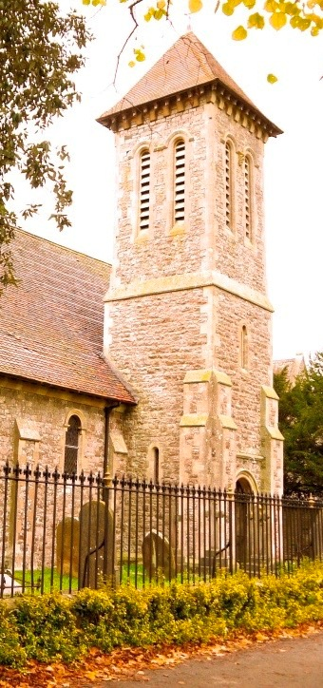

Allowing Ourselves Space for God

Cost of the Day
£15 to include all refreshments and lunch. Please bring cash on the day or a cheque made payable to PCC St Peters Framilode
Booking
Please e-mail
framiloderiversideretreats@gmail.com

Or phone 01452 741410

