**Churches Together in Chellaston**

**United Carol Service**

**on Youtube**

**19th December 2021**

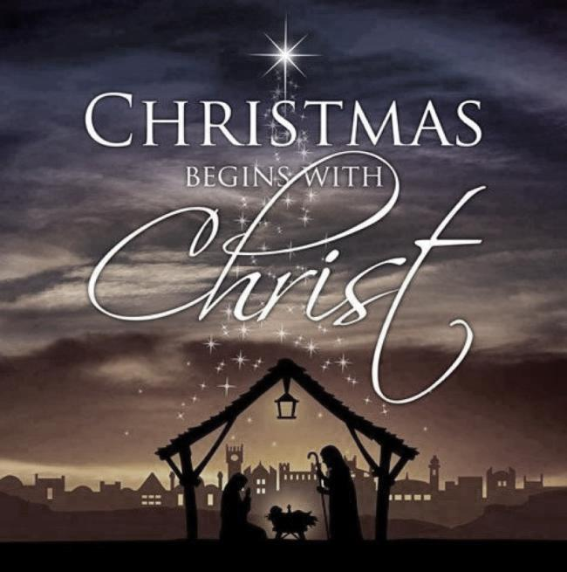

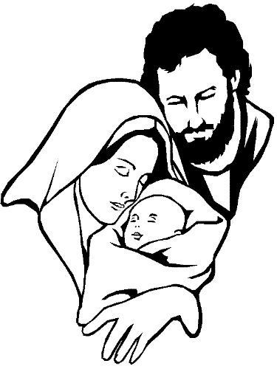

**Welcome. (BJ)**

**Carol: (first verse choir only)**

**1. Once in royal David’s city 2.** He came down to earth from heaven

stood a lowly cattle shed, who is God and Lord of all,  
where a mother laid her baby and his shelter was a stable,  
in a manger for his bed: and his cradle was a stall;  
Mary was that mother mild, with the poor and mean and lowly  
Jesus Christ her little child. lived on earth our Saviour holy.  
  
**3.**And through all his wondrous childhood 4. For he is our childhood’s pattern,  
he would honour and obey, Day by day like us he grew;  
love and watch the lowly maiden, He was little, weak and helpless,  
in whose gentle arms he lay. Tears and smiles like us he knew;  
Christian children all must be And he feeleth for our sadness,  
mild, obedient, good as he And he shareth in our gladness.

**5.** And our eyes at last shall see him, **6.**  Not in that poor lowly stable,  
through his own redeeming love, with the oxen standing by,  
for that child so dear and gentle we shall see him; but in heaven,  
is our Lord in heaven above; set at God’s right hand on high;  
and he leads his children on when like stars his children crowned  
to the place where he is gone. all in white shall wait around.

**Opening Prayers. (BJ)**

Minister: Loving God, you have come to us in Christ.

so now we come to you to offer our worship,

to hear your word, to reflect on your love.

Help us through all we share today

to hear the great story of Christmas

speaking to us as though for the first time.

May words that we know of old take on new meaning

so that the joy given to Mary, the glad tidings told to the shepherds, and the Christ-child visited by the wise men,

become good news for us. Amen

**The Lord’s Prayer: (BJ)**

**All: Our Father who art in heaven, hallowed be thy name.**

**Thy Kingdom come, thy will be done**

**On earth, as it is in heaven.**

**Give us this day our daily bread.**

**And forgive us our trespasses,**

**As we forgive those who trespass against us.**

**And lead us not into temptation,**

**But deliver us from evil.**

**For Thine is the kingdom, the power, and the glory,**

**For ever and ever.**

**Amen**

**1st Reading: Isaiah 9:2;6-7. (Christine)**

The people who walked in darkness

Have seen a great light.

They lived in the land of shadows,

But now light is shining on them.

A child is born to us!

A son is given to us!

And he will be our ruler.

He will be called ‘Wonderful Counsellor’,

Mighty God’, ‘Eternal Father’, Prince of Peace’.

His royal power will continue to grow;

His kingdom will always be at peace.

He will rule as King David’s successor,

Basing his power on right and justice,

From now until the end of time.

**Choir: Soon and Very Soon.**

**2nd Reading: Christmas begins with Christ. (Heather)**

In the tale of the nativity are familiar Christmas things –

Journeys and a crowded pub, family reunions and presents,

travellers and workers, lonely old people, suffering children…..

You will find everything in today’s headlines

is in that story, every experience and every need.

And at the centre of it all - a child –

born to love, born to die, born to live.

Christmas begins with him.

Born in the night he brings light to our darkness;

he gives point and purpose to the pain of a mother,

the pride of a father, the hopes of the simple,

the searching of the wise.

His hands full of miracles, his heart full of love,

he comes to share and enrich every part of your life.

**Carol**

**1. In the bleak mid-winter, 2.** Our God, heaven cannot hold Him,

Frosty wind made moan; Nor earth sustain,

Earth stood hard as iron, Heaven and earth shall flee away

Water like a stone. When He comes to reign.

Snow had fallen, snow on snow, In the bleak midwinter

Snow on snow; A stable-place sufficed

In the bleak midwinter, The Lord God Almighty,

Long ago. Jesus Christ.

**3.** Angels and archangels **4.** What can I give him

May have gathered there, Poor as I am?

Cherubim and seraphim If I were a shepherd

Thronged the air. I would bring a lamb.

But His mother only, If I were a wise man,

In her maiden bliss, I would do my part;

Worshipped the Belovèd Yet what I can I give him -

With a kiss. Give my heart.

**3rd Reading: Luke 1:26-28. (SRS Reader)**

In the sixth month of Elizabeth’s pregnancy God sent the angel Gabriel to a town in Galilee named Nazareth. He had a message for a girl promised in marriage to a man named Joseph, who was a descendant of King David. The girl’s name was Mary. The angel came to her and said, ‘Peace be with you! The Lord is with you and has greatly blessed you!’

Mary was deeply troubled by the angel’s message, and she wondered what his words meant. The angel said to her, ‘Don’t be afraid, Mary; God has been gracious to you. You will become pregnant and give birth to a son, and you will name him Jesus. He will be great and will be called the Son of the Most High God.

The Lord will make him a king, as his ancestor David was, and he will be the king of the descendants of Jacob for ever; his kingdom will never end.

Mary said to the angel, ‘I am a virgin. How, then, can this be?’

The angel answered, ‘The Holy Spirit will come on you, and God’s power will rest upon you. For this reason the holy child will be called the Son of God. Remember your relative Elizabeth. It is said that she cannot have children, but she herself is now six months pregnant, even though she is very old. For there is nothing that God cannot do.’

‘I am the Lord’s servant,’ said Mary; ‘may it happen to me as you have said.’ And the angel left her.

**Choir: The Angel Gabriel**

**4th Reading: Luke 2:1-6. (Dorothy)**

In those days a decree went out from Emperor Augustus that all the world should be registered. This was the first registration and was taken while Quirinius was governor of Syria. All went to their towns to be registered. Joseph also went from the town of Nazareth in Galilee to Judea, to the city of David called Bethlehem, because he was descended from the house and family of David. He went to be registered with Mary, to whom he was engaged and who was expecting a child. While they were there, the time came for her to deliver her child. And she gave birth to her firstborn son and wrapped him in bands of cloth, and laid him in a manger, because there was no place for them in the inn.

**Carol**

**O little town of Bethlehem**  
How still we see thee lie!  
Above thy deep and dreamless sleep   
The silent stars go by.  
Yet in thy dark streets shineth  
The everlasting Light;  
The hopes and fears of all the years  
Are met in thee tonight.

O morning stars together  
Proclaim the holy birth,  
And praises sing to God the King,  
And Peace to all on earth.

For Christ is born of Mary;  
And gathered all above,  
While mortals sleep, the angels keep  
Their watch of wondering love.  
  
How silently, how silently  
The wondrous gift is given!  
So God imparts to human hearts  
The blessings of His heaven.  
No ear may hear His coming;  
But in this world of sin,  
Where meek souls will receive him, still  
The dear Christ enters in.

O holy Child of Bethlehem,  
Descend to us, we pray;  
Cast out our sin and enter in,  
Be born to us today.  
We hear the Christmas angels  
The great glad tidings tell:  
O come to us, abide with us,  
Our Lord Emmanuel.

**Choir: Still, Still, Still**

**5th Reading: Luke 2:8-15. (SRS Reader)**

There were some shepherds in that part of the country, who were spending the night in the fields, taking care of their flocks. An angel of the Lord appeared to them, and the glory of the Lord shone over them. They were terribly afraid, but the angel said to them, ‘Don’t be afraid! I am here with good news for you, which will bring great joy to all people. This very day in David’s town your Saviour was born – Christ the Lord! And this is what will prove it to you: you will find a baby wrapped in strips of cloth and lying in a manger.’ Suddenly a great army of heaven’s angels appeared with the angel, singing praises to God: ‘Glory to God in the highest heaven, and peace on earth to those with whom he is pleased!’ When the angels went away from them back into heaven, the shepherds said to one another, ‘Let’s go to Bethlehem and see this thing that has happened, which the Lord has told us.’

**Carol:**

**While shepherds watched** their flocks by night, all seated on the ground,

The angel of the Lord came down and glory shone around.

‘Fear not’ said he, for mighty dread had seized their troubled mind;

‘Glad tidings of great joy I bring to you and all mankind.

‘To you in David’s town this day is born of David’s line

A Saviour, who is Christ the Lord, and this shall be the sign.

‘The heavenly babe you there shall find to human view displayed,

All meanly wrapped in swaddling bands, and in a manger laid.’

Thus spake the seraph; and forthwith appeared a shining throng

of angels, praising God, who thus addressed their joyful song:

‘All glory be to God on high and on the earth be peace;

Goodwill henceforth from heaven to all begin and never cease.’



**Choir: Cantemos a Maria**

**The reading from the Gospel of John. (David H)**

**6h Reading: John 1:1-14**

Before the world was created, the Word already existed; he was with God, and he was the same as God. From the very beginning the Word was with God. Through him God made all things; not one thing in all creation was made without him. The Word was the source of life, and his life brought light to mankind. The light shines in the darkness, and the darkness has never put it out.

God sent his messenger, a man named John, who came to tell people about the light, so that all should hear the message and believe. He himself was not the light; he came to tell about the light. This was the real light – the light that comes into the world and shines on all mankind.

The Word was in the world, and though God made the world through him, yet the world did not recognise him. He came to his own country, but his own people did not receive him. Some, however, did receive him and believed in him; so he gave them the right to become God’s children. They did not become God’s children by natural means, that is, by being born as the children of a human father; God himself was their Father.

And the word became flesh and lived among us, and we have seen his glory, the glory as of the father’s only son, full of grace and truth.

God sent his angels from heaven to bring the Good News of Jesus Birth. You have heard his story, the story of God's own Son. May he fill you with joy as you carry this good news to others.

**Carol:**

**1. O come, all ye faithful,**

joyful and triumphant,  
 O come ye, O come ye to Bethlehem;  
 come and behold him,  
 born the King of angels;  
 *O come, let us adore him,  
 O come, let us adore him,  
 O come, let us adore him, Christ the Lord!*

**2.** God of God, Light of Light, **3.** Sing, choirs of angels,  
lo! he abhors not the virgin’s womb; sing in exultation,  
very God, sing all ye citizens of heaven above:  
begotten, not created: “Glory to God in the highest:”  
O come, let us, etc. O come, let us, etc.

**Prayers and Responses. (Jacky)**

Each prayer ends with the words ‘God of love’

Please respond with **‘Hear our prayer’.**

**The Blessing. (BJ)**

May the joy of the angels,

the eagerness of the shepherds,

the perseverance of the wise men,

the obedience of Joseph and Mary,

and the peace of the Christ-child

be yours this Christmas;

and the blessing of God Almighty,

the Father the Son and the Holy Spirit

be with you and those whom you love

now and forever. **Amen**

**Carol**

**Hark the herald angels sing**  
Glory to the newborn King!  
Peace on earth and mercy mild  
God and sinners reconciled.  
Joyful, all ye nations rise,  
Join the triumph of the skies  
With the angelic host proclaim:  
Christ is born in Bethlehem  
Hark! The herald angels sing  
"Glory to the newborn King!"

Christ by highest heav'n adored,  
Christ the everlasting Lord,  
Late in time behold Him come,  
Offspring of a Virgin's womb!  
Veiled in flesh the Godhead see!  
Hail, the incarnate Deity!  
Pleased as man with man to dwell,  
Jesus, our Emmanuel!  
Hark! The herald angels sing  
"Glory to the newborn King!"  
  
Hail the heav'n-born Prince of Peace!  
Hail the Son of Righteousness!  
Light and life to all He brings,  
Ris'n with healing in His wings.  
Mild, He lays His glory by,  
Born that we no more may die,  
Born to raise the sons of earth,  
Born to give them second birth.  
Hark! The herald angels sing  
"Glory to the newborn King!"

**We wish you a very happy Christmas**

**and a peaceful New Year.**

