Welcome to our Churchyard

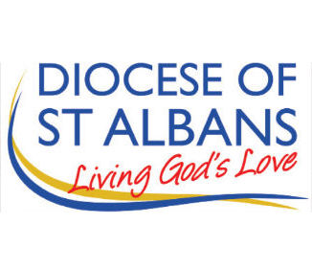
We sympathise with grieving families wishing to personalise their loved ones’ graves but we have to retain the natural beauty of the churchyard for everyone. Graves are actually owned by the Church of England, not the family, & subject to 2020 Churchyard Regulations (see Church of England website). We are inspected regularly and required to REMOVE items which are NOT PERMITTED to protect the environment and aid churchyard maintenance, including
No candles or solar lights
No plastic, china or glass containers
No photographs, letters, cards or other mementoes
No faded artificial or dead flowers
No shrubs or bushes
Bulbs or flowers may be planted in but not outside a grave
The grave space may not be extended. Gravel or a surround may not be added. Headstones, additions and alterations require signed approval on a form (from stonemasons)
Our churchyard is cared for by unpaid volunteers.
Donations and offers of help with upkeep are welcomed.
To include a loved one in the church Book of Remembrance please contact the churchwardens.
For free bereavement support please contact Ann Edwards edwardsa@hotmail.com 01438 230826
For a visit from any of the ministry team please contact the Rector jennygrayrectory@gmail.com 01920 830035

