The Great Summer Sponsored Railing Event 2021 –
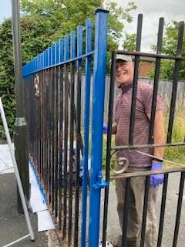
It's here and it's happening at St Mark's Church, Brampton.

156 railings need to be painted as part of our summer challenge to improve our curb appeal, improve & bring the railings back to life!

Just two months to transform railings ….

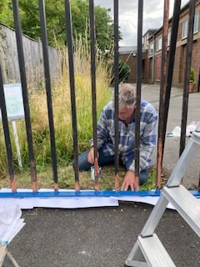

………. and transform lives

Sponsor a railing and help us raise money for Christian Aid,
and for
Friends of the Monkey Park
(money raised will be split 66:33).

Donations gratefully received by cash or
cheques (made payable to St Mark’s PCC)
or online at https://www.facebook.com/StMarksChurchBrampton/givealittle.co

or by scanning this QR code

THANK YOU EVERYONE FOR YOUR SUPPORT!

