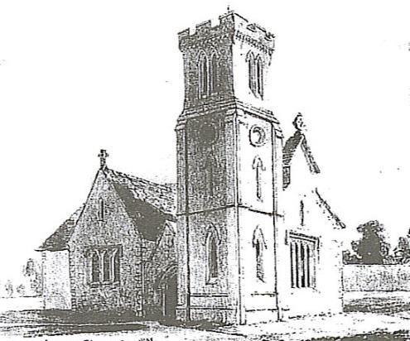 Church of St. Peter, Milton Bryan
Consent Form
We hope you enjoy hearing from us and we would love to stay in touch with you!

miltonbryanparishchurch@gmail.com
Consent Form 2021
Your privacy is important to us. We want to communicate with church members, everyone connected and to all who have interest in the life of our church, in a way which has their consent and in line with UK law on data protection. We need your consent so that we can contact you in the ways that you prefer.
Please fill in the contact details you want us to use to communicate with you:
If you would like to be informed of future events and other church news please tick the box below and let us have your contact details.
Name: _________________________________________________________________________
Address: _________________________________________________________________________
_________________________________________________________________________
Email Address: _________________________________________________________________________
Phone Number: _________________________________________________________________________
By signing this form you are confirming that you are consenting to the PCC of the Church of St. Peter, Milton Bryan holding and processing your personal data for the following purposes (please tick the boxes where you grant consent):
☐ To keep me informed about news, events, activities and services at St. Peter’s Church, Milton Bryan along with occasional news about our Benefice. I consent to the church contacting me by:
□ post □ phone or □email
Signed: __________________________________ Date: ___________________________
You can grant consent to all the purposes; one of the purposes or none of the purposes.
Please send your forms to: miltonbryanparishchurch@gmail or Kelvin White directly, details below.
Where you do not grant consent we will not be able to use your personal data; (so for example we may not be able to let you know about forthcoming services and events); except in certain limited situations, such as where required to do so by law or to protect members of the public from serious harm.
You can find out more about how we use your data from our “Privacy Notice” which can be obtained on request from the PCC, is available in the Church policy folder, on the church website and in church too. Please note that all processing of your personal data will cease once you have withdrawn consent, other than where this is required by law, but this will not affect any personal data that has already been processed prior to this point.
You can withdraw or change your consent and unsubscribe at any time, or by contacting: Kelvin White: 4, Church End, Milton Bryan, Bedfordshire, MK17 9HR. E-mail: kelvinbrucewhite@gmail.com – miltonbryanparishchurch@gmail.com - Tel: 01525 210337 Confirmation of your request to receive news, update details or cancellation will be confirmed.

