St. Stephen’s church
Fradley
Summer
Praise
Online
Sunday 18th July 2021

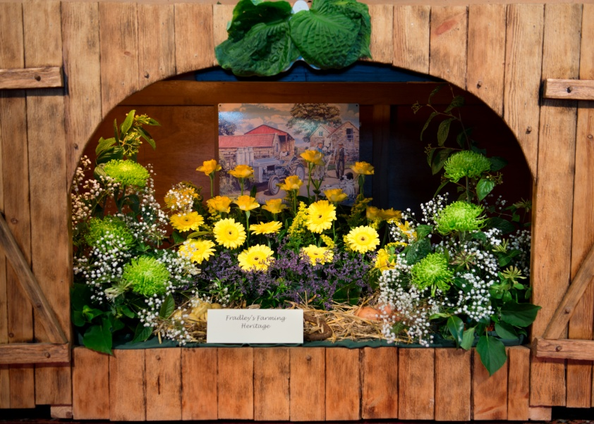

OPENING HYMN 108 Colours of day

WELCOME AND INTRODUCTION

O Lord, open our eyes to see what is beautiful,
our minds to know what is true,
and our hearts to seek what is good for Jesus’ sake.
All: Amen.

Creator God, we give thanks for your gifts:
For summer warmth and cooling breezes
All: We give you thanks and praise.

For refreshing rain and ripening crops
All: We give you thanks and praise.

For towering trees and fragrant blossom
All: We give you thanks and praise.

For mighty oceans and endless sky
All: We give you thanks and praise.

For all living creatures that share our earthly home
All: We give you thanks and praise.

For family relationships and friends we trust
All: We give you thanks and praise. Amen.

READING Psalm 67 ‘Let all praise God’

May God be gracious to us and bless us
and make his face to shine upon us,
that your way may be known upon earth,
your saving power among all nations.
Let the peoples praise you, O God;
let all the peoples praise you.
Let the nations be glad and sing for joy,
for you judge the peoples with equity
and guide the nations upon earth.
Let the peoples praise you, O God;
let all the peoples praise you.
The earth has yielded its increase;
God, our God, has blessed us.
May God continue to bless us;
let all the ends of the earth revere him.
Hear the Word of the Lord.
All: Thanks be to God.

MUSIC GROUP 17 All heaven declares

In a moment of quiet reflection, let us seek the renewal of our lives in the light of God’s love for us,
revealed by Jesus Christ.

(A short silence)

Jesus, Saviour of all, who revealed the breadth of
God’s love, forgive us when we fail to show care to
those who are different.
Lord, have mercy.
All: Lord, have mercy.

Jesus, Son of God, who revealed the depth of God’s
love, forgive us when we are too busy to pray or seek
God’s will.
Christ, have mercy.
All: Christ, have mercy.

Jesus, Son of Man, who revealed the cost of God’s love,
forgive us when we have made light of our sins.
Lord, have mercy.
All: Lord, have mercy.

May almighty God have mercy on us,
forgive us our sins,
and bring us to everlasting life,
through Jesus Christ our Lord.
All: Amen.

MUSIC GROUP 436 Majesty, worship his majesty

COLLECT

GOSPEL READING
A reading from the Gospel of Matthew.

‘Therefore I tell you, do not worry about your life, what you will eat or what you will drink, or about your body, what you will wear. Is not life more than food, and the body more than clothing? Look at the birds of the air; they neither sow nor reap nor gather into barns, and yet your heavenly Father feeds them. Are you not of more value than they? And can any of you by worrying add a single hour to your span of life?
And why do you worry about clothing? Consider the lilies of the field, how they grow; they neither toil nor spin,
yet I tell you, even Solomon in all his glory was not clothed like one of these. But if God so clothes the grass of the field, which is alive today and tomorrow is thrown into the oven, will he not much more clothe you—you of little faith? Therefore do not worry, saying, “What will we eat?” or “What will we drink?” or “What will we wear?” For it is the Gentiles who strive for all these things; and indeed your heavenly Father knows that you need all these things. But strive first for the kingdom of God and his righteousness, and all these things will be given to you as well. Matthew 6:25-33
Hear the Word of the Lord.
All: Thanks be to God.

MUSIC GROUP 305 Lord of the dance

THE PRAYERS
At the words
‘Lord of all life’…..
Please respond with ‘Hear our prayer’.

Solo “This Day” by Bob Chilcott sung by Julia Usher

THE LORD’S PRAYER
So we draw all our prayers together in the prayer that Jesus taught us-
Our Father in heaven,
hallowed be your name,
your kingdom come,
your will be done,
on earth as in heaven.
Give us today our daily bread.
Forgive us our sins
as we forgive those who sin against us.
Lead us not into temptation
but deliver us from evil.
For the kingdom, the power
and the glory are yours,
now and for ever.
Amen.

HYMN 476 O breath of life

BLESSING

May God the Father of our Lord Jesus Christ,
who is the source of all goodness and growth,
pour out his blessing upon all things created,
and upon you his children,
that you may use his gifts to his glory
and the welfare of all peoples;
and the blessing……
“Go in peace, go in joy, go in love”

Solo “May God’s blessing surround you each day”
sung by Graham Griffiths

