New Covid Guidance for
St Pauls Kersal and St Andrews Carr Clough
Please continue to:
Wear a mask Use hand sanitizer Keep socially distancing
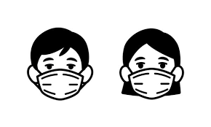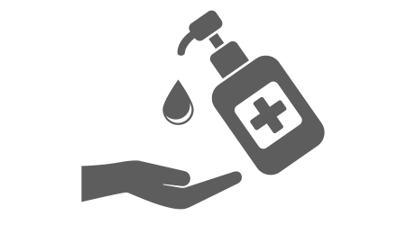

We can now:
Sing hymns and worship songs
and
Stay to chat in the social areas after services

We will be providing refreshments on:
Sundays at St Andrews Wednesdays at St Pauls
Remember: if you test positive or are unwell please stay at home

