Holy Cross Church Hall is an outstanding venue set in the heart of the attractive village of Swainby. Built in 2010 to the highest standards, its rural location overlooks the Cleveland Hills.

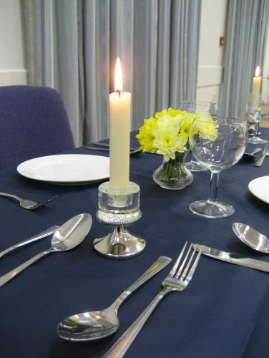
Features of the hall
(11 metres x 8 metres)

- Full disabled access and disabled toilet

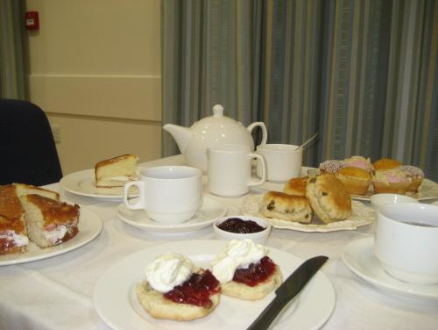
- Seating for 100 theatre style
- Seating for 70 at tables

- Maximum natural lighting

- 2 independent lighting systems, one for bright general lighting, the other for subdued atmospheric lighting

- Hearing loop

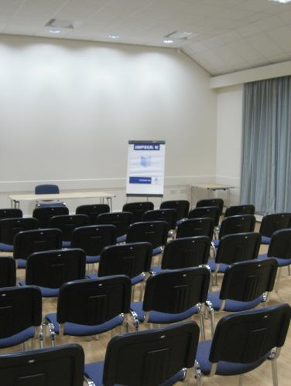
- Sound system with cordless microphones and hearing loop

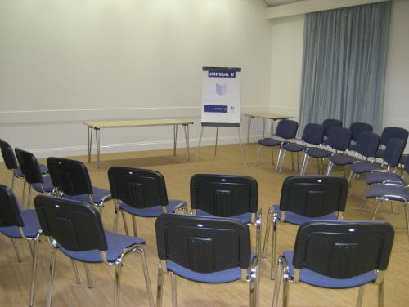
- Large plain wall, ideal for projection

- Projector and laptop on request*

- Excellent kitchen facilities

- Baby change facility

- Patio area

- Garden area with space for a marquee
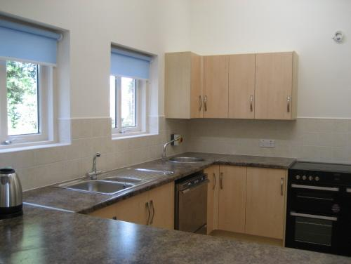
Excellent kitchen facilities:
5 burner hob,
double oven, dishwasher with 4 minute cycle,
wall-mounted
hot-water boiler,
full range of crockery, cutlery, and glasses
Scale of charges for private functions
with effect from 1 May 2021

Period of hire | Local* residents | Non-residents
Hourly | £12 | £16
Morning/afternoon/ Evening (4 hours)  Double session (2 x 4h) | £42  £75 | £55  £90
Full day  Weddings | £100  £200 | £130  £260
* residents of Swainby or Potto

Session / Evening rates are for
a 4 hour period: 9.00am -1.00pm,
1.00pm -5.00pm, or 6.00pm -10.00pm.
Charges include use of the main hall, kitchen and toilet facilities.

Wedding rates are for a full day plus one session either side for set/clear up. Please enquire.

Please enquire for our special discounts for groups making regular bookings.

Contact details for bookings:

e-mail:

swainbychurch@btinternet.com

Sue Lawton 01642 700491

The ideal venue for:

- Family parties
- Wedding receptions
- Baptism parties
- Children’s parties
- Meetings
- Conferences
- Quiet days
- Day and evening classes
- Charity fundraising events

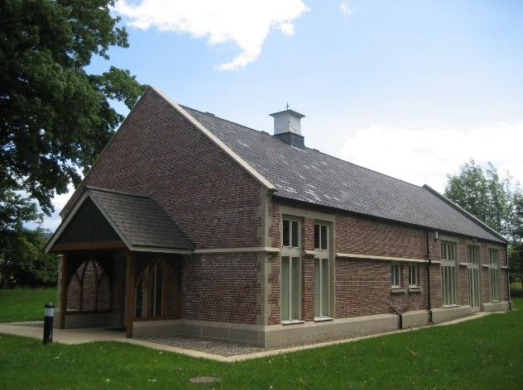
Holy Cross Church Hall,
Church Lane, Swainby, Northallerton, North Yorkshire. DL6 3EA

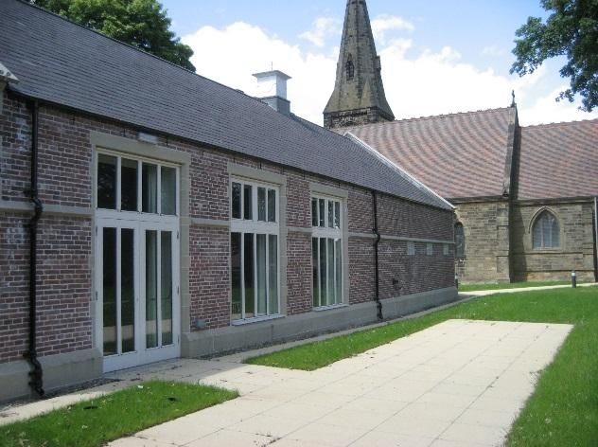

HOLY CROSS

CHURCH HALL

SWAINBY

