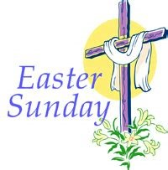
at
St Stephen’s
Sunday 4th April
9am Holy Communion BCP
10.30am Family Communion
We reopen for Public Worship
Please note that we must observe social distancing
Face coverings need to be worn in church

