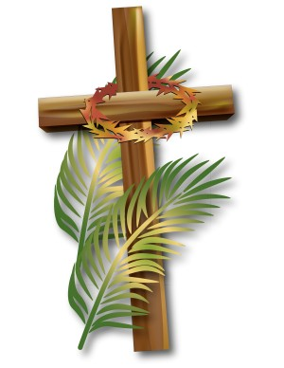

Introduction
Hymn: All Glory Laud and Honour

Affirmation
We are in the presence of God the Father, our Creator, of Christ the King
our Redeemer, of the Holy Spirit who
empowers us.

The Lord is here
All: His Spirit is with us.

We cannot come together in person.
We cannot walk with Christ in our churches
Yet still we are together, united in hearts and minds, united by Christ, whose broken body makes us one.
Today with the Church throughout the world, we set our eyes upon the Cross.
We remember Christ entering his own city obedient to his Father’s will:
ready to suffer, die and rise again. Let us travel with him hopefully.
Let us walk with him gently.
That we may come with him joyfully to share in his resurrection.

The Blessing of the Palms

God, our Father whose Son , our Saviour entered Jerusalem as the Christ to suffer and to die for us all, bless these palm crosses. May they remind us of all that Christ has done for us. May we welcome him into our lives and our homes. Grant that we who welcome him as King follow in his way until we come to the fullness of life eternal. We ask this in the name of him who is our King and Saviour, Jesus Christ our Lord.. Amen
Hosanna to the Son of David
All: Blessed is he who comes in the name of the Lord
Hosanna in the highest.

Lord Jesus, as you were welcomed when you entered into Jerusalem with palms and shouts of praise; we rejoice in your coming to us this day and pray that you may enter into our lives and the life of our community as our Lord and King; to you be all glory and honour, who lives and reigns with the Father and the Holy Spirit, One God now and for ever. Amen

Confession
God shows his love for us in that, while we were still sinners, Christ died for us..
Silence
God be gracious to us and bless us:
And make your face shine upon us
Lord have mercy
All: Lord have mercy

Make your ways be known on the earth,
Your saving power among the nations:
Christ, have mercy.
All: Christ have mercy

You, Lord, have made known your salvation,
And reveal your justice in the sight of the nations:
Lord have mercy
All: Lord have mercy

May almighty God have mercy on you, forgive you your sins, and bring you to everlasting life. Amen

Reading: Psalm 121

Reading : Mark 11: 1-11

The Reflection

The Creed
All We believe in one God, the Father, the Almighty,
maker of heaven and earth,
of all that is, seen and unseen.
We believe in one Lord, Jesus Christ, the only Son of God, eternally begotten of the Father,
God from God, Light from Light,
true God from true God, begotten, not made,
of one Being with the Father;
through him all things were made.
For us and for our salvation
he came down from heaven,
was incarnate from the Holy Spirit and the Virgin Mary and was made man.
For our sake he was crucified under Pontius Pilate;
he suffered death and was buried.
On the third day he rose again
in accordance with the Scriptures;
he ascended into heaven
and is seated at the right hand of the Father.
He will come again in glory
to judge the living and the dead,
and his kingdom will have no end.
We believe in the Holy Spirit,
the Lord, the giver of life,
who proceeds from the Father and the Son, who with the Father and the Son
is worshipped and glorified,
who has spoken through the prophets.
We believe in one holy catholic and apostolic Church.
We acknowledge one baptism for the forgiveness of sins. We look for the resurrection of the dead,
and the life of the world to come.
Amen

The Prayers including
The Collect for the Day
The Lord’s Prayer

The Blessing

Hymn: Ride on ride on in majesty

