St Peter’s Church
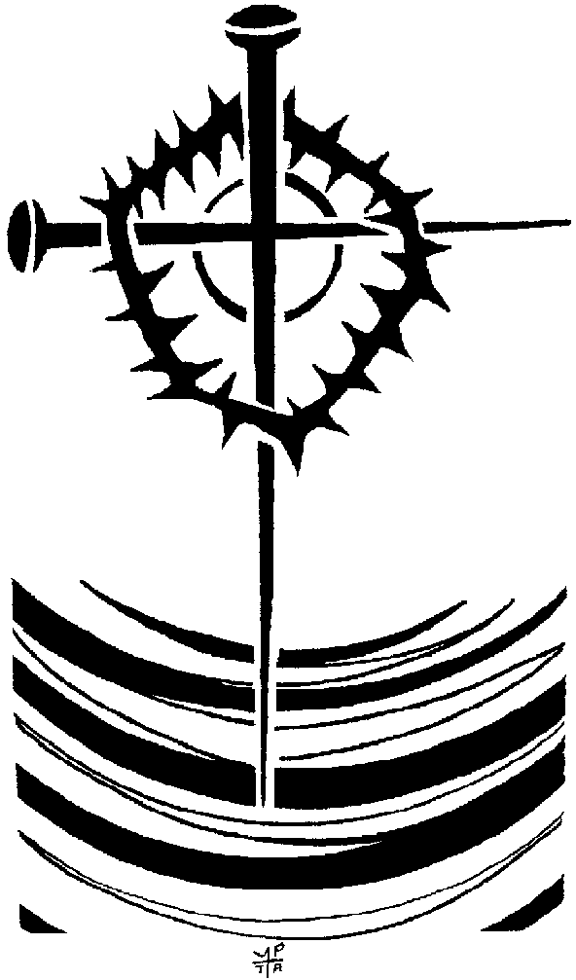

A service for

Ash Wednesday

WELCOME

HYMN

THE GATHERING

In the name of the Father,
and of the Son,
and of the Holy Spirit.
All Amen.

The Lord be with you
All and also with you.

The Call to a Lenten Discipline

Brothers and sisters in Christ: since early days Christians have observed with great devotion the time of our Lord’s passion and resurrection and prepared for this by a season of penitence and fasting.

By carefully keeping these days, Christians take to heart the call to repentance and the assurance of forgiveness proclaimed in the gospel, and so grow in faith and in devotion to our Lord.

I invite you, therefore, in the name of the Church, to the observance of a holy Lent, by self-examination and repentance; by prayer, fasting, and self-denial; and by reading and meditating on God’s holy word.

Let us pray for grace to keep Lent faithfully
Silence is kept.

The Collect
Almighty and everlasting God,
you hate nothing that you have made
and forgive the sins of all those who are penitent:
create and make in us new and contrite hearts
that we, worthily lamenting our sins
and acknowledging our wretchedness,
may receive from you, the God of all mercy,
perfect remission and forgiveness;
through Jesus Christ your Son our Lord,
who is alive and reigns with you,
in the unity of the Holy Spirit,
one God, now and forever.

All Amen.

THE LITURGY OF THE WORD

First Reading
2 Corinthians 5.20 – 6.10

At the end the reader may say

This is the word of the Lord.
All Thanks be to God.

Gospel Reading
Matthew 6.1-6, 16-21

At the end the reader may say

This is the word of the Lord.
All Thanks be to God.
THE SERMON. (Alison)

THE LITURGY OF PENITENCE

The sacrifice of God is a broken spirit;
a broken and contrite heart God will not despise.

Let us come to the Lord, who is full of compassion,
and acknowledge our transgressions in penitence and faith.

A time of silence is kept.

All Father eternal, giver of light and grace,
we have sinned against you and against our neighbour,
in what we have thought,
in what we have said and done,
through ignorance, through weakness,
through our own deliberate fault.
We have wounded your love,
and marred your image in us.
We are sorry and ashamed
and repent of all our sins.
For the sake of your Son Jesus Christ, who
died for us, forgive us all that is past;
and lead us out from darkness
to walk as children of light. Amen.

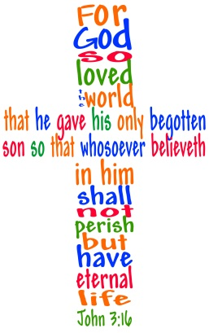
Kyrie Eleison

Lord, have mercy.
All Lord, have mercy.
Christ, have mercy.
All Christ, have mercy.
Lord, have mercy.
All Lord, have mercy.

The priest says

Almighty God,
who forgives all who truly repent,
have mercy upon you,
pardon and deliver you from all your sins,
confirm and strengthen you in all goodness,
and keep you in life eternal;
through Jesus Christ our Lord.
All Amen.

THE IMPOSITION OF ASHES?

The Priest says

As a sign of the spirit of penitence with which we shall keep this season of preparation for Easter, we would usually be invited to receive on your head in ash the sign of the cross, the symbol of our salvation. At the moment we are unable to do this. If we have your contact details you will have received a small card through the post with an ash cross marked on it. If you don’t have one perhaps you would like to mark a cross on a piece of paper.

I invite you to hold your cross in prayer.

God our Father,
you create us from the dust of the earth:
grant that these ashes may be for us
a sign of our penitence
and a symbol of our mortality;
for it is by your grace alone
that we receive eternal life
in Jesus Christ our Saviour.
All: Amen.

As we look at the sign of the cross . . .

Remember that you are dust, and to dust you shall return. Turn away from sin and be faithful to Christ.

This prayer is said by the President

God our Father,
The strength of all who put their trust in you,
Mercifully accept our prayers;
And because, in our weakness,
We can do nothing good without you,
Grant us the help of your grace,
That in keeping your commandments
We may please you, both in will and deed;
Through Jesus Christ our Lord.
All: Amen
THE PEACE

The Peace

Since we are justified by faith,
we have peace with God through our Lord Jesus Christ,
who has given us access to his grace.

The peace of the Lord be always with you
All and also with you.

Let us offer one another a sign of peace.

The Lord’s Prayer

Lord Jesus, remember us in your kingdom
and teach us to pray.

All Our Father in heaven,
hallowed be your name,
your kingdom come,
your will be done,
on earth as in heaven.
Give us today our daily bread.
Forgive us our sins
as we forgive those who sin against us.
Lead us not into temptation
but deliver us from evil.
For the kingdom, the power
and the glory are yours
now and forever. Amen

HYMN

The Blessing

Christ give you grace to grow in holiness, to deny yourselves, take up your cross, and follow him;
and the blessing of God almighty,
the Father, the Son, and the Holy Spirit,
be among you and remain with you always.
All Amen.

Go in peace to love and serve the Lord.
All In the name of Christ. Amen.

Copyright acknowledgment (where not already indicated above):
Some material included in this service is copyright: © 1989 National Council of the Churches of Christ, USA
Some material included in this service is copyright: © The Archbishops' Council 2000
Some material included in this service is copyright: © The Crown/Cambridge University Press: The Book of Common Prayer (1662)

St Peter’s Church 2021

