Can you help to support St Stephens Church?

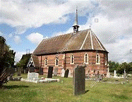
St Stephens Church is heavily dependent on voluntary donations and income from events in order to fulfil its ministry to the local and wider communities. The continuing pandemic is having a material impact on our income.
If you feel able, and would like to support us at this time,
donations can be made via our Just Giving page or by text.
With our huge thanks and appreciation!

https://www.justgiving.com/fundraising/ststephensfradley

Text - 21FRADLEY to 70085 followed by an amount
e.g. to donate £10 – text 21FRADLEY10

Texts cost the amount of your donation
plus one standard rate message.

