OUR VALUES:

OUR INSPIRATION:
“The question is, who — and how — shall we serve, and how soon can we start?”
Lucy Berry, Performance Poet

“It is for the Christian community to gather together and be taught how to be a better Christian and to strengthen up their faith and also help the needy”
Hertswood Academy student (aged 14)

“You did not choose me, but I chose you. And I appointed you to go and bear fruit, fruit that will last, so that the Father will give you whatever you ask him in my name.”
The Gospel of John, 15:16
The Parish of Elstree and Borehamwood
St Michael and All Angels
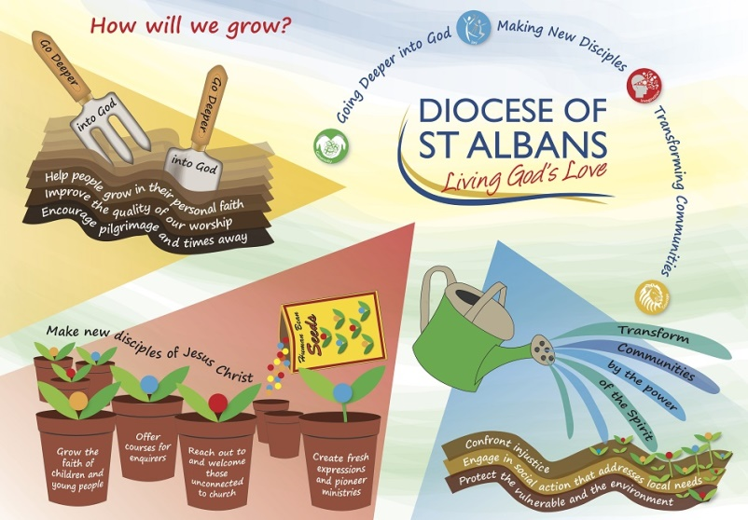

MISSION ACTION PLAN
2020

March 5th 2020
OUR VISION:
“To be a Church that pursues the Five Marks of Mission”
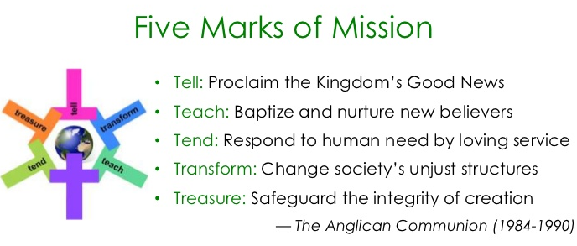

OUR PRIORITIES:
- TELL – To proclaim the Good News of the Kingdom
- TEACH – To teach, baptise and nurture new believers
- TEND – To respond to human need by loving service
- TRANSFORM – To transform unjust structures of society, to challenge violence of every kind and pursue peace and reconciliation
- TREASURE – To strive to safeguard the integrity of creation, and sustain and renew the life of the earth
OUR GOALS:
- TELL – To publicize Church activities by putting up a series of four outside banners and/or electronic notice boards
- TEACH – To bring together members of Wild @ St Michael’s, Junior Church, Borehamwood Air Cadets and others to put up an insect ‘bug hotel’ in the Church grounds
- TEND – To make a new Church role for a ‘Foodbank Champion’, in order to increase our awareness of the work of Borehamwood Foodbank and our support for it
- TEND – To support Knit and Natter in making knitted armbands and incubator covers for premature babies in local hospitals
- TRANSFORM – To strengthen our prayer ministry of Intercession for God’s world, by training and adding at least 6 new people to our Sunday Intercessions Team by end 2020
- TREASURE – To plant fruit trees in the Church grounds, by the end of 2020, thus increasing biodiversity, wildlife habitat, natural beauty and fruit

