**The Benefice of**

**Alrewas with Fradley**

**and Wychnor**

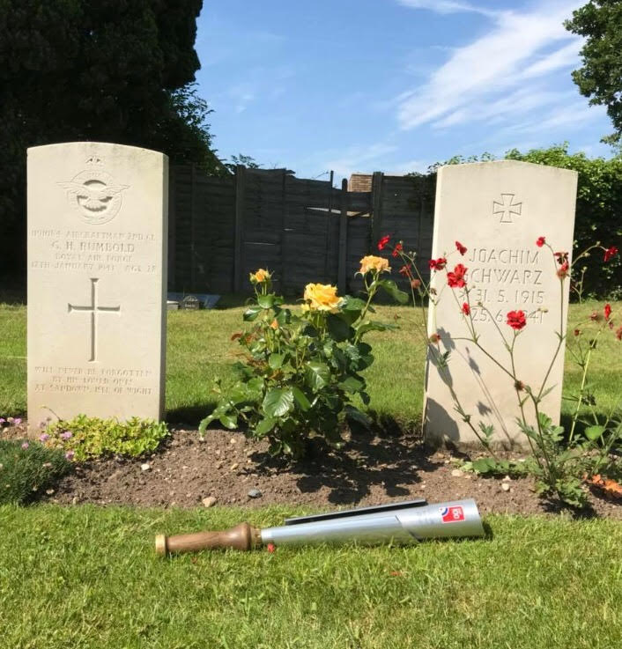

**VE DAY**

75th ANNIVERSARY

**10th May 2020**

**10.30am**

A Service of Thanksgiving

to mark the 75th anniversary

of Victory in Europe Day

**WELCOME**

When VE Day dawned on 8th May 2020 it was 75 years since the guns fell silent at the end of the war in Europe. Years of carnage and destruction had come to an end and millions of people took to the streets and pubs to celebrate peace, mourn their loved ones and to hope for the future, but not forgetting those still in conflict until 15th August when it was announced that Japan had surrendered unconditionally to the Allies, effectively ending World War II.

This 75th anniversary provides our nation, and our friends around the world, with an opportunity to reflect on the enormous sacrifice, courage and determination of people from all walks of life who saw us through this dark and terrifying period. It is an opportunity for us all to remember the enormous sacrifices that were made at home and abroad and to joyously celebrate as people did 75 years ago, the arrival of peace in Europe.

**Welcome**

**Opening Prayer**

**Reading**

In days to come the mountain of the Lord's house shall be established as the highest of the mountains, and shall be raised above the hills; all the nations shall stream to it. Many peoples shall come and say, ‘Come, let us go up to the mountain of the LORD, to the house of the God of Jacob; that he may teach us his ways and that we may walk in his paths.’ For out of Zion shall go forth instruction and the word of the LORD from Jerusalem. He shall judge between the nations, and shall arbitrate for many peoples; they shall beat their swords into ploughshares, and their spears into pruning-hooks; nation shall not lift up sword against nation, neither shall they learn war any more.

*Isaiah 2.1–4*

**Hymn**

**Love divine, all loves excelling,  
joy of heaven to earth come down;  
fix in us thy humble dwelling;  
all thy faithful mercies crown.**

**Jesus, thou art all compassion,  
pure unbounded love thou art;  
visit us with thy salvation;  
enter ev’ry trembling heart.**

Charles Wesley (1707-1788)

**Poem ‘*Unmentioned in Despatches’***

Some of them never come home to fanfares,

they dump their kit-bags down at the door,

kiss their wives and let their children

wrestle them down to the kitchen floor,

switch the telly on, pour out a whiskey,

search for the local football score.

Some of them skip the quayside welcome,

dodge the bunting and cannonade,

make their landfall in silent harbours,

nod to the coastguard, but evade

the searchlight of public scrutiny

like those engaged in the smuggling trade.

Some of them land at lonely airfields

far removed from the celebration,

hang their flying gear in a locker,

cadge a lift to the railway station,

make for home and take for granted

the short-lived thanks of a grateful nation.

Some of them miss the royal salute,

the victory parade along the Mall,

the fly-past, the ships in formation passing

the cheering crowds on the harbour wall.

Remembered only by friends and relatives,

some of them never come home at all.

*Poet: Peter Wyton*

**Some thoughts on VE75**

*The Nation’s Toast*

*to the Heroes of World War 11*

*“To those who gave so much”* 

*“We thank You”*

**Reading**

I pray that, according to the riches of his glory, he may grant that you may be strengthened in your inner being with power through his Spirit, and that Christ may dwell in your hearts through faith, as you are being rooted and grounded in love. I pray that you may have the power to comprehend,

with all the saints, what is the breadth and length and height and depth, and to know the love of Christ that surpasses knowledge, so that you may be filled with all the fullness of God. Now to him who by the power at work within us is able to accomplish abundantly far more than all we can ask or imagine, to him be glory in the church and in Christ Jesus

to all generations, for ever and ever. Amen.

*Ephesians 3:16-21*

**Hymn**

**Great is thy faithfulness, O God my Father;**  
there is no shadow of turning with thee;  
thou changest not, thy compassions, they fail not;  
As thou hast been, thou forever will be.

*Great is thy faithfulness!  
Great is thy faithfulness!  
Morning by morning new mercies I see.  
All I have needed thy hand hath provided;  
Great is thy faithfulness, Lord, unto me!*

Thomas Obadiah Chisholm(1866-1960)

©*1951 Hope Publishing Co*.

**The Prayers**

**Lord’s Prayer**

We join all our prayers together as we say

***All* Our Father, who art in heaven,**

**hallowed be thy name.**

**Thy Kingdom come;**

**thy will be done on earth**

**as it is in heaven.**

**Give us this day our daily bread**

**and forgive us our trespasses**

**as we forgive those who trespass against us.**

**And lead us not into temptation**

**but deliver us from evil**

**For thine is the kingdom, the power,**

**and the glory**

**for ever and ever. Amen.**

**Hymn**

**Put peace into each other’s hand**

**and like a treasure hold it;**

**protect it like a candle flame,**

**with tenderness enfold it.**

**Put peace into each other’s hand**

**with loving expectation;**

**be gentle in your words and ways,**

**in touch with God’s creation.**

**Put peace into each other’s hand**

**he is love’s deepest measure;**

**in love make peace, give peace a chance**

**and share it like a treasure.**

Fred Kaan (b. 1929) © 1989 *Stainer & Bell Ltd*

**Act of Rededication** *to be led by John and Elizabeth on behalf of our British and German friends*

We fought for peace, that the world might never again know such violence and destruction. *Will you work for peace and reconciliation in your homes and communities, and promote peace throughout the world*?

***All* With the help of God, we will.**

We fought for justice, that the scourge of prejudice and oppression might never again take root in our societies. *Will you work for a world in which hatred and injustice never have the final word, and where all people can flourish with dignity and hope?* ***All* With the help of God, we will.**

We struggled so that the whole human family might know good will, security, and freedom. *Will you always acknowledge how precious are the gifts which God has entrusted to us, and exercise the freedoms and responsibilities you have with gratitude and humility?* ***All* With the help of God, we will.**

**A Minister leads** a prayer for ourselves as we seek the way of peace and reconciliation…………...

***All*  Lord, strengthen our hearts, hands, and minds,**

**to work together for peace;**

**to see you in one another,**

**and to seek your kingdom above all things;**

**that your will may be done,**

**and your Kingdom come,**

**through Jesus Christ,**

**the Lord of Lords and King of kings.**

**Amen.**

**A moment of Reflection**

Music is played

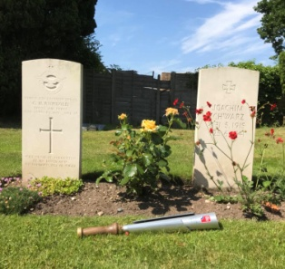

**Hymn**

**We shall go out with hope of resurrection,**

**we shall go out, from strength to strength go on.**

**We shall go out and tell our stories boldly,**

**tales of a love that will not let us go.**

**We’ll sing our songs of wrongs that can be righted,**

**we’ll dream our dream of hurts that can be healed;**

**we’ll weave a cloth of all the world united**

**within the vision of a Christ who sets us free.**

**We’ll give a voice to those who have not spoken,**

**we’ll find the words for those whose lips are sealed.**

**We’ll make the tunes for those who sing no longer,**

**vibrating love alive in every heart.**

**We’ll share our joy with those who are still weeping,**

**chant hymns of strength for hearts that break in grief;**

**we’ll leap and dance the resurrection story**

**including all within the circles of our love.**

[June Tillman](https://hymnary.org/person/boyce-tillman_j) (1993)© 1993 Stainer & Bell, Ltd.

Used by permission of Hope Publishing Company.

## Tune: Londonderry Air

## Blessing

Unto God’s gracious mercy

and protection we commit you.

The Lord bless you and keep you.

The Lord make his face to shine upon you

and be gracious unto you.

The Lord lift up the light of his countenance upon you and give you his peace this day and always.

*A*men.

***All* May the peace of Christ burn in our hearts and dawn on our world. Amen.**





Thank you for being part of this special

Commemoration today.

Some material in this Service booklet is copyright

reproduced under CCL 284076

Front cover photograph reproduced by courtesy of RAF100 Baton Team