St Stephen’s Fradley
Sunday 16th August
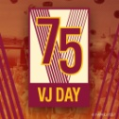

Online worship
commemorating
VJ Day
Live at 10.30am
Click on the link below to access

https://youtu.be/Vu8s5vGACjA

