Prayer in the Natural World

Resources for Prayer in the Natural World.

- God revealed in Creation Prayer Walk

The Sanctuary are a fabulous collective dedicated to enriching worship. You can find out more about them here

What the Sanctuary Authors say about this resource:

These prayer stations are designed to be used outside – either individually or as a series to form a prayer walk – and aim to help people both connect with God through creation and use natural settings to stimulate prayer for others. They can be done in any order and/or with a selection chosen to fit your specific circumstances and surrounding natural environment. They can also be done on your own as a meditative reflection or corporately with the group pausing at pre-decided points on the walk to read each station and reflect/pray together.

Each station explains the type of natural setting that is ideal so you might want to plan a walk and then see which of the stations best fit particular stopping points along the way – or choose which stations you want to use and then find a walk to match. Each station needs a minimum of 3-5 minutes so that you can read out the scripture and the short reflection or question which follows (in blue), but they can take longer if you want to have extended periods of time to reflect and/or pray. Print off the relevant stations in advance so that you have them with you to read out.

If you’re leading a group, don’t forget to explain to people what you’re doing, making sure that everyone is suitably dressed for the weather and also physically able to walk the distance and terrain.

This resource can be downloaded directly here.

- Forest Church

Forest Church is a contemporary movement, with roots in the long Christian tradition of engagement in nature, such as the Celtic and Franciscan approaches. Those engaged in Forest Church are seeking to meet with God in and through their connection with the natural world. The hope is that Forest Churches will become a spiritual home for those outside the traditional church who relate better to outdoor spirituality than gatherings in a church building.

Before lockdown began, I had hoped to begin a Forest Church in the Salisbury area - we may still once we are allowed to gather in the open air.
In the meanwhile you can find out more from Gloucester Diocese's website and their lead worker on forest church, Cate Williams.

Here as well is a short video produced by her:
https://youtu.be/-twiMjUGt1s
- A Rocha UK's Wild Christian Project

A Rocha UK's Wild Christian scheme is a community of families and individuals exploring the connections between our Christian faith, the natural environment, and how we live.

As we journey together, reflecting biblically and acting boldly, A Rocha UK invite you to share your story, ideas and learning so that collectively we can live more joyfully and sustainably with the rest of God’s Creation.
Sign up and each month A Rocha UK will send you something to think about and some practical actions that you can take to help you enjoy, nurture and protect nature. You’ll also have the opportunity to share your own stories, if you wish, and to help us generate ideas for future editions.

To find out more go to arocha.org.uk/wildchristian/
Want to let the Wild Christian community know what you’re up to, or be part of our creative team? Email wild.christian@arocha.org to find out more.
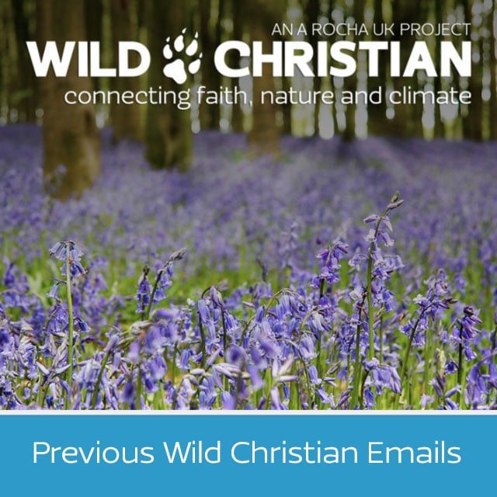

- The Wild Worship Field Guide

The Sanctuary, based in Harrogate, develop innovative worship resources. Here is their Wild Worship Field Guide which can help us worship God within the natural world:
http://thesanctuarycentre.org/resources/creative_prayer_idea_wild_worship_field_guide.pdf
- Gardening the Heart

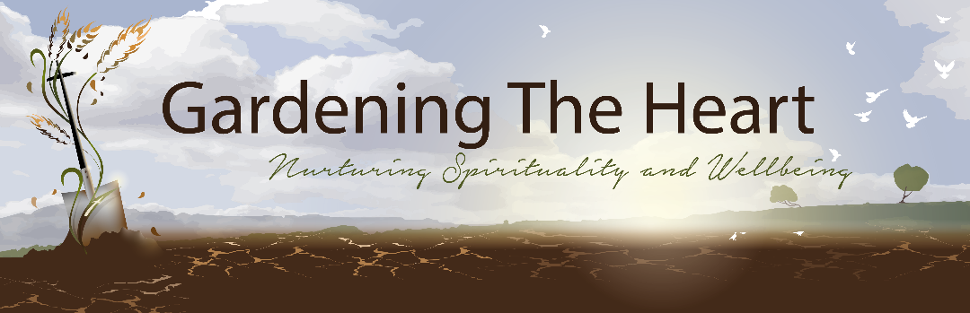
This is what Gardening the Heart say about what they do on their website:
Gardening The Heart (formerly Parable Garden) encourages and resources people of all ages in engaging with Creation, seasons, gardening and creativity as tools for discipleship, spirituality and wellbeing, at home, in schools, local churches, hospitals, Care Homes in rural and urban contexts.

- Outdoor Worship Resources from Leeds Diocese

Here are a range of resources that have been gathered together by Leeds Diocese. that you may like to try out in your local park, churchyard, or in the countryside. However, you may be able to find joy and wonder from your armchair looking out the window, viewing nature photos or videos or in your garden. You can view the sheet below and download it here

- "Outdoor Worship" Book

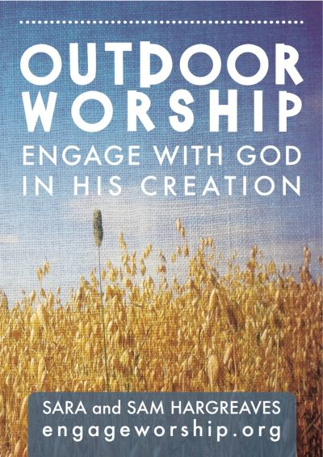

This is what Engage Worship say about their book:

"Outdoor Worship" is a resource book of ideas an inspiration to help mixed-age groups, families and churches engage with God in his world. This 52 page, full colour A5 book features space for your own "field notes", plus biblical reflections and articles on how we can better relate to the earth.

