St Peter’s Church

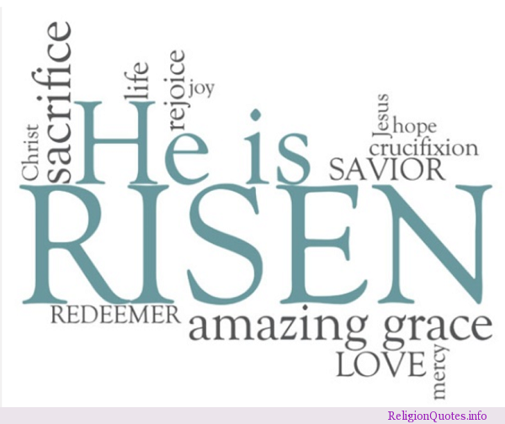

All Together
Holy Communion
for Easter Day

Welcome and notices.

The Greeting

Leader: Alleluia, Christ is risen!
All: He is risen indeed, Alleluia!

Opening Prayer

Astounding God,
Very early on that first day
You caught chaos unawares:
Planting grace in a garden,
Letting love loose on creation,
Flinging joy into the air.

You set us free to praise you
and with Jesus’ resurrection
gave us the promise of eternal life.

As we gather together to worship you,
As we share this celebration
flinging our joy into the air,
may our hearts overflow with grateful thanks.
Amen.

A Song

We say sorry to God for the wrong we have done.

Emptier of tombs,
On this morning of alleluias,
We must confess how human we are.
We haven’t done any great evil,
but we have failed you in so many ways.
We come to you now with hearts that are sorry
and ask your forgiveness for the wrong we have done.

A time of quiet.

We receive God unconditional forgiveness.

God, our Creator, gives us new life;
Christ, our Redeemer, prepares a table for us;
The Holy Spirit, our joy, calls us to service.
This is the Good News:
The tomb is empty, sin is powerless,
death is defeated for ever.

On this very first day,
And every day
We walk as God’s people -
Forgiven and made whole
We give thanks to God. Amen.

We sing The Peruvian Gloria (number 966 in the hymn books.)

The Collect for Easter Sunday

The Easter Gospel.

Hear the Gospel of our Lord Jesus Christ according to (N)
Glory to you O Lord!

This is the Gospel of the Lord.
Praise to you O Christ!

A Short Talk, Drama or Activity. Norma

Renewal of Baptism Vows.

Water is poured into the font and the Minister says:

This water reminds us of the baptism of Christ in the river Jordan. May it be blessed in the name of God almighty, Father, Son and Holy Spirit. Amen

The Profession of Faith

The president says

Let us affirm,
our common faith in Jesus Christ.

Do you believe and trust in God the Father,
source of all being and life,
the one for whom we exist?
All I believe and trust in him.

Do you believe and trust in God the Son,
who took our human nature,
died for us and rose again?
All I believe and trust in him.

Do you believe and trust in God the Holy Spirit
who gives life to the people of God
and makes Christ known in the world?
All I believe and trust in him.

This is the faith of the Church.
All This is our faith.
We believe and trust in one God,
Father, Son and Holy Spirit.

In baptism,
God calls us out of darkness into his marvellous light
To follow Christ
means dying to sin and rising to new life with him
Therefore, I ask:
Do you turn to Christ as Saviour?
I turn to Christ.
Do you come to Christ as Lord?
I come to Christ.
Do you give yourself to Christ, the way, the truth and the life?
I give myself to Christ.

The Priest walks round the church with branches of rosemary blessing the congregation with the water of baptism.

Giving of a Candle
When all have received a candle, the priest says

God has delivered us from the dominion of darkness and has given us a place with the saints in light. We have received the light of Christ; let us walk in this light all the days of our lives

All: And shine as a light in the world to the glory of God the Father.

Prayers
(sitting or kneeling)

Prayers of Intercession and Thanksgiving
for the Church, the World and those in need

As our Saviour taught us so we pray:

Our Father in heaven,
Hallowed be your name,
Your kingdom come,Your will be done,
On earth as in heaven.
Give us today our daily bread.
Forgive us our sins
As we forgive those who sin against us.
Lead us not into temptation
But deliver us from evil.
For the kingdom, the power,
And the glory are yours
Now and forever. Amen.

The Peace:

The risen Christ came and stood among his disciples and said, ‘Peace be with you.’
Then they were glad when they saw the Lord. Alelluia!

The Peace of the Lord be always with you.
And also with you.

We offer one another a sign of peace.
A Song – during which the collection is taken

The Communion

The God of every morning be with you
And also with you.

People of Easter morning, lift up your hearts.
We lift them to the one
who has raised Jesus from the grave.

People of Easter’s joy, give thanks to the One
who raises us to new life.
We sing our alleluias to the God of everlasting love.

Redeemer of the lost
On this day of joy and hope we sing our praises to you.

Very early in the morning,
Your Word shattered the silence of chaos,
And grace flowed forth like a river.
You reached down and gathered up the dust of creation,
forming us in your own image
and breathing life into us.
Yet the day came when we chose
to turn away from you.

You sent the prophets to speak your gracious hope,
but we refused to listen.
When you could have let us remain
in the clutches of sin and death,
You sent Jesus to be one of us,
so we could come home to you.

Therefore we join our voices this morning
With those who stood at the empty tomb
And with angels and archangels and all the company of heaven we sing out our Easter joy to you.

Holy, holy, holy Lord,
God of power and might,
heaven and earth are full of your glory.
Hosanna in the highest.

Blessed is he who comes in the name of the Lord.
Hosanna in the highest.

On the night he was betrayed, Jesus sat at the table with his friends.
He took the bread, said thank you to God, and broke it. He gave it to his friends, saying: ‘Take, eat: this is my body, given for you. Do this to remember me.’

After the meal, he took the wine, said thank you to God, and gave it to his friends to share, saying: ‘This wine is the new promise of my blood, which is poured out for you. Do this to remember me.’
We remember this and give thanks.

Great is the mystery of faith:
Christ has died:
Christ is risen:
Christ will come again.

Come to this table where the living Christ
offers us bread broken for our journeying
and wine poured out for our tears.

Share together in this meal
Where loss finds comfort in promise
And despair is transformed into hope.

Whoever you are, whatever you bring,
Hear the Risen Christ call your name;
And accept God’s invitation to new life.

All are welcome to share the bread and wine.

The body of Christ, broken for you
The blood of Christ, shed for you

The choir may sing an anthem after Communion.

After all have received the bread and wine, we pray together:

Easter God, you have met us in bread and wine,
And surprised us with your joy.
Send us out into the world
Dancing with delight and with alleluias ringing in our hearts, to share your justice and your peace. Amen.

A Song

The Blessing

The God of peace,
who brought again from the dead our Lord Jesus,
that great shepherd of the sheep,
through the blood of the eternal covenant,
make you perfect in every food work to do his will,
working in you that which is well-pleasing in his sight;
and the blessing of God almighty,
the father, the Son and the Holy Spirit,
be among you and remain with you always. Amen.

Alleluia! Christ is risen.
All: He is risen indeed. Alleluia!

Go in peace to love and serve God and each other.
All: We go in Jesus’ name.

Refreshments will be served in the Church Hall after the service.

Children are invited to take part in the Easter Egg Hunt in the churchyard with accompanying adults!

A happy and blessed Easter.

Christ is Risen!
He is risen indeed
ALLEUIA!

