St Peter’s Church, Chellaston
in the Diocese of Derby

Morning Worship
and
The Liturgy of the Hours
Index

Page Order
3 Morning Worship from Common Worship
11 A Northumbrian Order
19 An Iona Style Order
27 The Liturgy of the Hours

Before the service begins you may wish to use the following as preparation.
18 A Finger Labyrinth
35 The Liturgy of the Hours

St Peter’s Church, Chellaston
in the Diocese of Derby

An Order for
Morning Worship
Welcome
HYMN
We sit for the notices – then continue in prayer

Preparation
Grace, mercy and peace
from God our Father
and the Lord Jesus Christ be with you.
And also with you.

This is the day that the Lord has made.
Let us rejoice and be glad in it.

We have come together in the name of Christ
to offer our praise and thanksgiving,
to hear and receive God’s holy word,
to pray for the needs of the world,
and to seek the forgiveness of our sins,
that by the power of the Holy Spirit
we may give ourselves to the service of God.

Jesus says, ‘Repent for the Kingdom of Heaven is close at hand’

So let us turn away from our sin and turn to Christ,
as we sit or kneel, to confess our sins in penitence and faith.

Most merciful God,
Father of our Lord Jesus Christ,
We confess that we have sinned in thought, word and deed.
We have not loved you with our whole heart.
We have not loved our neighbours as ourselves.
In your mercy
forgive what we have been,
help us to amend what we are,
and direct what we shall be,
that we may do justly, love mercy,
and walk humbly with you, our God.
Amen

May the Father of all mercies
cleanse you from your sins,
and restore you in his image
to the praise and glory of his name,
through Jesus Christ our Lord.
Amen.

Blessed is the Lord,
For he has heard the voice of our prayer;

Therefore shall our hearts dance for joy,
And in our song will we praise our God.

Blessed are you, Lord our God, creator and redeemer of all:
to you be glory and praise for ever.
From the waters of chaos you drew forth the world
and in your great love fashioned us in your image.
Now, through the deep waters of death, you have brought your
people to new birth by raising your Son to life in triumph.
May Christ your light ever dawn in our hearts
as we offer you our sacrifice of thanks and praise.
Blessed be God, Father, Son and Holy Spirit:

Blessed be God for ever.
The night has passed and the da y lies open before us;
let us pray with one heart and mind.

Silence is kept

As we rejoice in the gift of this new day,
so may the light of your presence, O God,
set our hearts on fire with love for you; now and for ever. Amen

HYMN

The appointed psalm is said, ending with;
Glory to the Father and to the Son
and to the Holy Spirit:
as it was in the beginning is now
and shall be for ever. Amen

Reading(s) from Scripture.
At the end the reader may say:
This is the word of the Lord
Thanks be to God.

The following Canticle is said. (Psalm 100)

1. O be joyful in the Lord, all the earth; serve the Lord with
gladness and come before his presence with a song.

2. Know that the Lord is God; it is he that has made us and
we are his; we are his people and the sheep of his pasture.

3. Enter his gates with thanksgiving and his courts with praise;
give thanks to him and bless his name.

4. For the Lord is gracious; his steadfast love is everlasting, and
his faithfulness endures from generation to generation.
Glory to the Father and to the Son
and to the Holy Spirit;
as it was in the beginning is now
and shall be for ever. Amen.

A Reading from Scripture.

At the end the reader may say:
This is the word of the Lord.
Thanks be to God.

The Benedictus: (please stand) (Luke1:68-79)

1. Blessed be the Lord the God of Israel, who has come to his
people and set them free.

2. He has raised up for us a mighty Saviour, born of the house of his servant David.

3. Through his holy prophets God promised of old to save us from our enemies, from the hands of all who hate us,

4. To show mercy to our ancestors, and to remember his holy
covenant.

5. This was the oath he swore to our father Abraham: to set us free from the hands of our enemies.

6. Free to worship without fear, holy and righteous in his sight all the days of our life.

7. And you, child, shall be called the prophet of the Most High,
for you will go before the Lord to prepare his way.

8. To give his people knowledge of salvation by the forgiveness of sins.

9. In the tender compassion of our God the dawn from on high shall break among us.

10. To shine on those who dwell in darkness and the shadow of death, and to guide our feet into the way of peace.

Glory to the Father and to the Son
and to the Holy Spirit:
as it was in the beginning is now
and shall be for ever. Amen

HYMN

Sermon

The Choir may sing an Anthem.

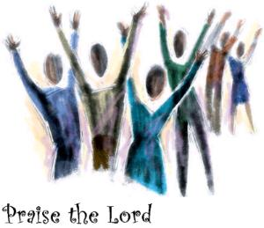

The Apostles’ Creed (please stand)

I believe in God, the Father Almighty,
creator of heaven and earth.

I believe in Jesus Christ, his only Son, our Lord,
who was conceived by the Holy Spirit,
born of the Virgin Mary,
suffered under Pontius Pilate,
was crucified, died and was buried;
he descended to the dead.
On the third day he rose again;
he ascended into heaven,
he is seated on the right hand of the Father
and he will come to judge the living and the dead.

I believe in the Holy Spirit,
the holy catholic church,
the communion of saints,
the forgiveness of sins,
the resurrection of the body,
and the life everlasting.
Amen.

HYMN

Collect for the Day

The Intercessions
Concluding with

The Lord’s Prayer
Gathering our prayers and praises into one, as our saviour taught us, so we pray:

Our Father, who art in heaven, hallowed be thy name;
Thy kingdom come,
thy will be done on earth as it is in heaven.
Give us this day our daily bread.
And forgive us our trespasses,
as we forgive those who trespass against us.
And lead us not into temptation; but deliver us from evil.
for thine is the kingdom, the power, and the glory
for ever and ever. Amen.

HYMN

The Grace
We share the grace with each other.

May the grace of our Lord Jesus Christ,
the love of God and the fellowship of the Holy Spirit
be with us all ever more. Amen.

The Dismissal
Go in the name of Christ
Thanks be to God.

St Peter’s Church, Chellaston
in the Diocese of Derby

A Northumbrian Order for
Morning Worship
Welcome
HYMN
We sit for the notices – then continue in prayer
Preparation
One thing I have asked of the Lord,
this is what I seek:
that I may dwell in the house of the Lord
all the days of my life;
to behold the beauty of the Lord
and to seek Him in His temple.

We have come together in the name of Christ
to offer our praise and thanksgiving,
to hear and receive God’s holy word,
to pray for the needs of the world,
and to seek the forgiveness of our sins,
that by the power of the Holy Spirit
we may give ourselves to the service of God.

Jesus says, ‘Repent for the kingdom of heaven is close at hand.’

We spend some time in silence as we come before God to confess our sins and seek his forgiveness.

Silence is kept.
Call: Who is it that you seek?
Response: We seek the Lord our God.
Call: Do you seek Him with all your heart?
Response: Amen. Lord, have mercy.
Call: Do you seek Him with all your soul?
Response: Amen. Lord, have mercy.
Call: Do you seek Him with all your mind?
Response: Amen. Lord, have mercy.
Call: Do you seek Him with all your strength?
Response: Amen. Christ, have mercy.

May the Father of all mercies
cleanse you from your sins,
and restore you in his image
to the praise and glory of his name,
through Jesus Christ our Lord.
Amen.

Blessed is the Lord,
For he has heard the voice of our prayer;

Therefore shall our hearts dance for joy,
And in our song will we praise our God.

The night has passed and the day lies open before us;
let us pray with one heart and mind.

Silence is kept

As we rejoice in the gift of this new day,
so may the light of your presence, O God,
set our hearts on fire with love for you; now and for ever. Amen

HYMN

The appointed psalm is said, ending with;
Glory to the Father and to the Son
and to the Holy Spirit:
as it was in the beginning is now
and shall be for ever. Amen

Reading(s) from Scripture.
At the end the reader may say:
Your word is a lantern to our feet
and a light upon our path.

The following Canticle is said.

Christ, as a light illumine and guide me.
Christ, as a shield, overshadow me.
Christ under me; Christ over me;
Christ beside me on my left and my right.
This day be within and without me,
lowly and meek, yet all-powerful.
Be in the heart of each to whom I speak;
in the mouth of each who speaks to me.
This day be within and without me,
lowly and meek, yet all-powerful.
Christ as a light; Christ as a shield;
Christ beside me on my left and my right.

Glory to the Father and to the Son
and to the Holy Spirit;
as it was in the beginning is now
and shall be for ever. Amen.
A Reading from Scripture.

At the end the reader may say:
Your word is a lantern to our feet
and a light upon our path.

HYMN

A Sermon or Meditation
(this may include music and/or an activity)

The Choir may sing an Anthem.

The Apostles’ Creed (please stand)

I believe in God, the Father Almighty,
creator of heaven and earth.

I believe in Jesus Christ, his only Son, our Lord,
who was conceived by the Holy Spirit,
born of the Virgin Mary,
suffered under Pontius Pilate,
was crucified, died and was buried;
he descended to the dead.
On the third day he rose again;
he ascended into heaven,
he is seated on the right hand of the Father
and he will come to judge the living and the dead.

I believe in the Holy Spirit,
the holy catholic church,
the communion of saints,
the forgiveness of sins,
the resurrection of the body,
and the life everlasting.
Amen.

HYMN

Collect for the Day

The Intercessions
Concluding with

The Lord’s Prayer
Gathering our prayers and praises into one, as our saviour taught us, so we pray:

Our Father, who art in heaven, hallowed be thy name;
Thy kingdom come,
thy will be done on earth as it is in heaven.
Give us this day our daily bread.
And forgive us our trespasses,
as we forgive those who trespass against us.
And lead us not into temptation; but deliver us from evil.
for thine is the kingdom, the power, and the glory
for ever and ever. Amen.

HYMN

The Dismissal (we say or sing together)

May the peace of the Lord Christ go with you,
wherever He may send you.
May He guide you through the wilderness,
protect you through the storm.
May He bring you home rejoicing
at the wonders He has shown you.
May He bring you home rejoicing
once again into our doors.

Go in the name of Christ
Thanks be to God.

A Finger Labyrinth
Place a finger from your non-dominant hand at the entrance to the labyrinth. As you trace the circuit, stay open to whatever presents itself: feelings, sensations, memories, images, or just “knowings.” Pause to meditate in prayer at any time, breathe, be with a memory, work with an image, or simply relax.

You may like to use the prayer below as you begin and end.

Walk with us Lord through all the twists and turns of life,
Walk with us when the clouds obscure the way,
when what seemed close is now so far away.
Walk with us Lord until we trust in you,
Lead us to the centre of your love.

St Peter’s Church, Chellaston
in the Diocese of Derby

An Iona Style Order for
Morning Worship

Welcome
HYMN
We sit for the notices – then continue in prayer

Preparation
Be still and listen to the day,
touch the breeze
with the quiet of your soul.
Let the turbulence
of the hurly burly rushing
pass you by.
Let God bless you with a quiet whisper,
which in all the day’s doing
keeps a calm silent centre
in your being.

Silence is kept.

Let us open our lives to God and ask his forgiveness and grace.

Silence is kept.

On the poverty of our seeing and the poverty of our believing,
Lord have mercy.
Lord have mercy.

On the poverty of our giving and on the poverty of our following,
Lord have mercy.
Lord have mercy.

On the poverty of our loving and the poverty of our living,
Lord have mercy.
Lord have mercy.

To all who turn to him, Christ says, ‘Your sins are forgiven.’
He also says, ‘Follow me.’
Amen. Thanks be to God.

The night has passed and the day lies open before us;
let us pray with one heart and mind.

Silence is kept

As we rejoice in the gift of this new day,
so may the light of your presence, O God,
set our hearts on fire with love for you; now and for ever. Amen

HYMN

The appointed psalm may be said, ending with;
Glory to the Father and to the Son
and to the Holy Spirit:
as it was in the beginning is now
and shall be for ever. Amen

Reading(s) from Scripture.
At the end the reader may say:
For the word of God in Jesus,
For God’s wisdom all around us;
For God’s word and wisdom in us,
Thanks be to God.
The following Canticle is said.
God of the ordinary,
we praise you.

You take the drabness of our thoughts
and brighten them into vivid imagination.

You take our everyday lives,
and transform them into holy, precious moments.

You take our meagre offerings
and multiply them into an abundance of delight.

Extraordinary God,
you light up our thoughts, our lives, our selves
with the wonder of your call.

With everything we are and have
we praise you – Amen.

A Reading from Scripture.
At the end the reader may say:
For the word of God in Jesus,
For God’s wisdom all around us;
For God’s word and wisdom in us,
Thanks be to God.
HYMN

A Sermon or Meditation
(this may include music and/or an activity)

The Choir may sing an Anthem.
The Creed (please stand)

We believe in God,
the maker and shaper of our pathways;
who sent Jesus to show us the narrow way,
and who is the beginning and ending of our travelling.

We believe in Jesus Christ
the sharer of our flesh;
who entered and experienced the human journey,
and who walks beside us on the road.

We believe in the Holy Spirit
the midwife and nurturer of our potential;
who drove Jesus into the desert,
and who calls us now to cast off from the shore.

We believe in Father, Son, and Holy Spirit
the shaper, sharer and stirrer of our journeys;
and we recommit ourselves to following their way.

HYMN

Collect for the Day

The Intercessions
Concluding with

The Lord’s Prayer
Gathering our prayers and praises into one, as our saviour taught us, so we pray:

Our Father, who art in heaven, hallowed be thy name;
Thy kingdom come,
thy will be done on earth as it is in heaven.
Give us this day our daily bread.
And forgive us our trespasses,
as we forgive those who trespass against us.
And lead us not into temptation; but deliver us from evil.
for thine is the kingdom, the power, and the glory
for ever and ever. Amen.

HYMN

The Dismissal
Send us out –
Send us out to seek wisdom
Send us out in peace.

Send us out –
Send us out to do justice.
Send us out in hope.

Send us out –
Send us out to be loving.
Send us out in joy.

Go now with God’s blessing
Go in justice and love,
Go and love your neighbour,
Go and respect the earth,
Go and befriend strangers,
Go and make peace.

Go in the name of Christ
Thanks be to God.

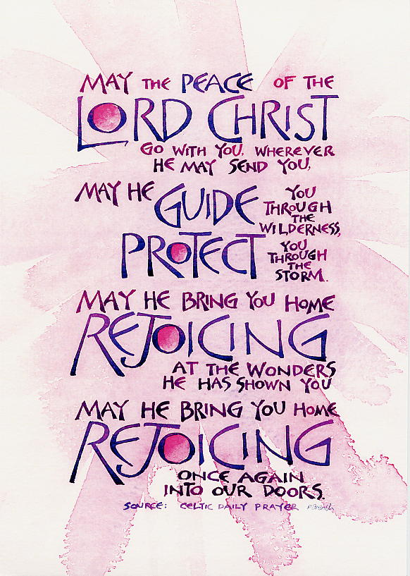

St Peter’s Church
Holding on to the Silence.
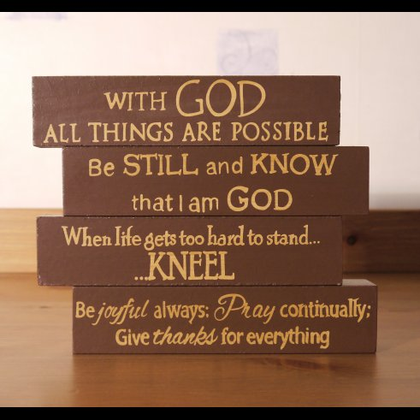

A Simple
Liturgy of the hours
for every day.
This simple form of Daily Office can be prayed in the morning, at midday, in the evening and at night or a combination, whichever is best for you. Use the prayers that are appropriate for each part of the day.

You can pray alone or with others.
You will find morning prayer readings listed on St Peter’s weekly notice sheet or look on the Church of England website for the lectionary. ( www.churchofengland.org )

As you prepare to pray - find a place where you can be still, then give yourself time to relax.
You may like to use the following to help you clear your mind of the busyness of the day.

Be silent, Be still.
Alone, Empty
Before your God.
Say nothing, Ask nothing.
Be silent, Be still.
Let your God look upon you.
That is all.

God knows, Understands,
Loves you with an enormous love.
God only wants to look upon you
with love.
Quiet, Still, Be.
Let your God – love you.

A candle may be lit at the beginning or you may like to hold an object to help focus your prayers.
If you are alone, hold in your prayers members of St Peter’s who will be using these same prayers in a different place.
PREPARATION
O Lord, open our lips
and our mouths shall proclaim your praise.

We come before your presence
You who are common to us all.

Morning:
O God, Creator of Light;
at the rising of your sun this morning,
let the greatest of all light, your love,
rise like the sun within our hearts
and set your blessing upon us
as we begin this day together,
united in prayer and thanksgiving.
Amen

Noon:
God in the midst, come close to us,
and help us to come close to you,
as, for a fraction of time,
we step back from the activities and
demands of the day.
So should, as this day goes on, we forget you,
do not forget us, O God. Amen.

Evening:
Holy One, you have brought us
through this day to a time of reflection.
make us wise in our understanding,
open in our listening,
generous in our giving and
vulnerable in our sharing. Amen.

Night:
It is night after a long day.
What has been done is done;
what has not been done
has not been done; let it be.
Let us be still in the presence of God.
Let the quietness of God’s peace enfold
us and let us look expectantly
to a new day, new joys and
new possibilities. Amen.

CANTICLE
Holy Wisdom, delight of our God,
you open our ears, we hear your word.

You enter deep into the being of humanity,
foolish to the world, you unmask our follies.

You shelter us by day
and are a steady flame through the night.
You lead us through turbulent waters,
and bring us safe to dry ground.

You open the mouths of those who are mute,
you loosen the tongues of infants in their cries.
A little child takes us by the hand
and leads us to wisdom and truth

Holy Wisdom, delight of our God,
you open our ears, we hear your word.

Glory to God, Source of all Being,
Eternal Word and Holy Spirit:
As it was in the beginning, is now
and shall be forever. Amen.

INTRODUCTION TO THE READING(S)

Spirit of Wisdom,
take from us all fuss, the clattering of noise,
the temptation to dominate by the power of words,
the craving for certainty.
lead us through the narrow gate of not knowing,
that we may listen and obey,
and come to a place of silence and stillness,
of true conversation and wisdom.

READING(S) (use the weekday readings printed on the notice sheet.)

SILENCE – Time to meditate on the readings.

Morning:
O God our Creator
your kindness has brought us
the gift of this new morning.
Help us to leave yesterday and not to covet tomorrow,
but to embrace and accept the uniqueness of today.
Amen.

Noon:
Throughout this day,
enliven our minds,
inspire our conversation.
inform our decisions and
protect those we love.
And should today bring
what we neither anticipate nor desire,
increase our faith and decrease our pride
until we know that when we face the unexpected,
we do not stand alone. Amen.

Evening:
For the roots of our community,
for what we share together,
for the path that lies before us now
and our future in your hands,
we give you thanks and praise. Amen

Night:
May God bless us
in our sleep - with rest,
in our dreams - with vision,
in our waking - with a calm mind,
in our soul - with the friendship of the Holy Spirit,
this night and every night. Amen.

PRAYERS
As the community of St Peter’s, Chellaston,
apart and a part of the whole,
in isolation and in communion,
near and far, together we pray . . .

For the World . . .

For the Church . . .

For the Sick and Suffering . . .

For those who have died and for the bereaved . . .

For our own joys and concerns . . .

COLLECT

Morning:
Eternal God and Father,
you create us by your power
and redeem us by your love:
guide and strengthen us by your Spirit,
that we may give ourselves in love and service
to one another and to you;
through Jesus Christ our Lord. Amen

Noon:
God of revelation
whose mercy embraces all peoples and nations:
tear down the walls which divide us,
break open the prisons which hold us captive
and so free us to celebrate your beauty in all the earth;
through Jesus Christ, our brother and redeemer. Amen.

Evening:
Guide us, Lord, in all our doings,
with your most gracious favour
and further us with your continual help;
that in all our works begun, continued
and ended in you,
we may glorify your holy name,
and by your mercy attain everlasting life;
through Jesus Christ our Lord. Amen.

Night:
Be present, O merciful God,
and protect us through the silent hours of this night,
so that we who are wearied by the changes
and chances of this fleeting world,
may rest upon your eternal changelessness;
through Jesus Christ our Lord. Amen.
THE LORD’S PRAYER
Our Father in heaven,
hallowed be your name,
your kingdom come,
your will be done,
on earth as in heaven.
Give us today our daily bread.
Forgive us our sins
as we forgive those who sin against us.
Lead us not into temptation
but deliver us from evil.
For the kingdom, the power,
and the glory are yours
now and for ever.
Amen.

or
Our Father, who art in heaven,
hallowed be thy name;
thy kingdom come;
thy will be done;
on earth as it is in heaven.
Give us this day our daily bread.
And forgive us our trespasses,
as we forgive those who trespass against us.
And lead us not into temptation;
but deliver us from evil.
For thine is the kingdom,
the power and the glory,
for ever and ever.
Amen.

THE CONCLUSION

May the road rise to meet you,
May the wind be always at your back,
May the sun shine warm upon your face,
and until we meet again
may God hold you in the hollow of his hand.

The Grace of our Lord Jesus Christ,
the love of God,
and the fellowship of the Holy Spirit,
be with us all evermore. Amen

The Liturgy of the Hours

With ev’ry morning I will kneel to pray,
To be a blessing in this coming day
In ev’rything I say and ev’rything I do,
To wholly honour you.

At noon remind me through this day to give
My full attention to the ones I’m with,
Be mindful of those things around and those within,
And fully enter in.

Teach me the wisdom of remembering,
And give me the wisdom to forget.
Lead me, Oh, teach me
To live each day for you.

And in the evening as my thoughts retell
This passing day let me remember well;
So that no bitterness takes root within my soul,
Help me to let them go.

And in the night-time may my mind be free
To truly rest and be refreshed in sleep;
And by releasing every worry, every strain,
Be free to start again.

Christ be with me, Christ within me,
Christ behind me and before;
Christ beside me, Christ to win me,
Christ to comfort and restore.
Christ beneath me, Christ above me,
Christ in peace and Christ in storm;
Christ in hearts of all who know me,
Christ in friend and stranger all.

Refreshments are usually served in the Church Hall
or at the back of Church following the 10.30am service.

Please do stay if you are able.

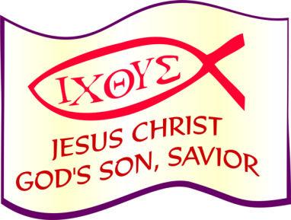

October 2015

©Material from: Common Worship, The Iona Community, Jim Cotter, Edwina Gately, Peter Millar, Janet Morley, The New Zealand Prayer Book, St Hilda Community, Ray Simpson and Stuart Townend. The Archbishops' Council 2000, The Northumbrian Community Trust.

