SO YOU’RE THINKING OF JOINING THE PCC?
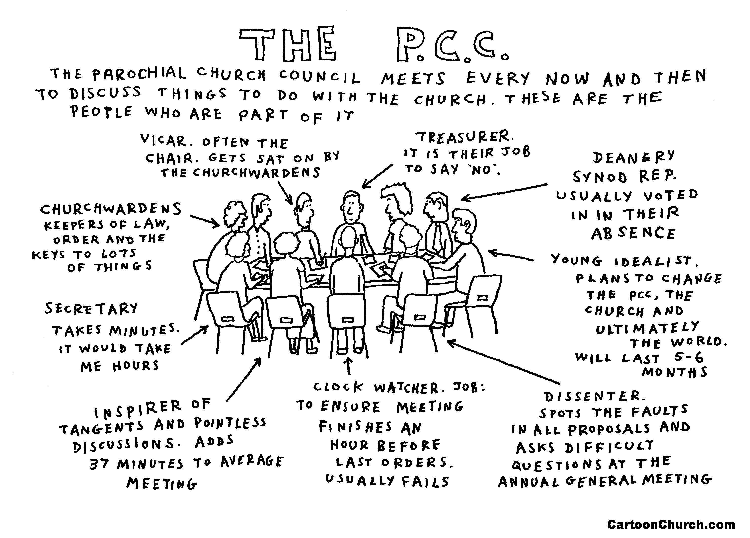

Five Key purposes of the PCC
- To enable the church to play its part in God’s mission to his world.
- To co-operate with the minister in sharing leadership.
- To ensure legal compliance with charity and ecclesiastical law
- To care for the buildings and churchyard
- To be a channel of consultation within the wider church

Who Can be a PCC member?
Elections for PCC members take place at the APCM. To be eligible to stand you must be aged 16+, on the church electoral role and a regular communicant member (minimum attendance of three times a year). There are some ex-officio members – the clergy (the vicar is the chair), Churchwardens, deanery or diocesan or General synod members and readers can but do not have to be. Members can also be co-opted on. The recommended number of elected members for a church with an electoral role under 50 is 6.
When does the PCC meet?
The PCC is a body corporate with perpetual succession and is meant to meet at least 4 times a year. Hazelwood’s meets at the Village Hall on the third Thursday and Holbrook’s in church on the second Wednesday of January, March, May, July, September and November from 7:30-9:30pm.

The agenda we follow is based on our Mission Action Plan:
Outward facing- community engagement, partnerships, communication, mission
Growing – worship, spirituality, pastoral care, welcome
Learning – training, schools work, children and families, participation
Healthy – leadership, management, safeguarding, finance, building

Expectations of PCC Members
- To prioritise meetings and do your best to attend and contribute
- To represent and offer leadership in a particular area of church life
- To listen and together seek to discern God’s will for our church
- To ensure our PCC meets the five key purposes of a PCC
- To attend a C1 safeguarding training event every three years

