St Thomas Church Stanningley
Sunday 8th September 2019 at 4pm

Service in memory of
Emma Carrick & Thomas Hardaker

The 150th Anniversary of their deaths

Two young Sunday school teachers killed by lightning

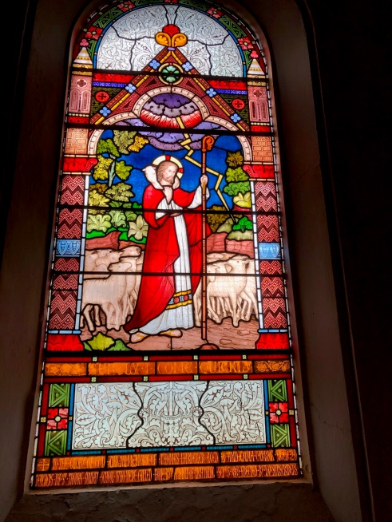

All welcome

Come and learn more about this tragic incident which at the time shocked so many people locally, nationally & across the world

