Marshfield Benefice
Safeguarding Officer
Mrs Aurea Hart
Contact on: aurea.hart@gmail.com
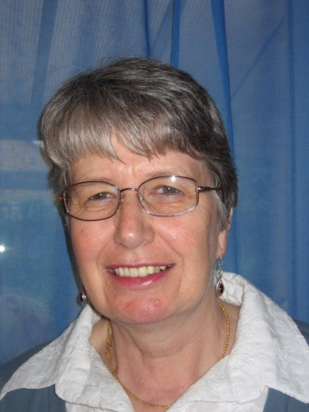

If you are concerned that a child or adult may be suffering abuse and the situation is urgent, please report the matter immediately to the Police or Local Authority.
Police: 101 or 999

South Gloucestershire Council:
Children's services: 01454 866000
Adult Services: 01454 868007
Out of Hours: 01454 615165
Bristol City Council:
Children's services: 0117 903 6444
Adult Services: 0117 922 2700
Out of Hours: 01454 615165

Or use the app “Bright Sky”

