Safeguarding at Camberwell
St Michael & All Angels
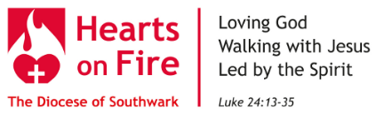
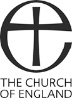
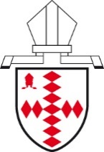
The Diocese of
Southwark

Jesus says: ‘I came that they may have life, and have it abundantly.’ (John 10:10)

You are welcome here.
You are safe.

Our God makes and mends all our lives. Jesus is for all. The Holy Spirit is given freely.

This church welcomes all children and young people: we take special care of them.
We welcome adults who are vulnerable.
We welcome all who need a safe place.

We say no to hitting and hurting others.
We say no to bullying, lying, tricking and threatening others.

We are part of a network of safety for vulnerable people.
We formally committed, again, to the Church of England’s House of Bishops’ Promoting a Safer Church policy in June 2019.
Our school, Ark All Saints Academy, is an effective safeguard for young people.
Our local Council, Southwark Borough, leads safeguarding.
Our National Church and Diocese take responsibility for safeguarding.
We work in partnership with the police.

If you are frightened and don’t feel safe, you can contact:

In this church: Naana Amuah and Grace Oluwaferanmi.
Diocesan Safeguarding Officer: 020 7939 9423 or 07982 279713
Childline: 0800 1111
NSPCC: 0808 800 5000
Samaritans: 116 123
Police: 999

The Diocese of Southwark
The South London Church Fund and Southwark Diocesan Board of Finance is a company limited by guarantee (No 236594)
Registered Office: Trinity House, 4 Chapel Court, Borough High Street, London SE1 1HW. Charity No 249678
Company Secretary: Ruth Martin

