Application for Holy Baptism
Baptism Preparation sessions will usually be carried out on the Second Monday of the month at 7pm.

Please complete in BLOCK CAPITALS.
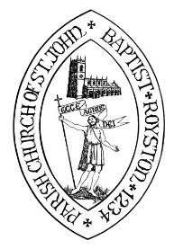

1. Child's date of birth: |  |  |  |  | 2. Proposed date of Baptism:
3. Child’s Christian name(s) and Surname: |  |  |  |  |  |  |  |  |  | Male or Female
4. Father’s Christian name(s) and Surname:
Have you been Baptised? |  |  |  |  | Confirmed?
5. Mother’s Christian name(s) and Surname:
Have you been Baptised? |  |  |  |  | Confirmed?
6. Address:
 |  |  |  |  | Telephone:
 |  |  |  |  | E-mail:
7. Father’s Occupation: |  |  |  |  | 8. Mother’s Occupation:
9. Names of Godparents/Sponsors (one Christian name in full):
 | Mr / Mrs / Miss / Ms
Has this person been Baptised? |  |  |  |  | Confirmed?
 | Mr / Mrs / Miss / Ms
Has this person been Baptised? |  |  |  |  | Confirmed?
 | Mr / Mrs / Miss / Ms
Has this person been Baptised? |  |  |  |  | Confirmed?
Please list any additional Godparents overleaf.
10. Approximate number of people in your party (for seating purposes):

Royston Vicarage, Church Street, Royston, Barnsley, South Yorkshire. S71 4QZ
Telephone: Barnsley (01226) 723029. E-mail: Fr.Craig@outlook.com

Notes:

- As a parent or Godparent, you should ask yourself:

- Are you prepared to the best of your ability, to give the child a Christian upbringing within the family of the Church?

- Will you help the child by being regular in public worship and private prayer, not only by your teaching but also by your example and your prayers?

- Will you encourage the child in due time to come to Confirmation and Holy Communion?

- It is traditional to have three Godparents, two of the same sex as the child and one of the opposite sex, but to have one Godparent of each sex is sufficient.

Parents may be Godparents to their own children, provided that the child has at least one additional Godparent.

Church law requires that Godparents should be Baptised and Confirmed, but the requirement of Confirmation may be relaxed in certain cases.

- It is preferable that a child should be Baptised at his or her Parish Church or at the Church that the parents normally attend.

- Please return this form to either Parish Office: Monday 6 – 6.45pm at Royston Church, or Thursday 10.45 – 11.30 am at Felkirk Church, or to Royston Vicarage within two weeks. Thank you.

11. Names of Godparents/Sponsors (one Christian name in full):
Mr / Mrs / Miss / Ms

Has this person been Baptised? |  |  |  |  | Confirmed?
Mr / Mrs / Miss / Ms

Has this person been Baptised? |  |  |  |  | Confirmed?
Mr / Mrs / Miss / Ms

Has this person been Baptised? |  |  |  |  | Confirmed?

12. Are you willing to attend a Baptism Preparation session?
YES/NO:

Please indicate the date you wish to attend:

13. Are you happy for us to share photos of your special day on social media?
YES/NO:

14. May we contact you to invite you to future events?
YES/NO:

Signed:

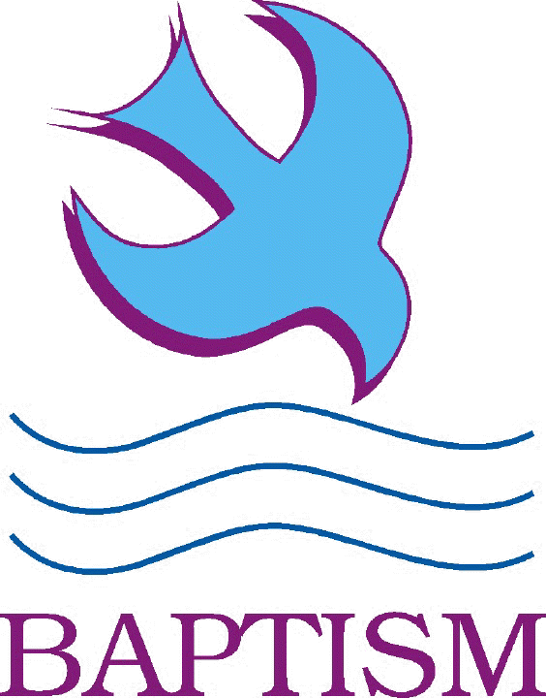

It is very important that you attend one of the Baptism Preparation sessions.

It will be an opportunity to discuss why baptism is important to you and your family, why it is important to Christianity and the Church, and also to give you an understanding of what will happen on the day.

Church Law requires that the priest shall instruct and prepare the parents or Godparents for the child’s baptism. Please make every effort to attend.

If you are not resident in this Parish, or do not regularly attend this church, then you must seek the goodwill of your own Parish Priest to have your child baptised here. Please ask us for further information.

