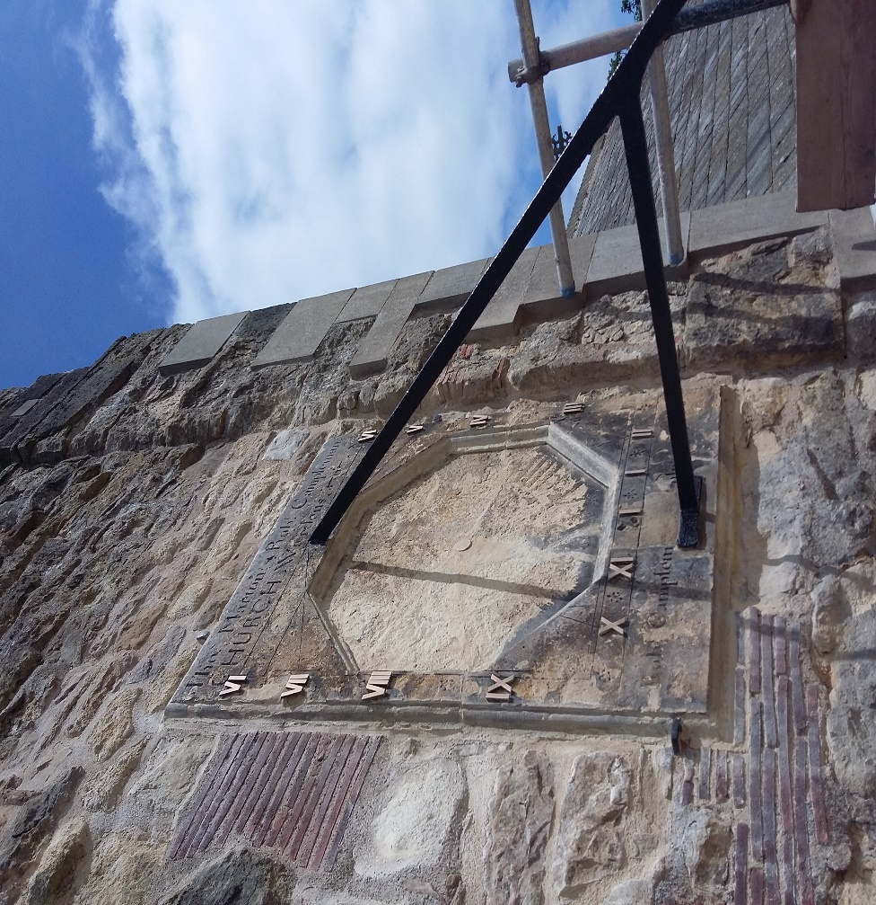
CONSERVATION OF THE TERRINGTON SUNDIAL.2018.

MARTIN COWARD STONE CARVING
In 2018 it was decided that a program of repairs and conservation were needed to make safe, and record details of the Sundial/Clock on All Saints Church, Terrington. The following is a summary of the work done at this time.

CONDITION
On close inspection, the Sundial had significant open cracks radiating from a central point, where there once was the opening for the clock hand/hands. These cracks had at some point in the past been poorly pointed in a dark cement based mortar. There was spalling to the top, and a considerable portion of stone missing around the bottom of the Gnomon due to past movement around this area, possibly from rust expansion of the Gnomon.
Over the years, there has been a considerable amount of splash back of rust from the Gnomon onto the surface of the Sundial causing dark staining to the surface. The Sundial is made in my opinion, from a limestone that does include some silica content and this would also explain why the surface of the stone is black in areas and has formed a hard skin on the surface. This form of weathering is particular to sandstones and examples of this decay can be seen on many of the buildings in the west riding.
My greatest concern was the condition of the surrounding ashlars, bonding the Sundial to the wall, and many of these had turned to powder due to the migration of moisture backwards and forwards, a common feature when a hard cement mortar is pointed around them. Open joints were excessive to the right, and particularly above the Sundial it was imperative that these areas were addressed, as the weight of the Gnomon would have a pulling, forward pressure at this point.

REPAIR, CONSERVATION AND RECORDING. METHOD.

Working from the right hand side upwards (Fig1), ashlars were removed and replaced, and it soon became apparent that the Sundial was only 4 inches thick, with a clear void of around 2inches to a dressed ashlar wall behind. Assessment of the support brackets around the edge of the Sundial holding it back were to be deemed in very good condition. A large bird’s nest and a considerable amount of debris were removed from the void (Fig2) and replaced with a lime putty mortar containing a good sized aggregate, bonding the new ashlars in place.
The removal and replacement of worn ashlars continued extensively above the sundial and then down to the lower left hand side where the remains of the birds nest and debris where also removed and repaired with new stone and mortar securing the Sundial safely. (Fig3, 4, 5, 6,).

The hard cement mortar was removed from the radial cracks and then resin bonded to minimise any future movement in these areas. A new circular length of stone was carved and placed into the central hole of the clock face to bond the front to the back. All cracks were pointed with a colour matched lime mortar and areas of stonework that had become friable, particularly within the clock face were given a lime coat to stabilise the surface. The spalled areas that were missing were built up in layers with a lime mortar repair and the moulding around the bottom was reproduced. (Fig7)
In line with the diocese recommendations, a program of light cleaning on the surface of the sundial was undertaken. With the nature of how this type of stone weathers, the staining is difficult to remove completely, the removal of the hard skin from vigorous cleaning could accelerate the decay mechanisms in the stone.
A lime wash over the entire stone could have disguised the appearance of the black areas for a short while, but in my opinion, the sundial was best left showing its ancient appearance and is in fact more legible left at this level of restoration. The Gnomon was painted with red lead undercoat and 3 layers of black hammerite paint. The final touch was to polish and lacquer the brass roman numerals that had been fixed sometime during the Sundial’s lifetime (Fig8), over existing incised numerals, I would imagine, to increase their legibility from the ground.
RECORDING

Using a fine profile gauge, accurate sections were taken from the less weathered areas of the Sundial to establish the original design of the mouldings and overall dimensions of the stone were taken. Rubbings of the lettering were taken and then used to transfer onto a full size drawing along with all the information needed to reproduce an exact replica of the stone. All the lettering forms and inscribed work were redrawn to compensate for the effects of weathering and are as they would be when the Sundial was new. (Fig.9).

Martin Coward Stone Carving. June 2018.
Helen Ashdown.
John Goodrick.
Members PCC.

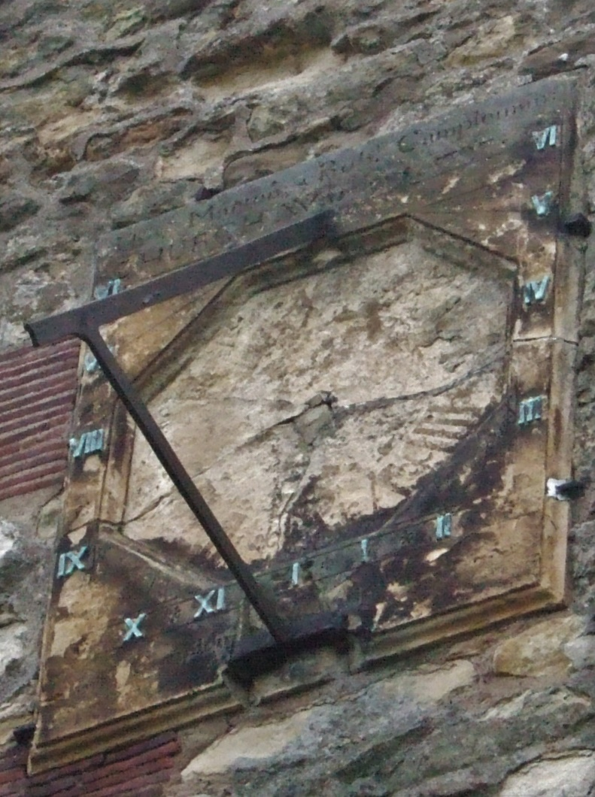

BEFORE RESTORATION.

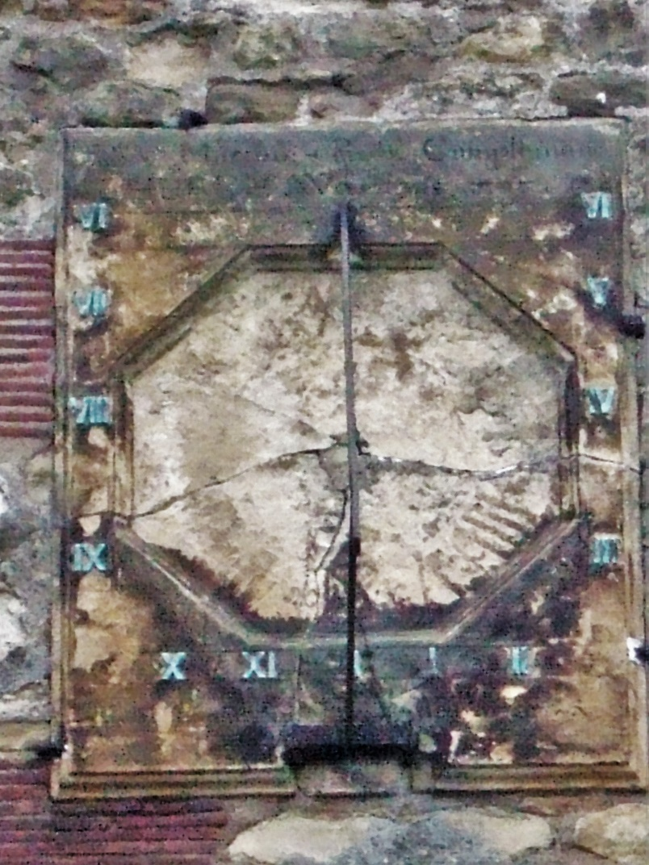
BEFORE RESTORATION
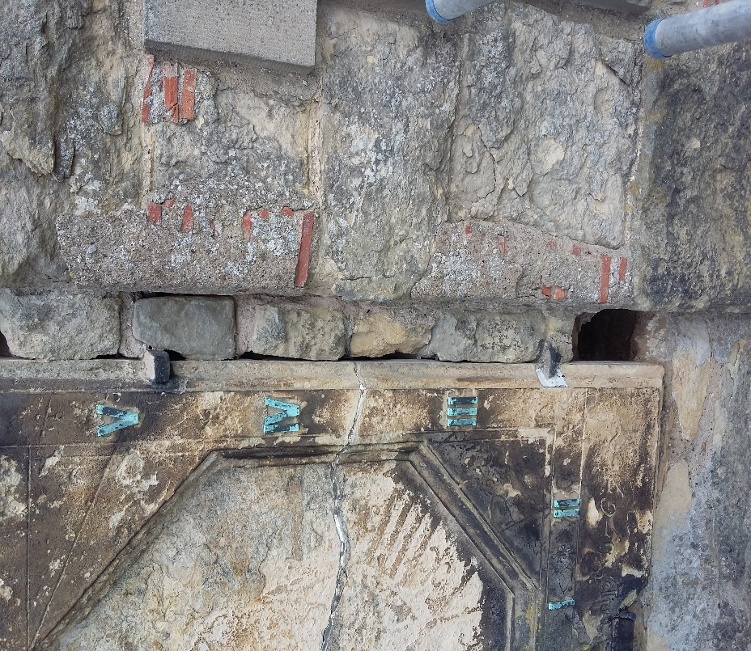
Fig1. Open joints on the right hand side
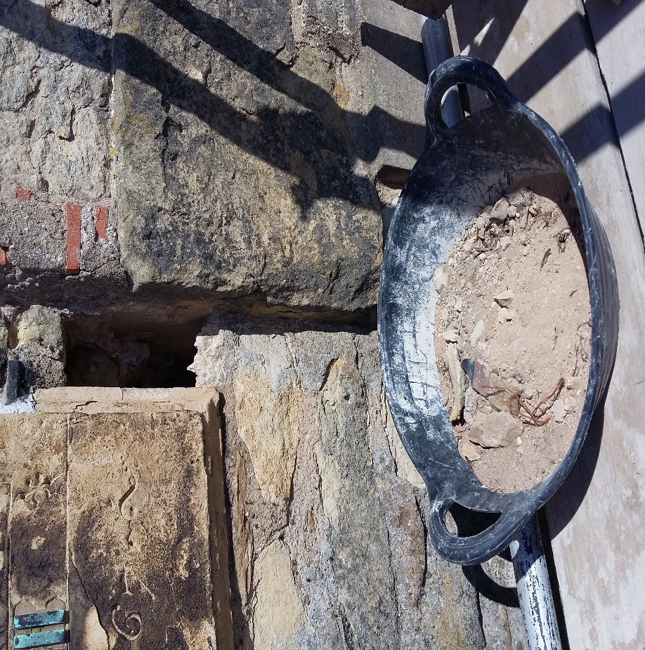
Fig 2. Debris removed from void behind.
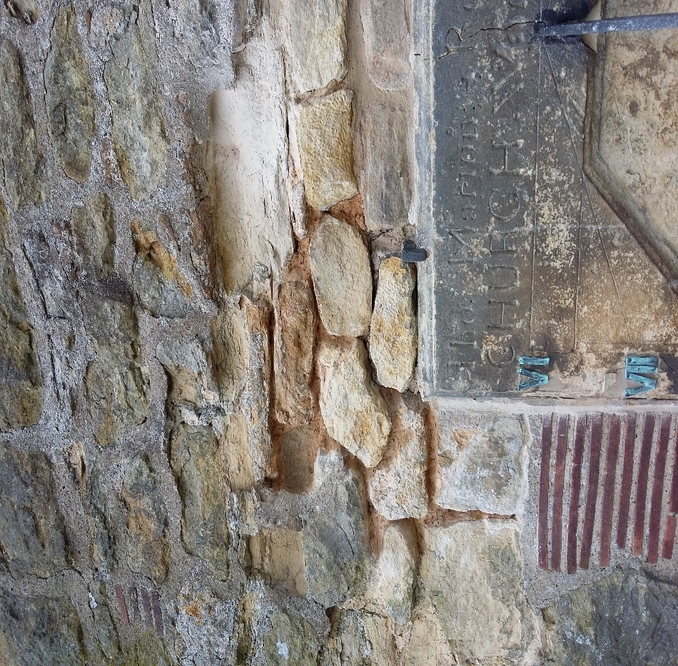
Fig 3. Removal of hard cement mortar.
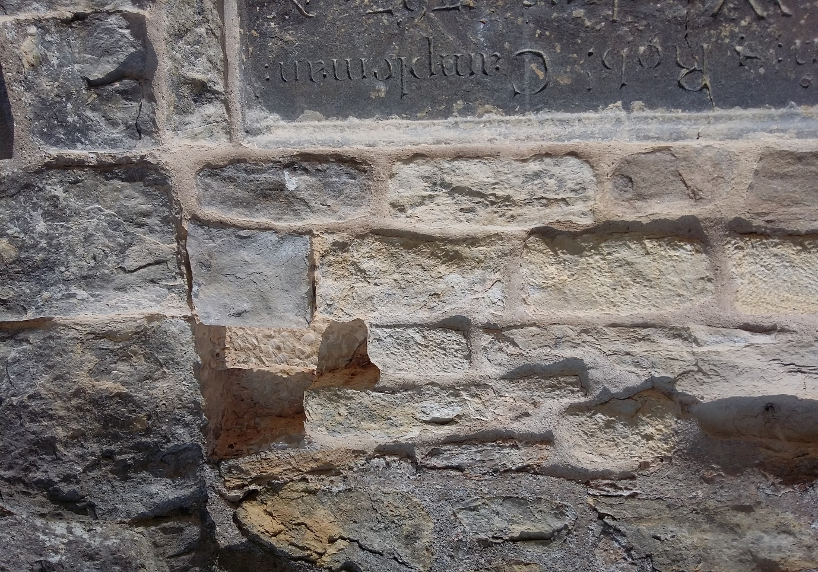
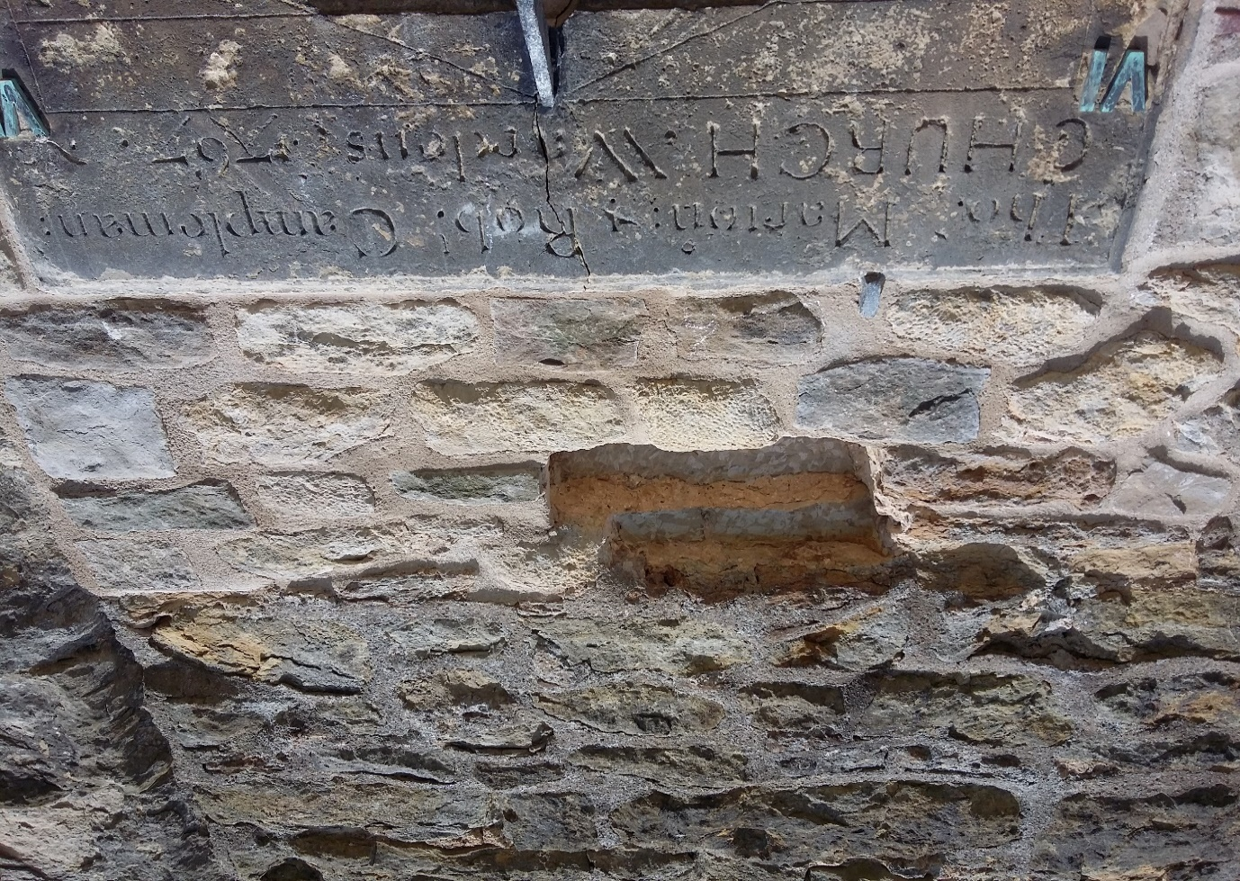Fig 4. Chopping out of old decayed stones and replacing with new ashlar stones and lime mortar.

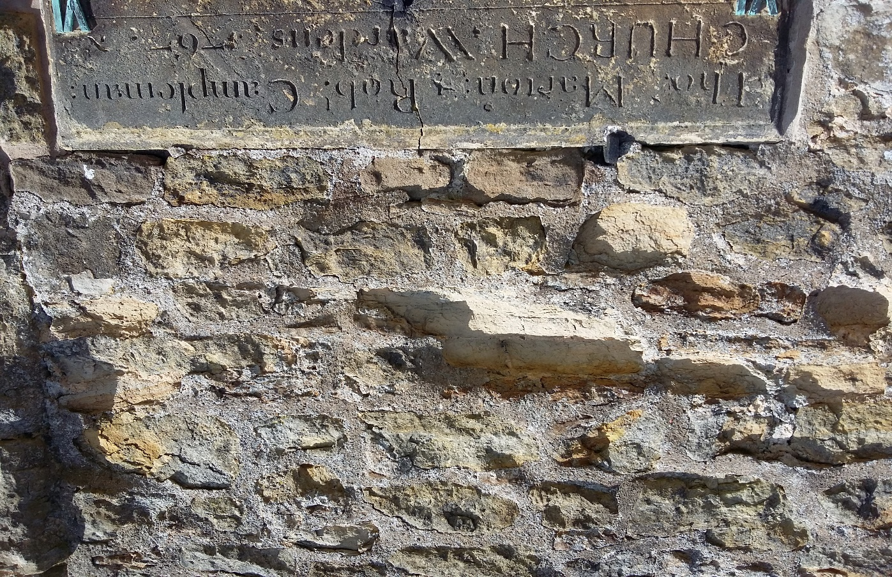
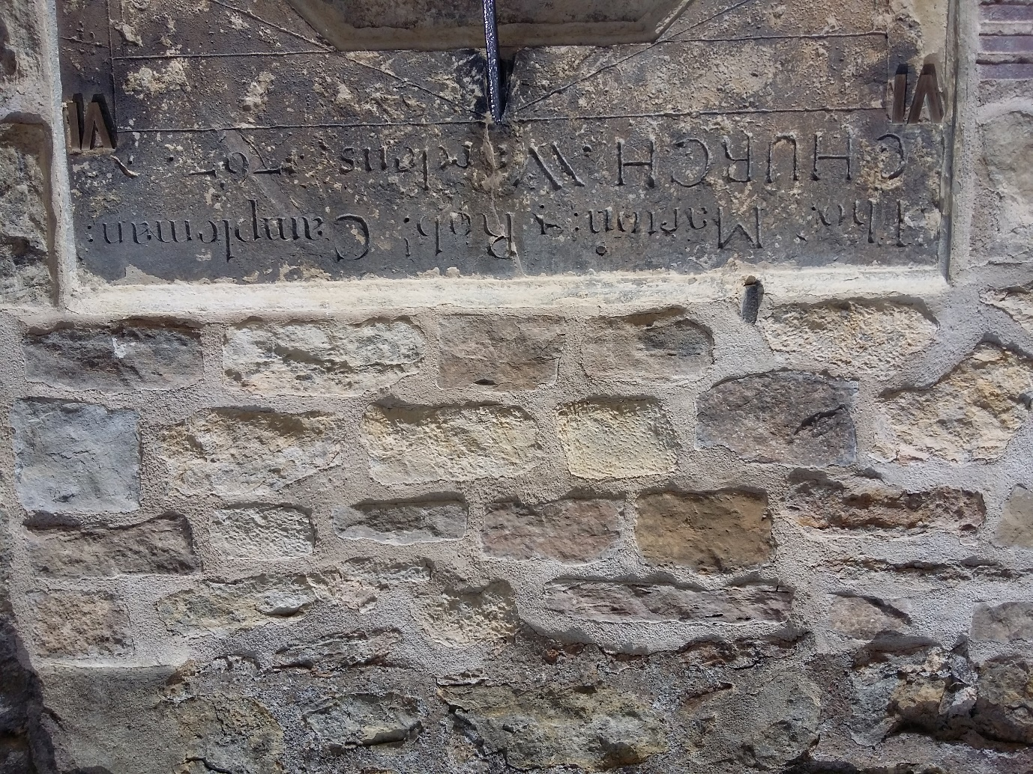
Fig 5. Before and after photograph with new ashlars and well bonded stonework above.
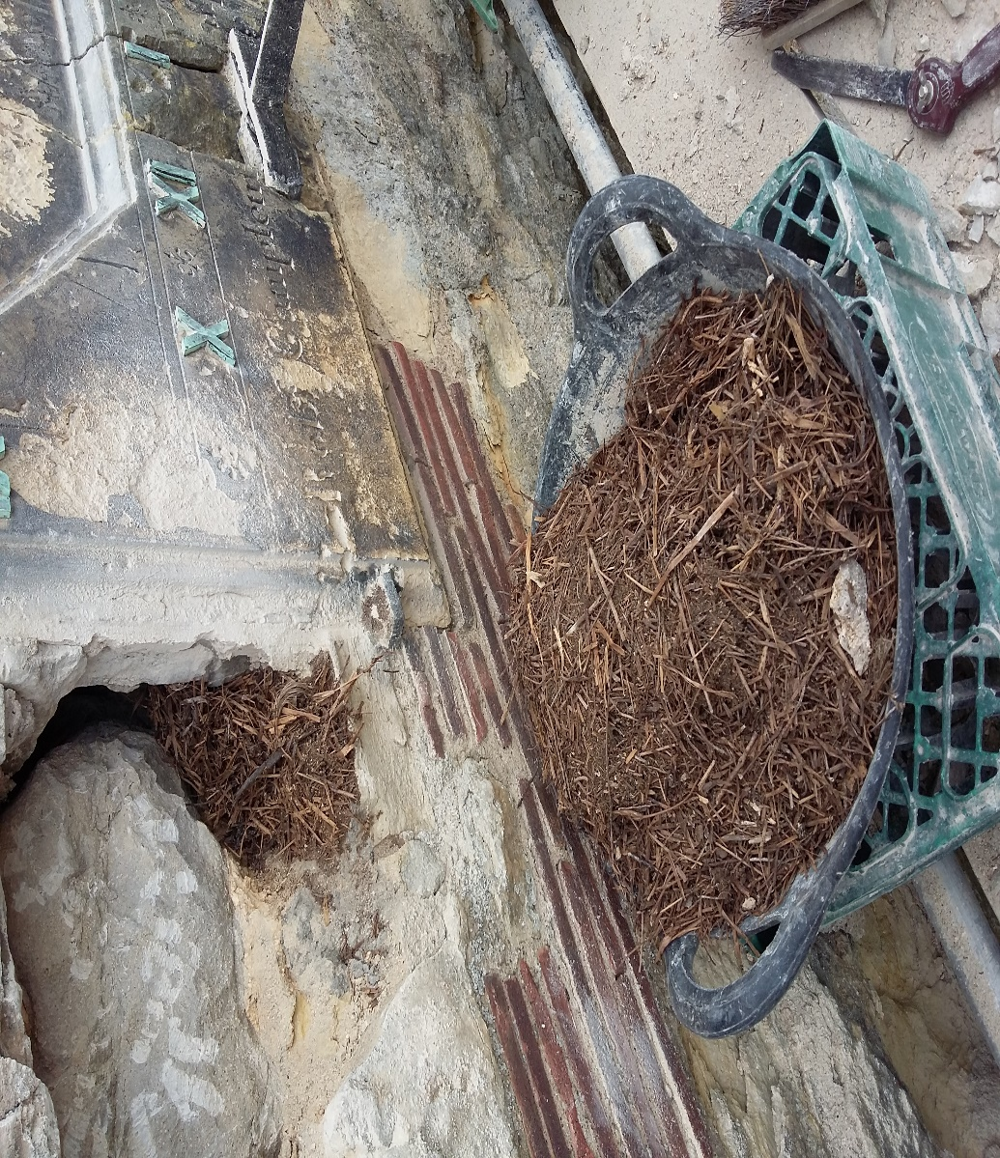
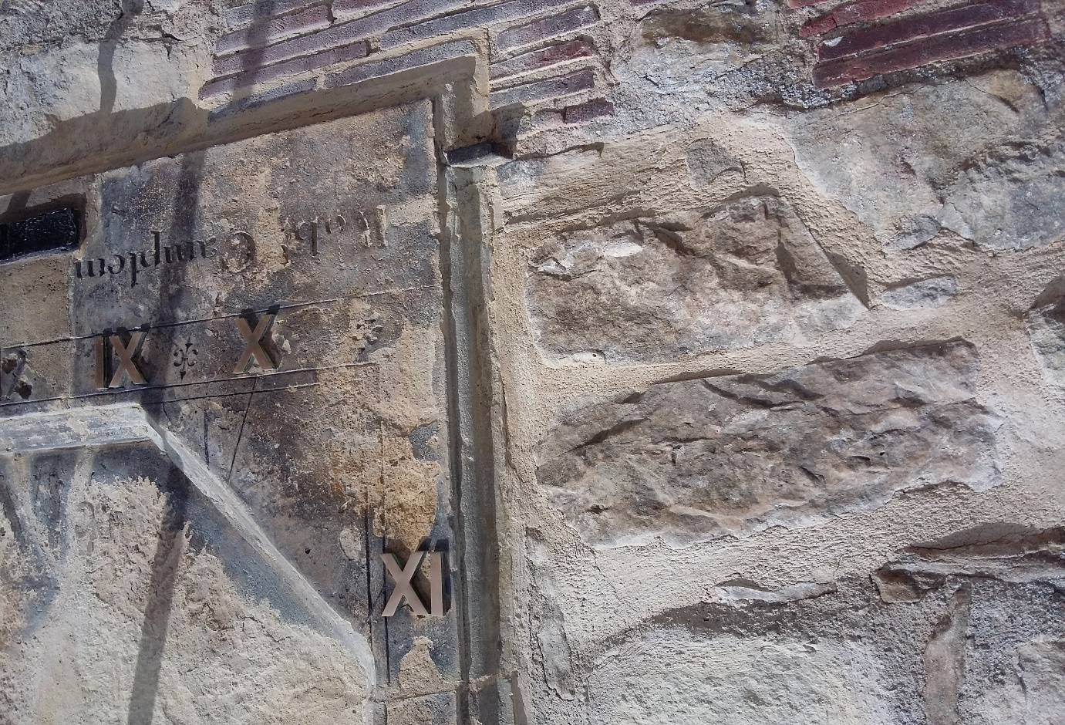
Fig 6. Removal of final debris behind and then large ashlars replaced.
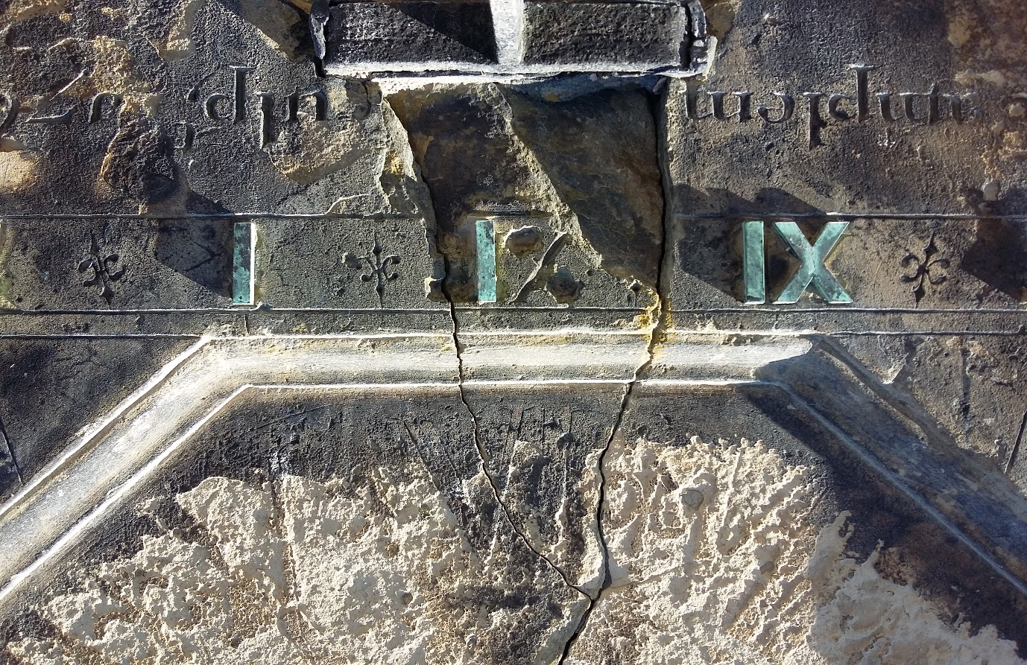

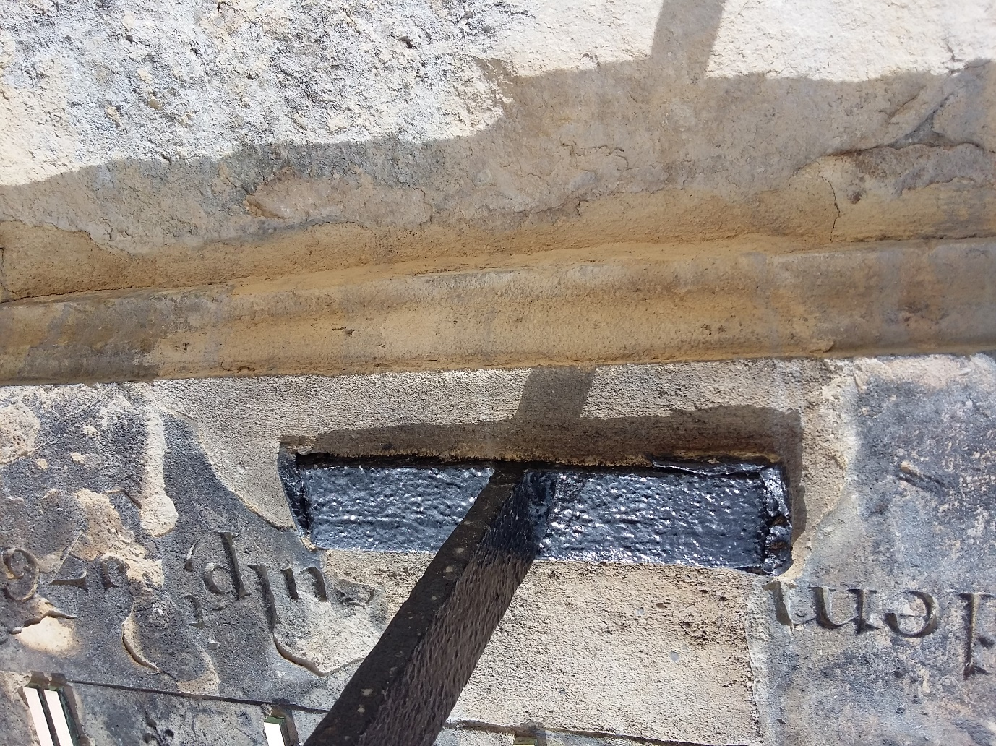
Fig 7. Mortar repairs to missing areas of stonework.
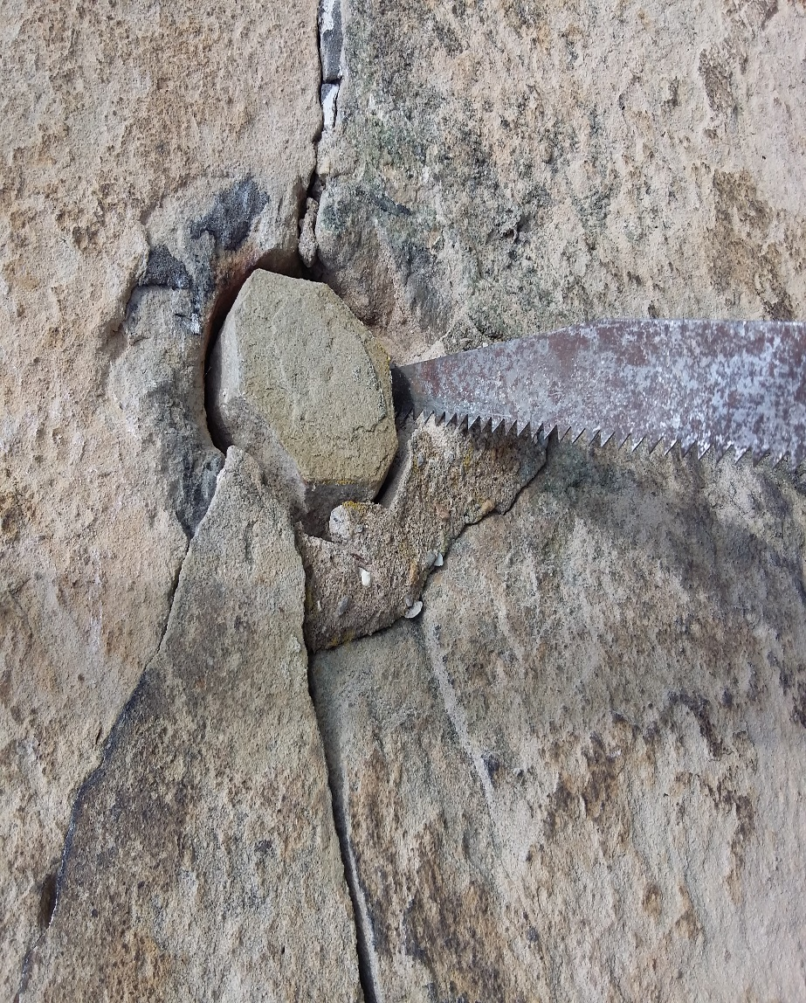

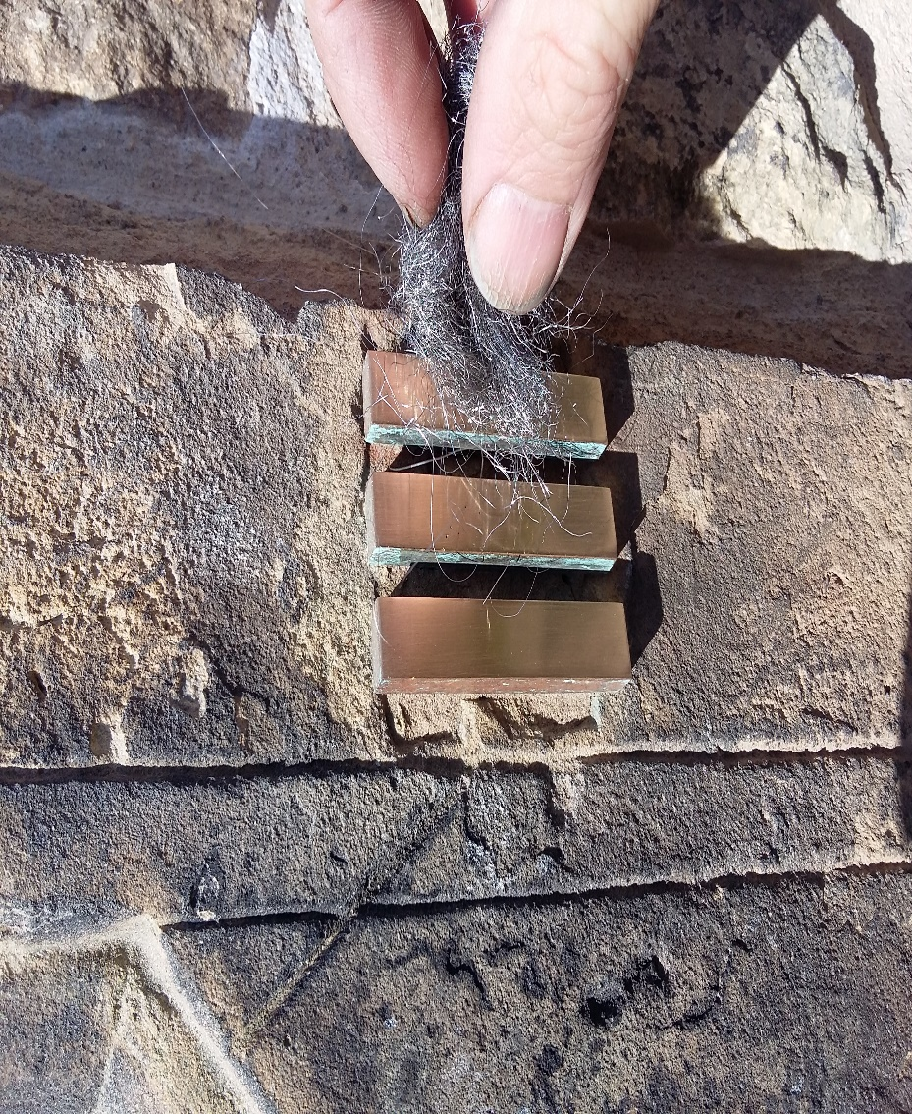
Fig 8. Clock dial centre replaced with new stone, bonding through. Polishing roman numerals.
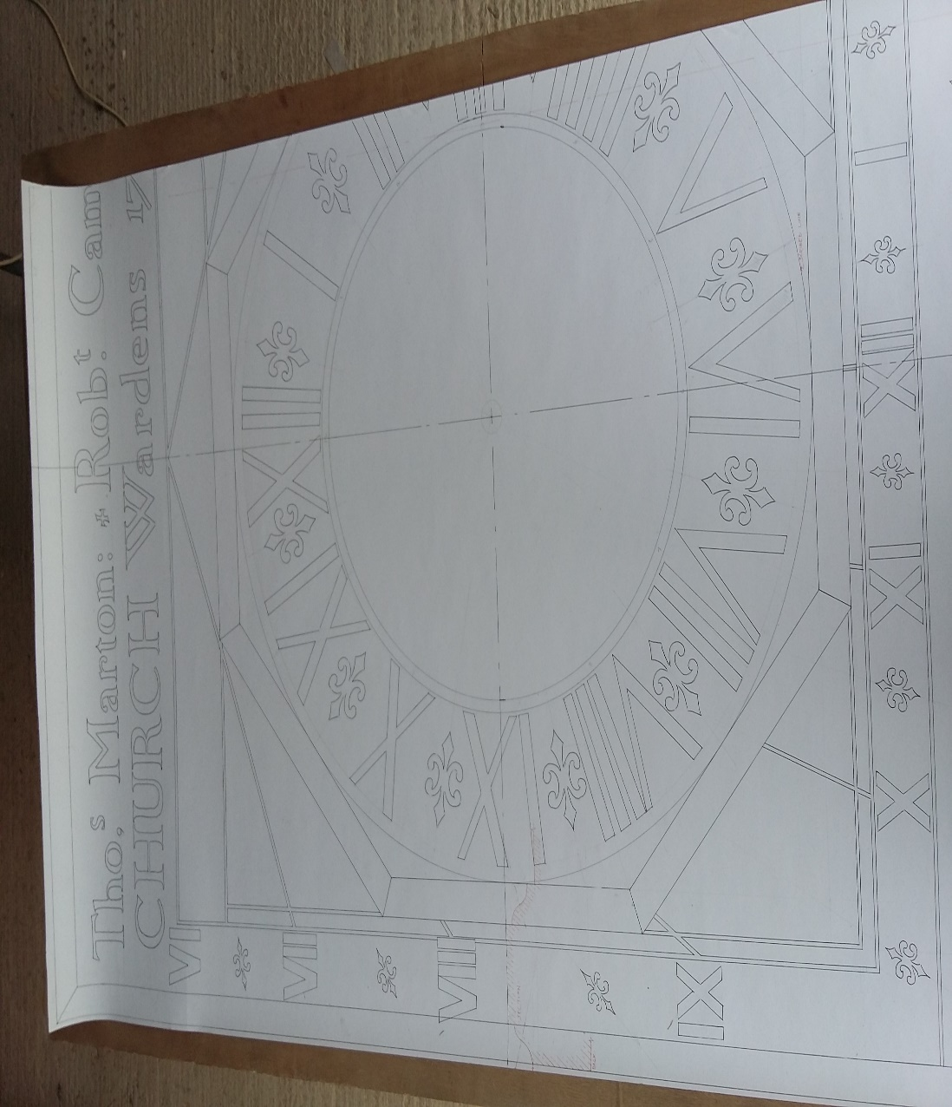
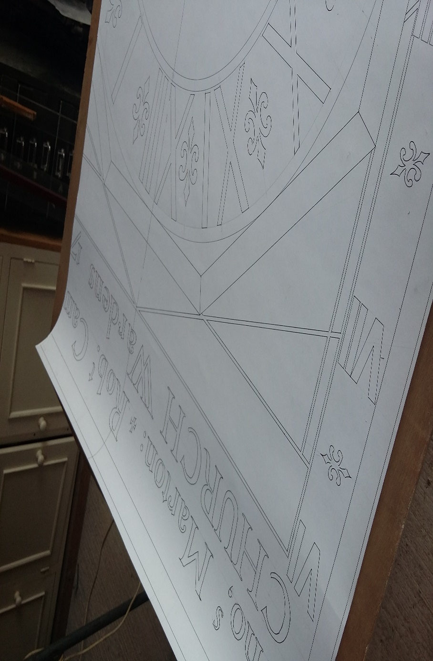
Fig 9. 1:1 drawing showing sections and dimensions
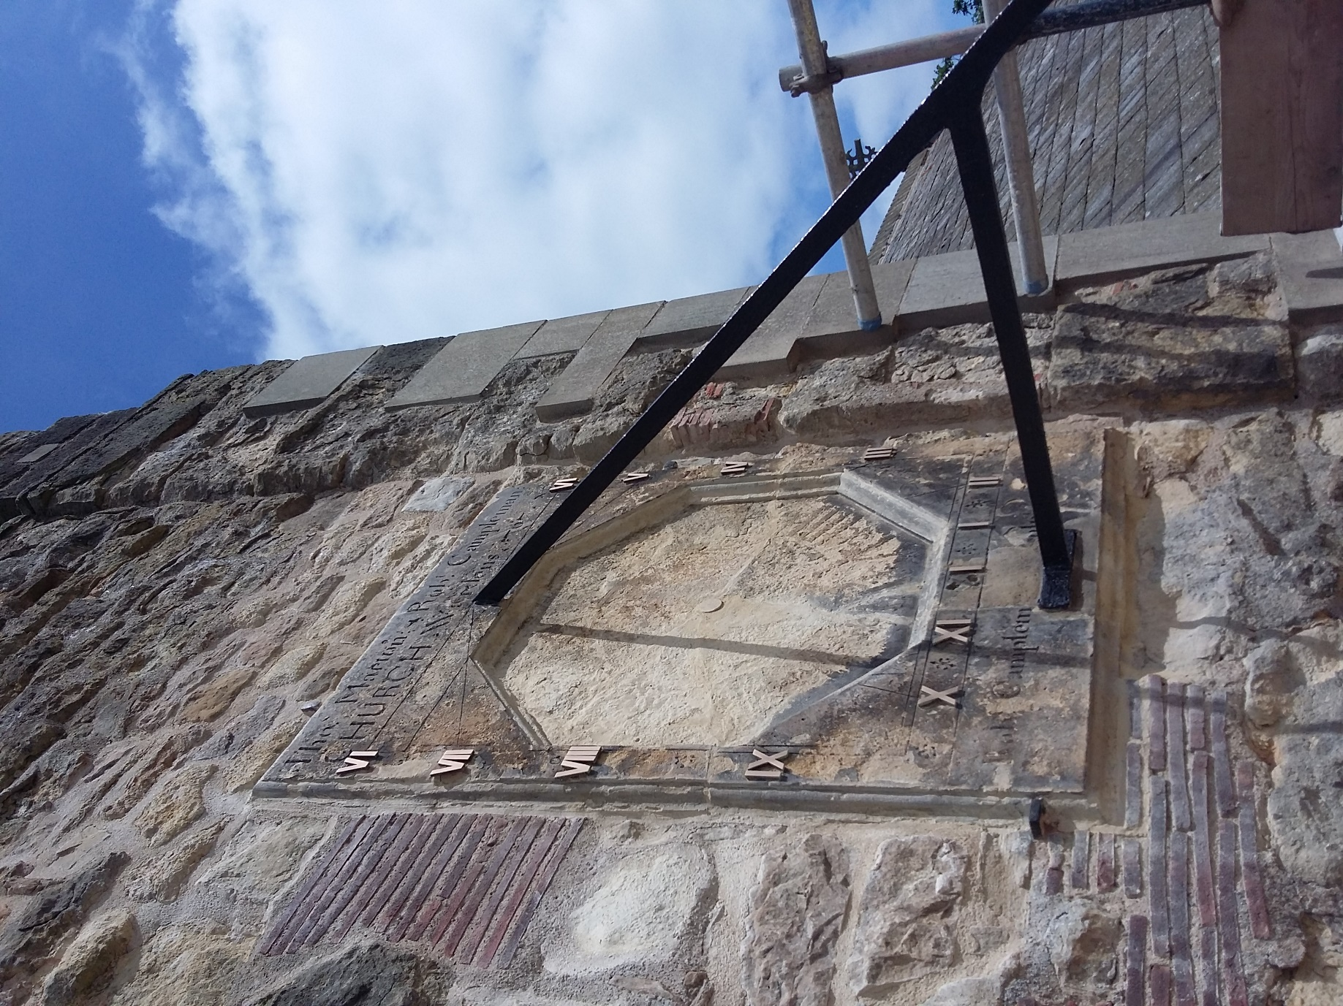
Fig 10. Repaired and conserved Sundial complete.

Martin Coward Stone Carving. June. 2018.

