The History of Fairseat Chapel .

What may be a surprise to some is that the Church at Fairseat is the second Church of the Holy Innocents at Fairseat, the first being established in one of the farm buildings adjacent to the children’s convalescent home at the Manor House which was managed by a staff for Sir Phillip and Lady Waterlow.
The first church had many gifts from the Waterlow family members, including an American organ by Sir Phillip, the altar crucifix by Sir Edgar, and a stained glass window now in the south side of the present church, given by Lady Waterlow in memory of her sister.
The second Church of the Holy Innocents at Fairseat, known affectionately as Fairseat Chapel, was built in 1930 by Sir Phillip Hickson Waterlow, Baronet, to the memory of his wife, his father and his mother and other relatives who lived at Fairseat.

In 1921 Lady Waterlow had established a children’s convalescent home at the adjacent Old Manor House. The home gave free convalescence to children from the London hospitals, in particular from St. Bartholomew’s Hospital.
It was therefore fitting that the church to her memory was so closely connected with it.

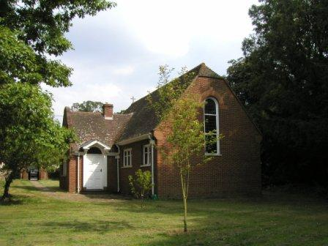
Church of the Holy Innocents Fairseat
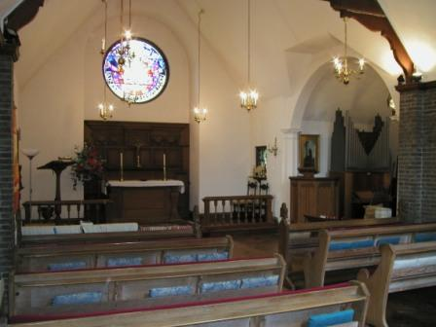
Interior of the church

The church was consecrated by Dr. Harmer the Bishop of Rochester on Tuesday 26th August 1930 when the beautiful little building was crowded with worshippers including twelve members of the Waterlow family and children from the convalescent home.
The clergy in attendance included Rev. F. W. Fisher, M.A., Rector, Rev. Cro1e-Rees, Diocesan Chaplain to the Bishop; Rev. F. W. Warland, Rural Dean of Kingsdown; Rev. A. P. Pascoe, Rector of Wrotham and Rev. F. F. Key. Mr. H N. Grimwade was the Registrar, in the absence of Mr. R. A. Arnold, Diocesan Registrar. The organist was Mr. W. Jones and Churchwardens Miss B. Stap and Mr. T. W. Webb.
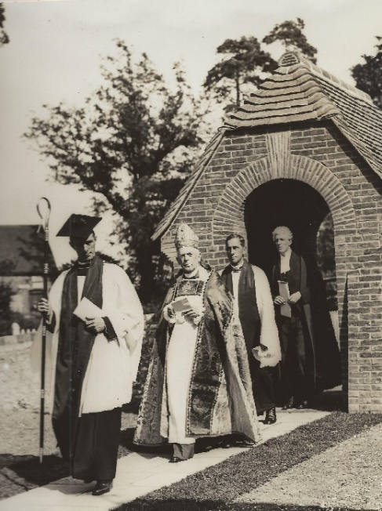
The Bishop, with the procession; arrived at the closed door of the church, and after the reading of a Collect, Dr. Harmer knocked with his staff on the door, saying “Lift up your heads O ye gates, and be ye lift up, ye everlasting doors, and the King of glory shall come in.” Following responses from within, the door was opened and on his crossing the threshold, the ‘Petition for Consecration’ was presented to the Bishop.
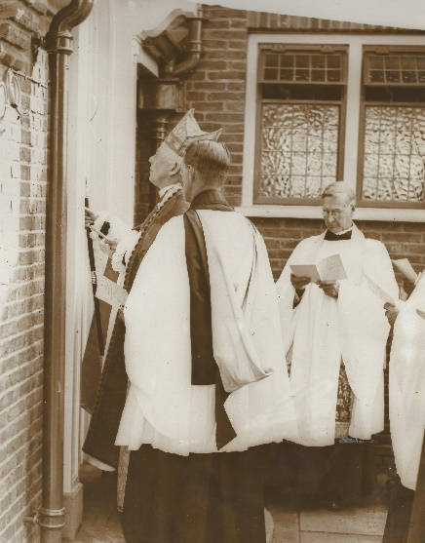
Rev. Fisher reading the Collect

Addressing the assembly, the Bishop said the church reflected the skill and genius of the architect Mr Waterhouse. Speaking of Lady Waterlow, the Bishop said she had one of those kind and generous hearts which would always help and succour those she recognised as being in want or difficulty. It was natural with such a kind disposition that nine years ago she had established a home for little children. But others had an opportunity for worship besides the children – the people in the district had in the new church fresh means of helping forward God's work. The church would not in any sense divide the parish but would assist in uniting it.
The architect of the building, Mr. Michael Waterhouse, A.R.I.B.A., of Staple Inn Building, High Holborn, told the Kent Messenger that Sir Philip wanted the chapel to harmonise with the Manor House and farm buildings, and while retaining its ecclesiastical dignity, to keep some of the domestic character of a chapel of ease, and
of the children's convalescent home, which explained the appearance of the doors, windows, and other architectural features. It could not be any regular ecclesiastical style, but in its proportion and general form it took something from the Georgian character of the Manor House. The plan was extremely simple in order, to retain the feeling of the place.
Externally there are narrow russet coloured bricks, with a deep coloured tiled roof to harmonise with the surrounding buildings: The walls of the nave are finished in grey brick, while the chancel and transepts are plastered with a rough natural coloured buff plaster.
Mr Waterhouse paid tribute to Messers A. Tye Ltd. of Sevenoaks, the builders, saying that Sir Phillip and he were extremely pleased with the way in which the work had been carried out. It was an example of first – class craftsmanship.
At the time of the consecration many gifts were made to the church by the Waterlow family members including a lectern, font, altar candlesticks, vases, collection plate and altar cloth. The Prayer and Hymn books were gifted by the staff of Sir Phillip Waterlow’s home at Trosley Towers.
Sadly Sir Phillip died in 1931; the stained glass rose window being gifted in his memory by his children.

Over the years the church has received many generous gifts including during the 1930’s an engraving in gilt frame from Mr Phillip Waterlow, the oak prayer desk and chair by Miss E Rogers, and the oak notice board by Mrs F F Lance.
In the 1960’s the pipe organ was purchased and installed as a gift of Mr and Mrs Pasteur who also gifted the sanctuary rug in 1979.
In 1988 the wall and hanging lights were restored by Nevil Acheson-Grey.

The church at Fairseat continues to be loved by everyone, is well maintained and regularly used for services and weekly prayer groups.

Colin Evans, Churchwarden

