The Parish of St Paul
Shepley

Churchyard Burials

This leaflet is designed to answer any questions you may have
regarding the burial or interment of ashes in the churchyard.

Churchyards are sacred ground and very special places of peace, tranquillity, beauty. For these and other reasons, people continue to want a churchyard burial or interment of ashes either for themselves or for their loved ones. We are very pleased that you are considering this churchyard and we hope this leaflet will guide you through the questions you may have.

Is the Churchyard Open?

We are pleased to advise you that this churchyard is open. This means that there are still plots available. Please do not make the assumption that where there are no memorial stones in the churchyard, there are no plots. It is most likely that these are unmarked graves. Always check where the available plots are with your vicar (or their designated person).

1.
What happens when the Churchyard is closed?

This means that there are no more available plots. If you see a burial take place in a closed churchyard, it is because a plot was previously reserved or there is space available in a family grave. When the churchyard is closed, its maintenance shifts from the Parochial Church Council (the PCC) to the Local Authority.

Can anybody be buried in the Churchyard?

Anybody who lives within the parish boundary, those named on the church electoral roll and those who die in the parish all have a legal right to be buried in the churchyard. Where there is still space available, relatives may be buried in an existing family grave. If a person is not baptised or a worshipper at this church, just so long as the above criteria are met, this will not pose a problem.
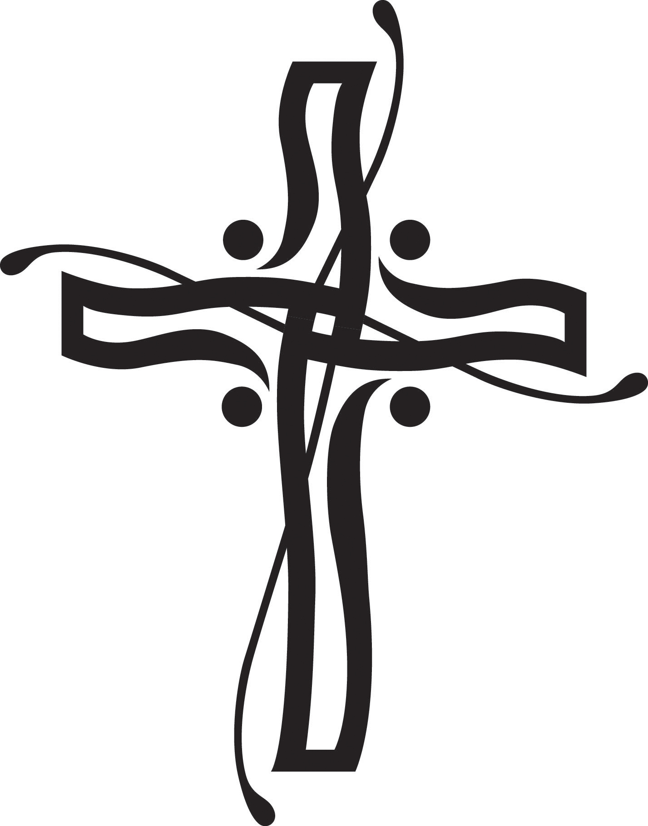
The Final Resting Place

The nature of the rite of burial is to say 'farewell' to the deceased and to commend them to the mercy and love of God in Christ and to await the transformation of resurrection. There is accordingly a theological finality to all interments, including those of cremated remains, in ground consecrated according to the rites of the Church of England. This is inconsistent with the concept of portability of remains and the future prospect of exhumation. It is therefore important that the grave is understood as the final resting place.

2.
Can I reserve a Burial Plot?

Because of the shortage of grave space in the area the PCC does not now allow the reservation of burial plots in this churchyard.

How soon after the funeral can there be a headstone?

You need to wait at least six months for the ground to settle. This will also allow time to think about what sort of memorial and inscription you would like.

Memorial Stones

The type of stone, its design and memorial inscription is regulated by the Consistory Court. This may vary from church to church if there are local regulations in force. . It also means that you may not always have your first choice of design. To avoid any disappointment, please first find out what is permissible and get this approved in principle by the vicar. The stonemason will work with you on this and will submit a final draft for approval by the vicar.

We regret that any stones placed illegally in the churchyard will be removed at the expense of the next of kin.

Types of headstones which may be permitted by parish clergy

The vicar has authority to permit the introduction of a headstone, which complies with the following requirements.

3.
Size
Memorial plate
Height (from base) 2ft 3 ins (min) to 4ft (max)
Width 1ft 8 ins (min) to 3ft (max)
Thickness 3 ins (min)* to 6 ins (max)
*except when slate is used, in which case 1.5 ins (min) is permitted

Memorial base(if included)
Height (from ground) 3 ins (min) to 6 ins (max)
Width 2ft (min) to 3ft (max)
Depth 10 ins (min) to 1ft (max)

The base may incorporate up to 2 integral sockets for flower vases.

Foundation slab
The foundation slab must be fixed flush with the ground such that a mower may freely pass over it.

Materials

The following stone is permitted for a headstone, but combinations of two or more types of stone are not allowed:

Limestone
Sandstone
Slate
Granite – honed light to dark grey but NOT black, red, blue, green, white or multi-coloured
4.
Appearance

Polished stone or mirror finish is not permitted.

Inscriptions

Bronze or ceramic inserts are not to be used. Badges, crests or emblems may be used provided they are seemly and appropriate for the deceased. Any representation will need to be designed so that it may be accurately cut by a skilled craftsman. Incised lettering may be painted in gold, silver, matt white, matt black or matt grey. Plastic inserted lettering is not permitted.

Graveside Flowers and Ornamentation
We are happy to say that graveside fresh flowers are permissible. In order to keep the graveside beautiful, they need to be removed from wrappings or bows and we kindly ask that flowers are removed before they decay. We also welcome the planting of small spring bulbs. We regret that free-standing vases, artificial flowers, balloons, lights and ornamentation are not permitted under the Chancellor’s Directions and will be removed.

Poppies for Remembrance Sunday are permissible.

Kerbstones are not allowed and neither is any kind of fencing or stone chippings as they impede the maintenance of the churchyard.
5.
Who owns the Grave?

Every grave is the property of the incumbent (i.e. the vicar as office holder). By contrast, any memorial belongs to the person who paid for its erection. After their lifetime it then belongs to the heir-at-law of the person commemorated. That person has a duty to maintain it and a legal liability for its safety.

Who is Responsible for the Care of the Grave?

The churchyard is cared for by members of the PCC who may instruct professional gardeners or form a gardening team of volunteers to ensure its upkeep. Once the churchyard is closed, its upkeep becomes the responsibility of the Local Authority. Many people find it therapeutic to join the church gardeners from time to time. If at any time you would like to join the gardeners, please speak to the vicar to arrange this.

In Memoriam

We do our utmost to ensure that the churchyard is a place of peacefulness and solace where people can feel near to their loved ones, close to their thoughts and in gentle communion with God. Every year, there is a special All Souls church memorial service for our loved ones (at this or another church in the Benefice), which you and your family and friends are most welcome to attend. Please make sure you get this date in your diary.

6.
A Prayer

O God of times and seasons
of beginnings and endings
of life and hope.
Mend the shards of this broken heart.
I thank you for those whose life has touched my life for good;
for their love and their unique way of being;
for the way my life is changed because of them.
As they pass through this fleeting life,
hold them in your love
And keep them in eternal life.
And may the day come when we shall be reunited in the place
You have shaped for all who love you.
Amen.

For further questions or enquiries, please contact

The vicar (Revd Canon Joyce Jones) 206 Barnsley Road, Denby Dale, HD8 8TS.
Telephone: 01484 862350. Email: joycerjones@aol.com

The Chancellor, The Diocesan Registry: Yorkshire House, East Parade, Leeds, LS1 5BD. Telephone: 0113 280 2241.

The Chancellor’s Churchyard Regulations are available at http://www.westyorkshiredales.anglican.org/legal/consistory-court

7.

