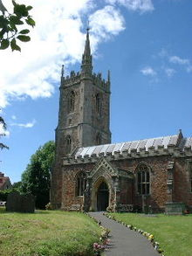
Consent Form

St Andrew’s Church, Chew Stoke
Keeping in touch

We would like to stay in touch with you and let you know about future events and news from St. Andrew’s. If you are happy to hear from us, please tick the box below and let us have your contact details so we can add you to the list of of those receiving such information. We will not share your details and you can take your name off at any time by contacting the Church Office (lakesidegroupoffice@gmail.com)

Name……………………………. Email/Address……………………...

Signed……………………………

Date………................................

