I wish to celebrate a life

Minimum donation of £5.00 per person in memory of

I wish to make a donation of £___________ in loving memory of:
(PLEASE PRINT)

1. __________________________________________________
2. __________________________________________________
Names will be automatically recorded in the Book of Remembrance.
Do you also wish the names to be recorded on the website? YES / NO
Your name ______________________________________________
(PLEASE PRINT)
Donor Details
Address ________________________________________________

________________________________POSTCODE_____________
Telephone Number _______________________________________
Do you wish YOUR name to be recorded on the Book of Remembrance and / or Website? – Please delete as appropriate.
Payment

I enclose a cheque made payable to Woodchurch PCC for £______________
I enclose cash handed into the Parish Office and a receipt given for £______________
Would you like your name retained so we can contact you in future years? YES/NO
Gift Aid

If you are UK Taxpayer your donation can increase by 25% with no additional cost to you. Please tick to gift aid and ensure address is completed.
Please return your form to: Parish Office, Holy Cross Church, c/o 20 Eltham Green, Arrowe Park, Wirral CH49 5NG.

This Christmas remember those we have lost, love and cherish
TREE OF LIGHT

SWITCH ON SERVICE
2ND DECEMBER 2018
6.00 pm


5th YEAR
Please join us for this very special evening of reflection, remembrance and carols on Sunday 2nd December 2018 at 6.00pm.

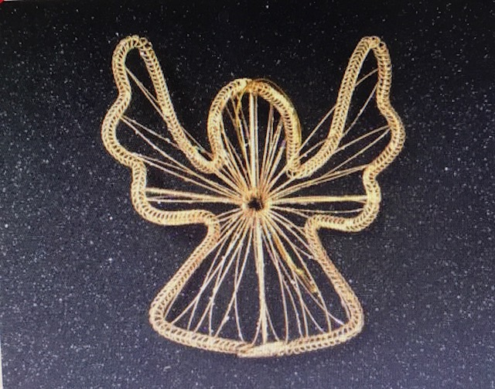
Refreshments will be available after the service
in the Parish Community Hall.
Please note that part of the service is held outdoors and suitable clothing and footwear is advised.
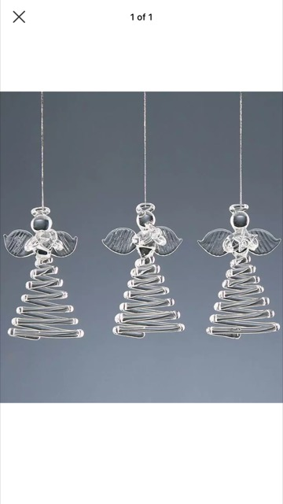
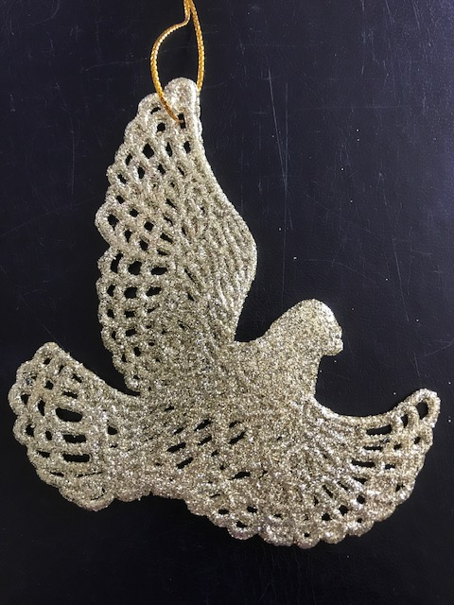
There will also be an option to purchase various items together with a label to write your own personal message and this will be hung inside our Church on our Christmas Tree during December.
On Saturday 15th December the Church will be open from 12 noon to 3pm for you to enjoy some quiet time and reflection and collect your Angel or Star to take home to be hung on your own Christmas Tree over Christmas.

If you are unable to attend, you can still make a dedication which will be included in the
Tree of Light Book of Remembrance.

Remember somebody you miss in a special way
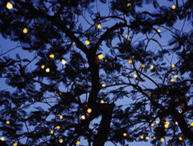
Christmas can be a very special time for sharing memories and thinking of those close to us. Holy Cross TREE OF LIGHT is an opportunity to remember a loved one who can’t be with you at Christmas.

The TREE OF LIGHT helps us to remember family and friends who have helped light up our lives. By giving a donation a light will be placed on the TREE OF LIGHT situated in the Churchyard which can be seen around parts of the Parish in Woodchurch and bringing light and love around our neighbourhood.
Minimum donation of £5.00
The name of your loved one will be recorded in the BOOK OF REMEMBRANCE located at the back of Church and on our new website together with the name of the donor.
The TREE OF LIGHT will be lit from Sunday 2nd December 2018 until 5th January 2019.
We would like to thank you for your ongoing support towards our fundraising. If you would like to participate in this project, please return the form and payment to the Parish Office by Monday 26th November 2018.

