SUNDAY READING SHEET 8th November 2026 REMEMBRANCE SUNDAY

A Reading from the Wisdom of Solomon

Wisdom is radiant and unfading,
and she is easily discerned by those who love her,
and is found by those who seek her.
She hastens to make herself known to those who desire her.
One who rises early to seek her will have no difficulty,
for she will be found sitting at the gate.
To fix one’s thought on her is perfect understanding,
and one who is vigilant on her account will soon be free from care,
because she goes about seeking those worthy of her,
and she graciously appears to them in their paths,
and meets them in every thought.

Wisdom of Solomon 6:12-16

GOSPEL

‘Then the kingdom of heaven will be like this. Ten bridesmaids took their lamps and went to meet the bridegroom. Five of them were foolish, and five were wise. When the foolish took their lamps, they took no oil with them; but the wise took flasks of oil with their lamps. As the bridegroom was delayed, all of them became drowsy and slept. But at midnight there was a shout, “Look! Here is the bridegroom! Come out to meet him.” Then all those bridesmaids got up and trimmed their lamps. The foolish said to the wise, “Give us some of your oil, for our lamps are going out.” But the wise replied, “No! there will not be enough for you and for us; you had better go to the dealers and buy some for yourselves.” And while they went to buy it, the bridegroom came, and those who were ready went with him into the wedding banquet; and the door was shut. Later the other bridesmaids came also, saying, “Lord, lord, open to us.” But he replied, “Truly I tell you, I do not know you.” Keep awake therefore, for you know neither the day nor the hour. Matthew 25:1-13


If you wish to make a donation to the church, then please hold Your phone’s camera over this image then touch the link that appears:

Royston Parish Church
Where all are welcome and God’s love is shared
Sunday 8TH November 2026 REMEMBRANCE SUNDAY

If you would like regular copies of the Notice Sheet emailed to you please email the
Parish Office at admin@roystonparishchurch.org.uk

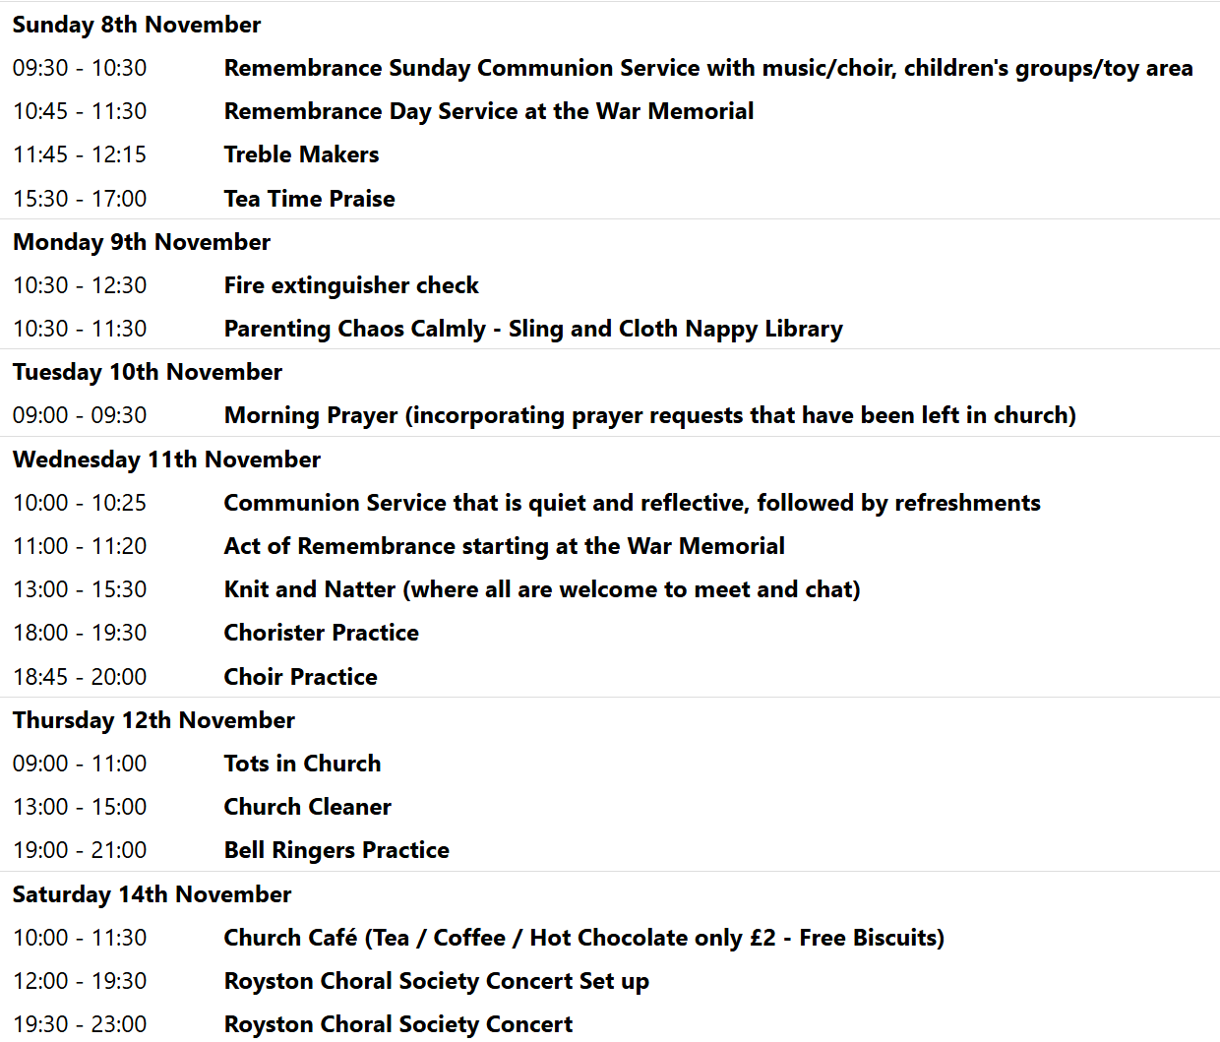
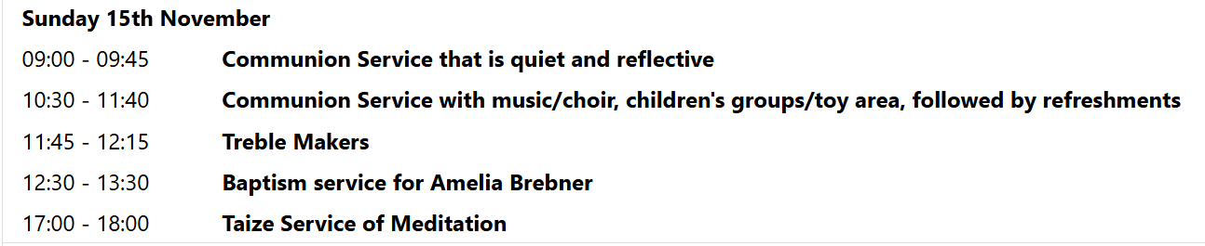

We pray for all Christians worldwide:
For all Christians in Oceania
For all who worship at Christ Church (Royston Evangelical Church): Jonathan Scott
For the work of our mission partners: Tear Fund

Pray for the community of Royston:
For our local health centres
For all our local Road Sweepers and those who empty of bins

We pray for our world and ECO projects:
The 2026 UN Climate Change Conference (COP 31) will take place from 9-20th November 2026 in Antalya, Türkiye. We pray that nations may come together with sincerity and determination to respond to the Climate and Biodiversity crisis.

We pray for the sick and suffering:
1st Nov | 8th Nov | 15th Nov | 22nd/29th Nov
Emma Thompson | Pat Tidey | Val Brown | Peter Coates
Jackson Herbert | Mike Brown | Angie & Ken Rushall | Peggy Dawes
Marion | Clare Rice | Paula Walker
Rina Marias | Max Elliott | Sandra Landels  (nee Cornwell) | Keith & Elaine Edwards

We pray for those who have died in the faith of Christ:
Deceased Bereaved
Deborah King Mervyn, family and friends
Bill Bryson Pauline, Nick, family and friends

We pray for those whose anniversaries fall at this time:
Anthony Payne, Allan Jones

NOTICES

SUNDAY 8TH NOVEMBER 9.30 AM: AND WEDNESDAY 11TH NOVEMBER 10.00 AM please note a change of times, this is to enable us to have a Remembrance Day Service at the War Memorial at Sunday 10.45 am and Wednesday 11 am.

JULIAN PRAYER MEETINGS: The November Julian Prayer meeting will be Thursday 19th at 11 Middle Drift, 7pm . The December meeting will be Thursday 10th and will have an advent theme and be led by Steven .

MINCE PIES: Donations of mince pies would also be welcome, to offer a sweet option, please ensure they are in date to cover Christmas period. Please leave in the kitchen.

BIBLE SOCIETY MEETING: Thursday 12th November 7.30 pm for 7.45 pm. Venue: Christ Church Royston (formerly Evangelical Church) SG8 5HJ. Guest speaker Neil Rees.

CHRISTMAS RAFFLE : We are going to run a Christmas Raffle as usual this year, with prizes of LUXURY hampers etc.
We would be very grateful for any donations towards the hamper contents. The hampers will have to be made up on Saturday 14th November and we will need your donations before then, please.
Please leave any items in the kitchen.
FOOD HAMPERS: We are looking for at least 2 good hampers plus some smaller prizes. Any LUXURY food or drink items especially Christmas foods, thank you.
TOILETRIES HAMPER: Any nice toiletries to make a small to medium sized hamper, please.
CHILDRENS HAMPER: We had a separate raffle for children last year which was well received. Any Christmas chocolates such as selection boxes, small toys, games etc.
If you need ideas and inspiration there is a suggestions list on the table at the back of Church.
This is a good fundraiser for the Church and we are very grateful for all your contributions.
THANK YOU. The Events Committee.

