CHURCH CALENDAR AND SERVICES

NOVEMBER

1st ALL SAINTS DAY Holy Communion
8th REMEMBRANCE SUNDAY Matins 10.30 p.m.
15TH Trinity XXIV Holy Communion
22nd Sunday next before Advent Matins
29th Benefice Carol Service at Silton 6.00 p.m.

DECEMBER

6th Advent II Holy Communion
13th Advent III Matins
20th CAROL SERVICE (followed by mulled wine and mince pies)
24TH Christmas Eve Holy Communion 6.00 p.m.
25th CHRISTMAS DAY Holy Communion 11.00 a.m.
27th Benefice Service at St Mary’s Gillingham
Holy Communion 9.30 a.m.

JANUARY

3rd Christmas I Holy Communion
10th Christmas II Matins

All services are from the Book of Common Prayer and are at
11 a.m. every Sunday, unless otherwise stated.

All services will be publicised on the website and may be subject to alteration.

Next PCC Meeting: Tuesday 19th January at 2.00 p.m.

As we move towards the end of the Church and calendar years and the days grow shorter, we all crave a little comfort. So it’s probably not surprising that the traditions of the feasts and festivals of this part of the year include a good deal of baking. There really is nothing quite as comforting as something stodgy and sweet – especially when it’s warm from the oven!
All Saint’s and All Souls’ Days bring us soul cakes – a cross between a biscuit and scone that was given to children as they went ‘souling’, a distant ancestor of today’s trick-or-treating. Armistice Day is also St Martin’s Day, marked in Spain with cakes made with the abundant chestnuts of this time of year. And, of course, we have Stir Up Sunday, when the words of the collect give us a prompt to make our cakes and puddings, so they have a chance to mature before Christmas. From the low countries and Germany, we have delicious treats like speculoos to mark St Nicholas’ Day.
And then Advent – like Lent, a season of fasting before a feast of great rejoicing. Not the easiest time to be trying to resist delicious things like mince pies, ecclefechan tarts, stollen and lebkuchen, as they fill the shelves in our supermarkets!
In these months of cooling temperatures, soggy mornings and growing darkness, we reach for the memories of the delicious produce of the summer preserved in milled grain, dried fruits and warming spices to sustain us. Every mouthful takes us back to the sun of summer and feeds our souls through the dark days into which Jesus came as Light to the world. May all the good things that we eat through these seasons help to remind us of the gift that God gave us in His Son, born into a world of scarcity and pain as a promise of abundance and healing for us all.
Rev’d Philippa

 | SATURDAY 21ST NOVEMBER  CHRISTMAS COFFEE MORNING  SILTON VILLAGE HALL 10 a.m. – 12 noon  Coffee, cakes, preserves, books, raffle, bric-a-brac, gifts, etc.  Bring your friends.  In aid of Silton PCC Charity Giving

RIDE AND STRIDE
A very big thank you to all who sponsored Peter and/or Diana, Mike and Michela – their efforts raised a total of £1,600 for Dorset Historic Churches Trust, half of which will come back to our PCC.
SOFOS CHRISTMAS DRINKS AND QUIZ NIGHT
Saturday 12th December from 6.00 p.m. To book a table for the Quiz contact: Jackie Dyer (01747 840087) jack27.dyer@gmail.com
SILTON VILLAGE HALL
Creative Stitch: Every 3rd Monday in the month 10 a.m.- 4.p.m. All details on Village Hall website
Castle Hill Quilters: Every Thursday 1.30 p.m.- 4.30.p.m.
Friday Markets: 10 a.m.-12.30 in the Village Hall. Fresh Fruit and Vegetables, Home Baked Cakes, Pies, Bread, Jams, Chutneys and Pickles as well as other goodies and of course Teas and Coffees.
The Village Hall Calendar: This can be viewed online - you can also now make an enquiry though the website www.siltonvillage.co.uk.
For Village Hall enquiries contact Sue@siltonmanor.co.uk or Tel: 07970 865790

CHURCH AND PARISH OF
ST. NICHOLAS, SILTON, SP8 5PR
www.siltonchurch.org

NOVEMBER - DECEMBER 2026

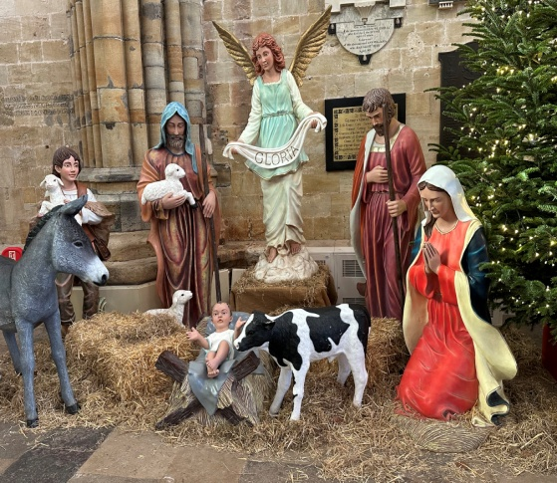
Churchwardens

Peter Williams (01747 840275) peterwilliams53@gmail.com
James Smith (07846 020731) jamesexaminer.js@gmail.com

Society of Friends of Silton:

Chairman: Charles Peel: (01747 840303)
Secretary: Jackie Dyer (01747 840087) jack27.dyer@gmail.com

Parish Meeting:

Chairman: Diana Masters (01747 840288) mastersbagmore@btinternet.com
Acting Parish Clerk: Chris Woodhouse (01747 841243) cardsfarmhouse@btinternet.com

Village Hall:

Chairman: Keith Harris (07966166905) keith@siltonmanor.co.uk
Secretary: Sue Harris (07970865790) sue@siltonmanor.co.uk

Silton Village Website: www.siltonvillage.co.uk

Parish Office:

Miriam Light 01747 821598 gillinghamanglican@gmail.com

