SUNDAY READING SHEET 11th October 2026 – 19th Sunday after Trinity

A Reading from the Book of Exodus

When the people saw that Moses delayed to come down from the mountain, the people gathered around Aaron and said to him, ‘Come, make gods for us, who shall go before us; as for this Moses, the man who brought us up out of the land of Egypt, we do not know what has become of him.’ Aaron said to them, ‘Take off the gold rings that are on the ears of your wives, your sons, and your daughters, and bring them to me.’ So all the people took off the gold rings from their ears, and brought them to Aaron. He took the gold from them, formed it in a mould, and cast an image of a calf; and they said, ‘These are your gods, O Israel, who brought you up out of the land of Egypt!’ When Aaron saw this, he built an altar before it; and Aaron made proclamation and said, ‘Tomorrow shall be a festival to the Lord.’ They rose early the next day, and offered burnt-offerings and brought sacrifices of well-being; and the people sat down to eat and drink, and rose up to revel. The Lord said to Moses, ‘Go down at once! Your people, whom you brought up out of the land of Egypt, have acted perversely; they have been quick to turn aside from the way that I commanded them; they have cast for themselves an image of a calf, and have worshipped it and sacrificed to it, and said, “These are your gods, O Israel, who brought you up out of the land of Egypt!”’ The Lord said to Moses, ‘I have seen this people, how stiff-necked they are. Now let me alone, so that my wrath may burn hot against them and I may consume them; and of you I will make a great nation.’ But Moses implored the Lord his God, and said, ‘O Lord, why does your wrath burn hot against your people, whom you brought out of the land of Egypt with great power and with a mighty hand? Why should the Egyptians say, “It was with evil intent that he brought them out to kill them in the mountains, and to consume them from the face of the earth”? Turn from your fierce wrath; change your mind and do not bring disaster on your people. Remember Abraham, Isaac, and Israel, your servants, how you swore to them by your own self, saying to them, “I will multiply your descendants like the stars of heaven, and all this land that I have promised I will give to your descendants, and they shall inherit it for ever.”’ And the Lord changed his mind about the disaster that he planned to bring on his people. Exodus 32:1-14

GOSPEL

Once more Jesus spoke to them in parables, saying: ‘The kingdom of heaven may be compared to a king who gave a wedding banquet for his son. He sent his slaves to call those who had been invited to the wedding banquet, but they would not come. Again he sent other slaves, saying, “Tell those who have been invited: Look, I have prepared my dinner, my oxen and my fat calves have been slaughtered, and everything is ready; come to the wedding banquet.” But they made light of it and went away, one to his farm, another to his business, while the rest seized his slaves, maltreated them, and killed them. The king was enraged. He sent his troops, destroyed those murderers, and burned their city. Then he said to his slaves, “The wedding is ready, but those invited were not worthy. Go therefore into the main streets, and invite everyone you find to the wedding banquet.” Those slaves went out into the streets and gathered all whom they found, both good and bad; so the wedding hall was filled with guests. ‘But when the king came in to see the guests, he noticed a man there who was not wearing a wedding robe, and he said to him, “Friend, how did you get in here without a wedding robe?” And he was speechless. Then the king said to the attendants, “Bind him hand and foot, and throw him into the outer darkness, where there will be weeping and gnashing of teeth.” For many are called, but few are chosen.’
Matthew 22:1-14

Royston Parish Church
Where all are welcome and God’s love is shared
Sunday 11th October 2026 –19th Sunday after Trinity
If you would like regular copies of the Notice Sheet emailed to you please email the
Parish Office at admin@roystonparishchurch.org.uk

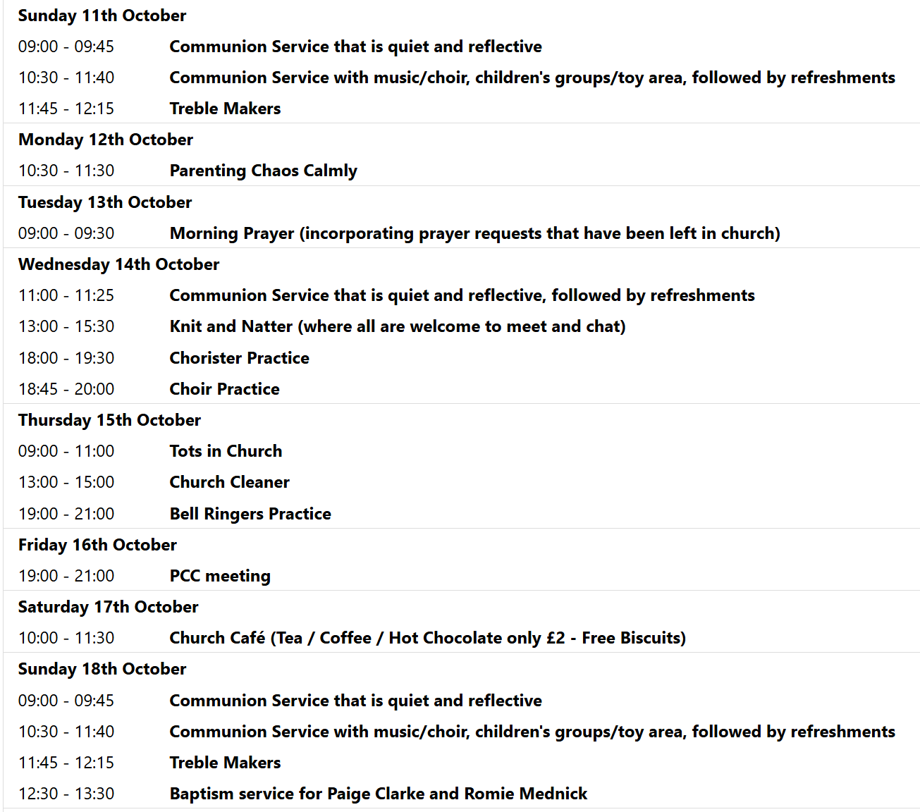

We pray for all Christians worldwide:
For all Christians in Costa Rica, El Salvador, Nicaragua, Panama
For all who worship at Trinity Life Church: Petr Chapman
For the work of our mission partners: Orchid Progect
Pray for the community of Royston:
For our local health centres
For all our local farmers and land workers
We pray for our world and ECO projects:
14 October is International E-Waste Day, when we are invited to retrieve, recycle and revise our unused electronic devices (e.g. safely declutter old mobile phones, cables, USB sticks, games consoles, computers, etc). See https://weee-forum.org/iewd-about/
We pray for the Rt. Revd Andrew Rumsey installed on the 19th September as the 11th Bishop of St Albans
We pray for all who may be considering applying for our Minister of Music.

We pray for the sick and suffering:
4th October | 11th October | 18th October | 25th October
Emma Thompson | Pat Tidey | Val Brown | Peter Coates
Jackson Herbert | Mike Brown | Angie & Ken Rushall | Peggy Dawes
Marion | Clare Rice | Paula Walker | Chris Stratton
 | Max Elliott | Sandra Landels  (nee Cornwell) | Keith & Elaine Edwards

We pray for those who have died in the faith of Christ:
Deceased Bereaved
Barbara Goy Kate, family and friends

We pray for those whose anniversaries fall at this time:
Roger Burns

NOTICES

HELP NEEDED PLEASE: Saturday 17th October 11.30 am we would like to organise a work party to help with clearing ivy etc, moving corner stones, and sorting a stone cross, in the Additional Burial Ground. If you are able to help in anyway please speak to the Church wardens, Kay and Richard. Thank you.

BIBLE SOCIETY MEETING: Thursday 12th November 7.30 pm for 7.45 pm. Venue: Christ Church Royston (formerly Evangelical Church) SG8 5HJ. Guest speaker Neil Rees.

CHRISTMAS RAFFLE : We are going to run a Christmas Raffle as usual this year, with prizes of LUXURY hampers etc.
We would be very grateful for any donations towards the hamper contents. The hampers will have to be made up on Saturday 14th November and we will need your donations before then, please.
Please leave any items in the kitchen.
FOOD HAMPERS: We are looking for at least 2 good hampers plus some smaller prizes. Any LUXURY food or drink items especially Christmas foods, thank you.
TOILETRIES HAMPER: Any nice toiletries to make a small to medium sized hamper, please.
CHILDRENS HAMPER: We had a separate raffle for children last year which was well received. Any Christmas chocolates such as selection boxes, small toys, games etc.
If you need ideas and inspiration there is a suggestions list on the table at the back of Church.
This is a good fundraiser for the Church and we are very grateful for all your contributions.
THANK YOU. The Events Committee.

ANNUAL SHOEBOX APPEAL Link-to-Hope is a Christian charity which at Christmas sends shoeboxes containing gifts for poor families in Ukraine, Moldova, Bulgaria and Romania. Here at St. John's we support the shoebox appeal each year, and you are invited to join in by filling your own box during the month of October.
Please collect a leaflet from church, which suggests items you can put in your box - either for elderly folk, or for families with children. You can drop your box off at church any time, but the closing date is Sunday November 1st.. If you are unable to fill a box, you may wish instead make a financial donation towards the charity's costs. Please see Duncan Rodgers about this. THANK YOU!

JULIAN PRAYER EVENING: Thursday 22nd October 7 pm at 11 Middle Drift.


If you wish to make a donation to the church, then please hold Your phone’s camera over this image then touch the link that appears:

