
All Souls’ service
Bridlington Priory
Sunday 1st November 4pm
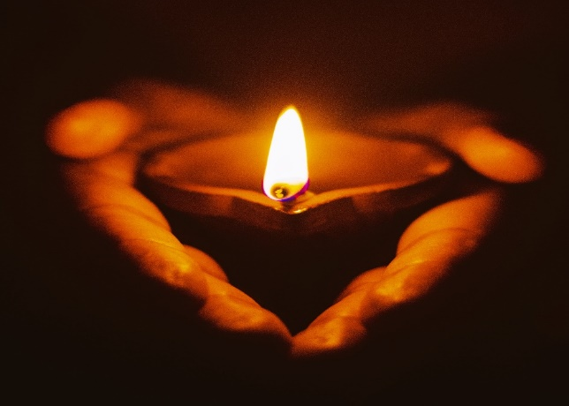
A very special service with prayers, music and readings, to remember those we continue to love but see no more.
Candles will be lit as names are also read out.
All are welcome.

