SUNDAY READING SHEET 4th October 2026 HARVEST FESTIVAL

A Reading from Paul’s Second Letter to the Corinthians

The point is this: the one who sows sparingly will also reap sparingly, and the one who sows bountifully will also reap bountifully. Each of you must give as you have made up your mind, not regretfully or under compulsion, for God loves a cheerful giver. And God is able to provide you with every blessing in abundance, so that by always having enough of everything, you may share abundantly in every good work. As it is written,
“He scatters abroad; he gives to the poor;
his righteousness endures forever.”
He who supplies seed to the sower and bread for food will supply and multiply your seed for sowing and increase the harvest of your righteousness. You will be enriched in every way for your great generosity, which will produce thanksgiving to God through us, for the rendering of this ministry not only supplies the needs of the saints but also overflows with many thanksgivings to God. Through the testing of this ministry you glorify God by your obedience to the confession of the gospel of Christ and by the generosity of your partnership with them and with all others, while they long for you and pray for you because of the surpassing grace of God that he has given you. Thanks be to God for his indescribable gift! 2 Corinthians 9:6-15

GOSPEL

Jesus told them a parable: “The land of a rich man produced abundantly. And he thought to himself, ‘What should I do, for I have no place to store my crops?’ Then he said, ‘I will do this: I will pull down my barns and build larger ones, and there I will store all my grain and my goods. And I will say to my soul, Soul, you have ample goods laid up for many years; relax, eat, drink, be merry.’ But God said to him, ‘You fool! This very night your life is being demanded of you. And the things you have prepared, whose will they be?’ So it is with those who store up treasures for themselves but are not rich toward God.” He said to his disciples, “Therefore I tell you, do not worry about your life, what you will eat, or about your body, what you will wear. For life is more than food and the body more than clothing. Consider the ravens: they neither sow nor reap, they have neither storehouse nor barn, and yet God feeds them. Of how much more value are you than the birds! And which of you by worrying can add a single hour to your span of life? If then you are not able to do so small a thing as that, why do you worry about the rest? Consider the lilies, how they grow: they neither toil nor spin, yet I tell you, even Solomon in all his glory was not clothed like one of these. But if God so clothes the grass of the field, which is alive today and tomorrow is thrown into the oven, how much more will he clothe you, you of little faith! And do not keep seeking what you are to eat and what you are to drink, and do not keep worrying. For it is the nations of the world that seek all these things, and your Father knows that you need them. Luke 12:16-30


If you wish to make a donation to the church, then please hold Your phone’s camera over this image then touch the link that appears:

Royston Parish Church
Where all are welcome and God’s love is shared
Sunday 4th October 2026 –HARVEST FESTIVAL
If you would like regular copies of the Notice Sheet emailed to you please email the
Parish Office at admin@roystonparishchurch.org.uk

SUNDAY 4th OCTOBER – HARVEST FESTIVAL
Non-perishable gifts welcome at both services, to be gifted to the Foodbank. Thank you

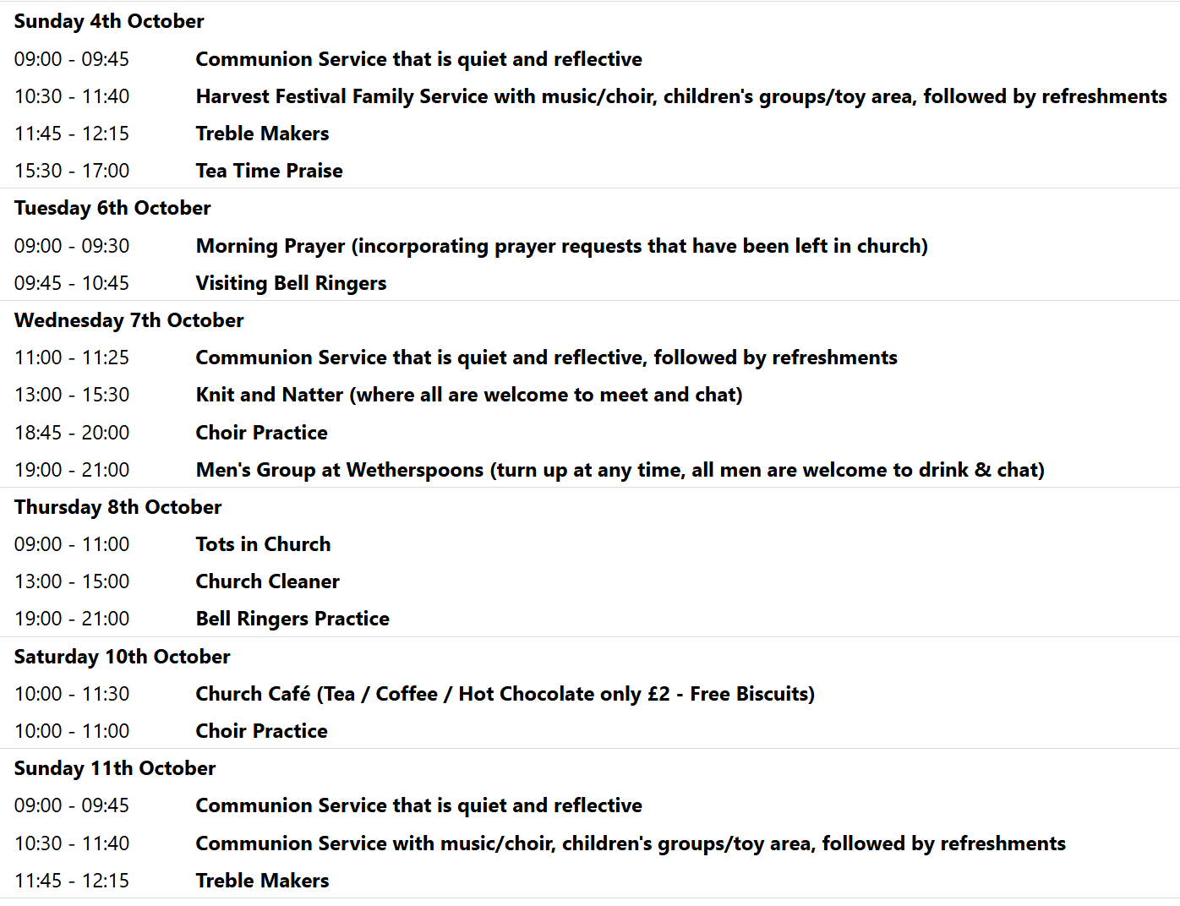

We pray for all Christians worldwide:
For all Christians in Colombia, Ecuador, Venezuela
For all who minister and worship at Royston Parish Church
For the work of our mission partners: Vietnamese Church: Pastor Na
Pray for the community of Royston:
For our local health centres
For all employed at our local Industrial estates
We pray for our world and ECO projects:
4th October is the feast day of St Francis of Assisi. Even though this denotes the end of Creationtide, we pray that we may not forget our responsibilities to care for the planet in our daily lives.
We pray for the Rt. Revd Andrew Rumsey installed on the 19th September as the 11th Bishop of St Albans
We pray for all who may be considering applying for our Minister of Music.

We pray for the sick and suffering:
4th October | 11th October | 18th October | 25th October
Emma Thompson | Pat Tidey | Val Brown | Peter Coates
Jackson Herbert | Mike Brown | Angie & Ken Rushall | Peggy Dawes
Marion | Clare Rice | Paula Walker | Chris Stratton
 | Max Elliott | Sandra Landels  (nee Cornwell) | Keith & Elaine Edwards

We pray for those who have died in the faith of Christ:
Deceased Bereaved
Sylvia Penn Ritchie, family and friends
Kazimierz Nowak (pronounced Novak) Lucas, family and friends
Barbara Goy Kate, family and friends

We pray for those whose anniversaries fall at this time:
Frances Jones, Lynda Andrews

NOTICES

ANNUAL SHOEBOX APPEAL Link-to-Hope is a Christian charity which at Christmas sends shoeboxes containing gifts for poor families in Ukraine, Moldova, Bulgaria and Romania. Here at St. John's we support the shoebox appeal each year, and you are invited to join in by filling your own box during the month of October.
Please collect a leaflet from church, which suggests items you can put in your box - either for elderly folk, or for families with children. You can drop your box off at church any time, but the closing date is Sunday November 1st.. If you are unable to fill a box, you may wish instead make a financial donation towards the charity's costs. Please see Duncan Rodgers about this. THANK YOU!

JULIAN PRAYER EVENING: Thursday 22nd October 7 pm at 11 Middle Drift.

HELP NEEDED PLEASE: Saturday 17th October 11.30 am we would like to organise a work party to help with clearing ivy etc, moving corner stones, and sorting a stone cross, in the Additional Burial Ground. If you are able to help in anyway please speak to the Church wardens, Kay and Richard. Thank you.

BIBLE SOCIETY MEETING: Thursday 12th November 7.30 pm for 7.45 pm. Venue: Christ Church Royston (formerly Evangelical Church) SG8 5HJ. Guest speaker Neil Rees.

