SUNDAY READING SHEET 25th October 2026 – BIBLE SUNDAY

A Reading from the Book of Nehemiah

All the people gathered together into the square before the Water Gate. They told the scribe Ezra to bring the book of the law of Moses, which the Lord had given to Israel. Accordingly, the priest Ezra brought the law before the assembly, both men and women and all who could hear with understanding. This was on the first day of the seventh month. He read from it facing the square before the Water Gate from early morning until midday, in the presence of the men and the women and those who could understand; and the ears of all the people were attentive to the book of the law. The scribe Ezra stood on a wooden platform that had been made for the purpose; and beside him stood Mattithiah, Shema, Anaiah, Uriah, Hilkiah, and Maaseiah on his right hand; and Pedaiah, Mishael, Malchijah, Hashum, Hash-baddanah, Zechariah, and Meshullam on his left hand. And Ezra opened the book in the sight of all the people, for he was standing above all the people; and when he opened it, all the people stood up. Then Ezra blessed the Lord, the great God, and all the people answered, ‘Amen, Amen’, lifting up their hands. Then they bowed their heads and worshipped the Lord with their faces to the ground. So they read from the book, from the law of God, with interpretation. They gave the sense, so that the people understood the reading. And Nehemiah, who was the governor, and Ezra the priest and scribe, and the Levites who taught the people said to all the people, ‘This day is holy to the Lord your God; do not mourn or weep.’ For all the people wept when they heard the words of the law. Then he said to them, ‘Go your way, eat the fat and drink sweet wine and send portions of them to those for whom nothing is prepared, for this day is holy to our Lord; and do not be grieved, for the joy of the Lord is your strength.’ So the Levites stilled all the people, saying, ‘Be quiet, for this day is holy; do not be grieved.’ And all the people went their way to eat and drink and to send portions and to make great rejoicing, because they had understood the words that were declared to them.
Nehemiah 8:1-6, 8 -12

GOSPEL

The sign of the Son of Man will appear in heaven, and then all the tribes of the earth will mourn, and they will see “the Son of Man coming on the clouds of heaven” with power and great glory. And he will send out his angels with a loud trumpet call, and they will gather his elect from the four winds, from one end of heaven to the other. ‘From the fig tree learn its lesson: as soon as its branch becomes tender and puts forth its leaves, you know that summer is near. So also, when you see all these things, you know that he is near, at the very gates. Truly I tell you, this generation will not pass away until all these things have taken place. Heaven and earth will pass away, but my words will not pass away. Matthew 24:30-35


If you wish to make a donation to the church, then please hold Your phone’s camera over this image then touch the link that appears:

Royston Parish Church
Where all are welcome and God’s love is shared
Sunday 25th October 2026 BIBLE SUNDAY

If you would like regular copies of the Notice Sheet emailed to you please email the
Parish Office at admin@roystonparishchurch.org.uk

PLEASE REMEMBER: CLOCKS GO BACK 1 HOUR THIS WEEKEND

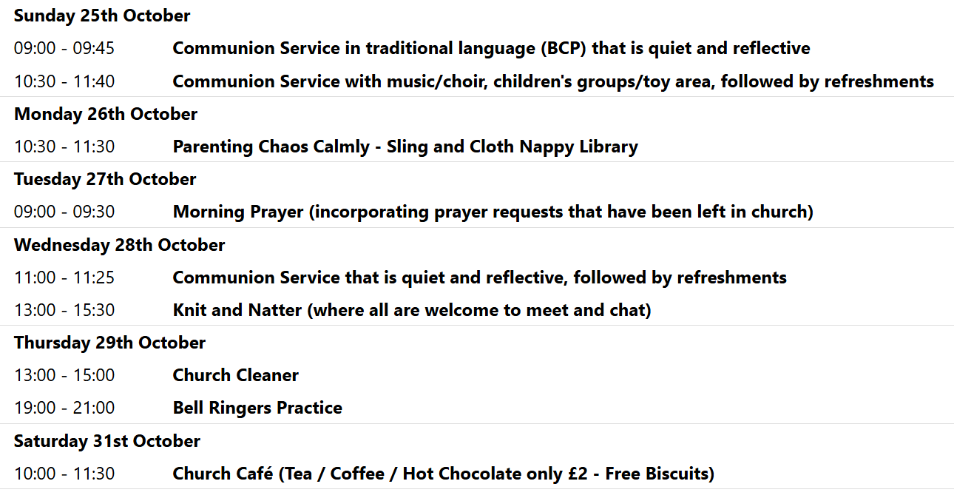
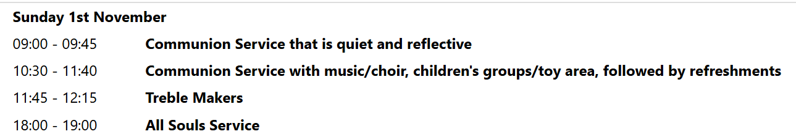

We pray for all Christians worldwide:
For all Christians in The Caribbean
For all who worship at Barley/ Barkway/ Reed Churches: Revd. Mark Bridgen
For the work of our mission partners: The Bible Society

Pray for the community of Royston:
For our local health centres
For all our local Food Bank

We pray for our world and ECO projects:
October has been designated "Unblocktober": a time to think more carefully to protect our drains, sewers and waterways by not flushing away harmful substances such as fats and non-flushable items.

We pray for the sick and suffering:
4th October | 11th October | 18th October | 25th October
Emma Thompson | Pat Tidey | Val Brown | Peter Coates
Jackson Herbert | Mike Brown | Angie & Ken Rushall | Peggy Dawes
Marion | Clare Rice | Paula Walker | Chris Stratton
Rina Marias | Max Elliott | Sandra Landels  (nee Cornwell) | Keith & Elaine Edwards

We pray for those who have died in the faith of Christ:
Deceased Bereaved

We pray for those whose anniversaries fall at this time:
Hazel Moss, Rita Easy

NOTICES

WEDNESDAY 11TH NOVEMBER please note a change of time to 10 am, this is to enable us to have a Remembrance Day Service in the park at 11 am.

PUMPKIN SOUP: We are preparing the bags of pumpkin this weekend, ready for you to make batches of soup for giving out over the Christmas open days. If you can make the soup, and freeze it, and bring it back into church on Friday 27th November, that would be great. Recipe will be available as well. Thank you in anticipation.
ALSO…..MINCE PIES: Donations of mince pies would also be welcome, to offer a sweet option, please ensure they are in date to cover Christmas period. Please leave in the kitchen.

Light Party October 31st.
Churches Together are once again running the Light Party at the Coombes Community Centre, as a Christian alternative to Halloween. The event has continued to grow year on year and many children look forward to the fun evening of games, craft, food and music. As always the party cannot happen without a band of willing volunteers and we are very grateful for those who have served in this way in the past. If you are willing to volunteer - again, or for the first time - please give your name to Duncan Rodgers. Thank you

BIBLE SOCIETY MEETING: Thursday 12th November 7.30 pm for 7.45 pm. Venue: Christ Church Royston (formerly Evangelical Church) SG8 5HJ. Guest speaker Neil Rees.

CHRISTMAS RAFFLE : We are going to run a Christmas Raffle as usual this year, with prizes of LUXURY hampers etc.
We would be very grateful for any donations towards the hamper contents. The hampers will have to be made up on Saturday 14th November and we will need your donations before then, please.
Please leave any items in the kitchen.
FOOD HAMPERS: We are looking for at least 2 good hampers plus some smaller prizes. Any LUXURY food or drink items especially Christmas foods, thank you.
TOILETRIES HAMPER: Any nice toiletries to make a small to medium sized hamper, please.
CHILDRENS HAMPER: We had a separate raffle for children last year which was well received. Any Christmas chocolates such as selection boxes, small toys, games etc.
If you need ideas and inspiration there is a suggestions list on the table at the back of Church.
This is a good fundraiser for the Church and we are very grateful for all your contributions.
THANK YOU. The Events Committee.

ANNUAL SHOEBOX APPEAL Link-to-Hope is a Christian charity which at Christmas sends shoeboxes containing gifts for poor families in Ukraine, Moldova, Bulgaria and Romania. Here at St. John's we support the shoebox appeal each year, and you are invited to join in by filling your own box during the month of October.
Please collect a leaflet from church, which suggests items you can put in your box - either for elderly folk, or for families with children. You can drop your box off at church any time, but the closing date is Sunday November 1st.. If you are unable to fill a box, you may wish instead make a financial donation towards the charity's costs. Please see Duncan Rodgers about this. THANK YOU!

