SUNDAY READING SHEET 1st November 2026 – All Saints

A Reading from the first letter of John

See what love the Father has given us, that we should be called children of God; and that is what we are. The reason the world does not know us is that it did not know him. Beloved, we are God’s children now; what we will be has not yet been revealed. What we do know is this: when he is revealed, we will be like him, for we will see him as he is. And all who have this hope in him purify themselves, just as he is pure. 1 John 3:1-3 N

GOSPEL

When Jesus saw the crowds, he went up the mountain; and after he sat down, his disciples came to him. Then he began to speak, and taught them, saying:
‘Blessed are the poor in spirit, for theirs is the kingdom of heaven.
‘Blessed are those who mourn, for they will be comforted.
‘Blessed are the meek, for they will inherit the earth.
‘Blessed are those who hunger and thirst for righteousness, for they will be filled.
‘Blessed are the merciful, for they will receive mercy.
‘Blessed are the pure in heart, for they will see God.
‘Blessed are the peacemakers, for they will be called children of God.
‘Blessed are those who are persecuted for righteousness’ sake, for theirs is the kingdom of heaven.
‘Blessed are you when people revile you and persecute you and utter all kinds of evil against you falsely on my account. Rejoice and be glad, for your reward is great in heaven, for in the same way they persecuted the prophets who were before you.

Matthew 5:1-12 New Revised Standard Version, Anglicised


If you wish to make a donation to the church, then please hold Your phone’s camera over this image then touch the link that appears:

Royston Parish Church
Where all are welcome and God’s love is shared
Sunday 1st November 2026 All Saints’ Day

If you would like regular copies of the Notice Sheet emailed to you please email the
Parish Office at admin@roystonparishchurch.org.uk

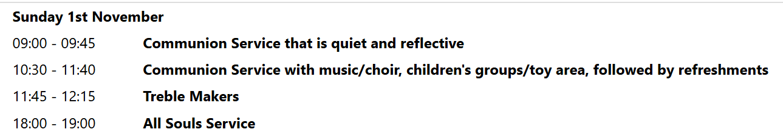
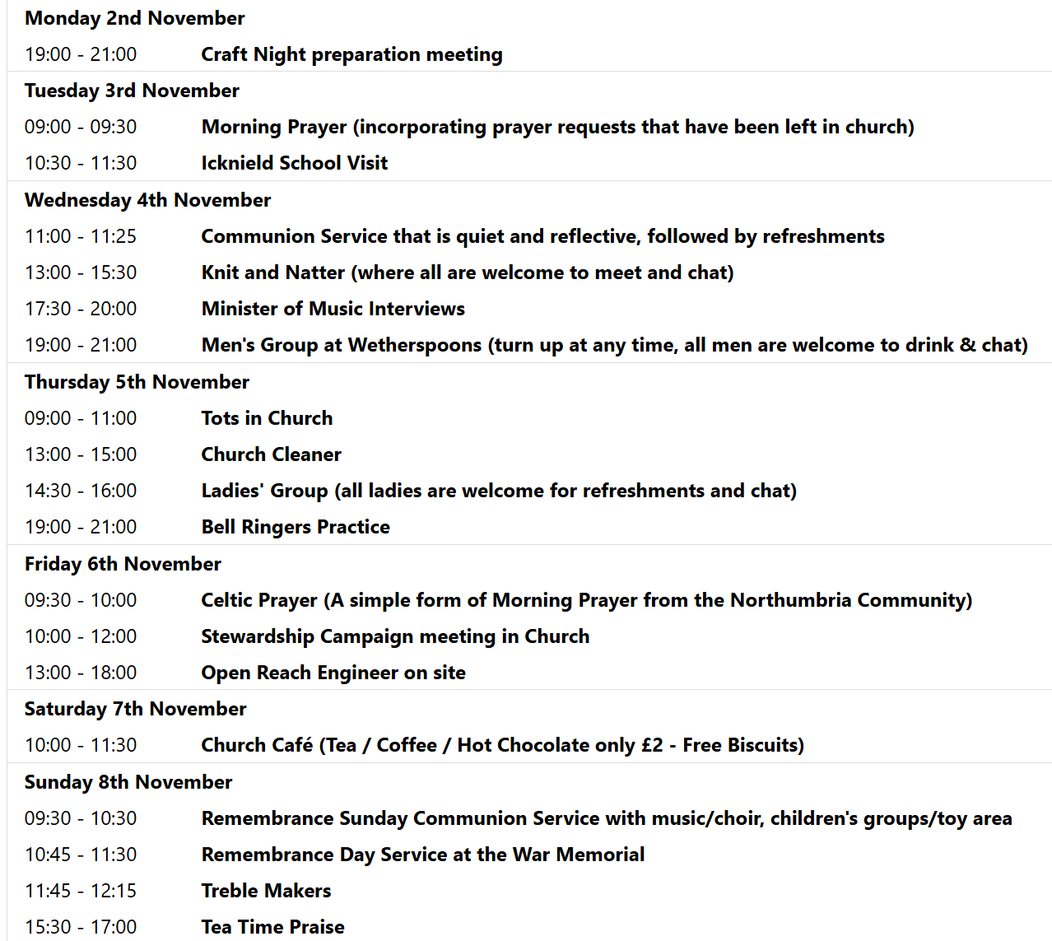

We pray for all Christians worldwide:
For all Christians in Canada, United States of America
For all who worship at Kneesworth House Hospital: Ged McHale
For the work of our mission partners: Royston Home Start

Pray for the community of Royston:
For our local health centres
For all our local Baby and Toddler Groups

We pray for our world and ECO projects:
November is World Vegan month. We pray that we may reduce our Carbon Footprint by choosing foods that have less impact on the planet.

We pray for the sick and suffering:
1st Nov | 8th Nov | 15th Nov | 22nd/29th Nov
Emma Thompson | Pat Tidey | Val Brown | Peter Coates
Jackson Herbert | Mike Brown | Angie & Ken Rushall | Peggy Dawes
Marion | Clare Rice | Paula Walker
Rina Marias | Max Elliott | Sandra Landels  (nee Cornwell) | Keith & Elaine Edwards

We pray for those who have died in the faith of Christ:
Deceased Bereaved
Chris Stratton Andrew, Frances, family and friends
Deborah King Mervyn, family and friends

We pray for those whose anniversaries fall at this time:
Arthur Wallace, Ann Milton, Malcolm Hill, Paul Wallace

NOTICES

WEDNESDAY 11TH NOVEMBER please note a change of time to 10 am, this is to enable us to have a Remembrance Day Service in the park at 11 am.

JULIAN PRAYER MEETINGS: The November Julian Prayer meeting will be Thursday 19th at 11 Middle Drift, 7pm . The December meeting will be Thursday 10th and will have an advent theme and be led by Steven .

MINCE PIES: Donations of mince pies would also be welcome, to offer a sweet option, please ensure they are in date to cover Christmas period. Please leave in the kitchen.

LIGHT PARTY OCTOBER 31ST OCTOBER
Churches Together are once again running the Light Party at the Coombes Community Centre, as a Christian alternative to Halloween. The event has continued to grow year on year and many children look forward to the fun evening of games, craft, food and music. As always the party cannot happen without a band of willing volunteers and we are very grateful for those who have served in this way in the past. If you are willing to volunteer - again, or for the first time - please give your name to Duncan Rodgers. Thank you

BIBLE SOCIETY MEETING: Thursday 12th November 7.30 pm for 7.45 pm. Venue: Christ Church Royston (formerly Evangelical Church) SG8 5HJ. Guest speaker Neil Rees.

CHRISTMAS RAFFLE : We are going to run a Christmas Raffle as usual this year, with prizes of LUXURY hampers etc.
We would be very grateful for any donations towards the hamper contents. The hampers will have to be made up on Saturday 14th November and we will need your donations before then, please.
Please leave any items in the kitchen.
FOOD HAMPERS: We are looking for at least 2 good hampers plus some smaller prizes. Any LUXURY food or drink items especially Christmas foods, thank you.
TOILETRIES HAMPER: Any nice toiletries to make a small to medium sized hamper, please.
CHILDRENS HAMPER: We had a separate raffle for children last year which was well received. Any Christmas chocolates such as selection boxes, small toys, games etc.
If you need ideas and inspiration there is a suggestions list on the table at the back of Church.
This is a good fundraiser for the Church and we are very grateful for all your contributions.
THANK YOU. The Events Committee.

ANNUAL SHOEBOX APPEAL Link-to-Hope is a Christian charity which at Christmas sends shoeboxes containing gifts for poor families in Ukraine, Moldova, Bulgaria and Romania. Here at St. John's we support the shoebox appeal each year, and you are invited to join in by filling your own box during the month of October.
Please collect a leaflet from church, which suggests items you can put in your box - either for elderly folk, or for families with children. You can drop your box off at church any time, but the closing date is Sunday November 1st.. If you are unable to fill a box, you may wish instead make a financial donation towards the charity's costs. Please see Duncan Rodgers about this. THANK YOU!

