
CANALSIDE NEWS
for AUGUST 2026

Thought from Joy

In recent years, church leaders have been encouraged to “grow younger.” I don’t mean to reverse our chronological ages, but to actively work to encourage families and young people into buildings and into our services! With this in mind in our benefice, we currently offer Breakfast Church in St. George’s and Tea@TheTin in St. Mary Magdalen, both aimed at families and those young at heart. And in September we will also be relaunching Toddlers@TheTin for pre-school children and their parents/carers. This is all in addition to our ongoing work every week in our schools. Even in the last week, welcoming our schools into church, as the Year Sixes celebrated the end of their time in Primary School. It was wonderful to see how they have grown into confident children, speaking clearly and with courage about their journey to date as they prepare for the next big step moving onto new schools.

However, most of the people who attend our churches do not attend these services, and Chris and I are fully aware that most of us are not in the first flush of youth. As our congregation grows older, how can we best serve them, and others in our villages and communities?

Providing pastoral care for the older members of our congregations is a real privilege for the ministry team, but it is not always regarded as the most direct way to create a ‘successful’ church! Too often pastoral ‘success’ has been measured by how many new people have been encouraged to attend church on a regular basis, rather than those everyday encounters we have with each other and the housebound, the elderly, the sick, and the lonely.

And yet there is something very important and special about what we do in Canalside. Ministering to each other. Holding the light of Christ aloft for those of our villages who in times of trial recognise their need for the support and comfort of the story of God. We may not be “growing younger,” but I do believe what we offer is vital and it is about ‘Making Jesus Known’ in this benefice. Not in a way that will necessarily attract masses of young people into our churches every Sunday, but in a way that is faithful to God and focused on the needs of our communities.

Canalside may not be one of the new mission hubs that are currently drawing much attention in our diocese, but we still have much work to do, keeping the light of Christ burning bright, to guide those who need it, home to God.

So I encourage you to “fear the Lord and serve him faithfully with all your heart” (1 Samuel 12:24) as we each reflect on the good things he has done for us!

Used Postage Stamps



Don’t forget to let us have all your used postage
stamps. It would be great if you could save all your
stamps and pass them on to Bill and Marilyn Stubbs
who in turn pass them on to the Bible Society. Ju st
pop them into the Storehouses boxes in the church
porches and we will pass them on for you.

Prayer Requests

It is important that we pray for all who seek our support. Please let Michael know of anyone who particularly needs our prayers. Do ensure that you have their permission.
Alison Meader | Den and Alison | Maureen Mitchell
Andrew Margetts | Edward Fairclough | Mike Aldridge
Audrey Sheppard | Eve Banks | Richard Marshman
Barbara Tucker | Helen Thomas | Roger Emes
Catherine | Hilary and Mark Heaton | 
Colin | Jeannette

• We pray for all those who are mourning the loss of a loved one at this time.
• We continue to pray for the people of Sudan at this time of conflict, including Archbishop Ezekiel as he leads the Anglican Church there.
• We pray for all those preparing for marriage this Summer and in particular for Darren and Nicola whose wedding is being held at St Michael’s on 1st August and for Graham and Arabella’s marriage at St Michael’s on 22nd August. May God Bless both couples for long, happy and healthy marriages.
• Please also hold in your prayers Miles Ethan Payne who will be baptised at St Michael’s on 30th August and their Parents, Godparents, family and friends.




RELAUNCH




Together with many other Foodbanks across the country both Melksham and Trowbridge are desperate for more donations, as the demand is very high at present, so please give as generously as you are able.

If you can donate any food or hygiene items PLEASE, pop them in our trolleys or come on down and bring them to us. If you are a little flush; you can do online shopping with ASDA as they will deliver to us on your behalf. Please drop into the building as we now do a breakfast for the homeless so eggs are always needed plus cheese, butter bacon etc as we have a fridge freezer, and fridge. Fruit and vegetables are always welcome but do not put in a trolley.
Please continue to donate to us so we can keep blessing the people of Trowbridge. Thank you all.

Please use the collection boxes in the porches of St Mary Magdalen’s and St Michael’s to drop off food donations etc. A BIG thankyou to Tony Roddis for taking on the collections for us from Bill Stubbs.
If you prefer you can make a one off financial donation or support Trowbridge Storehouse regularly, please follow the link below and select storehouse. https://westwiltsvineyard.churchsuite.co.uk/donate/fund/zk54op3a Storehouse is always in need of carrier bags

Melksham Foodbank continue to need all items, especially tinned meats and vegetables. The demand for support is very high (please ensure all items are well within the best before date). They can also take large bags of rice, tea bags, sugar & pasta as these can be decanted into smaller bags for distribution. Please take your donations to the porch at St George’s, Semington before 6pm on Wednesday.

Our continued support of Melksham FoodBank and Trowbridge StoreHouse is vital, and a part of our response to God’s generosity to us.

CANALSIDE DIARY
Please pray for all events taking place in the next few weeks

Day | Date | Time | Event details | Location
J U L Y 2 0 2 6
Su | 26th | THE EIGHTH SUNDAY AFTER TRINITY
Su | 26th | 1030 | ‘Explore’ Service | St Mary Magdalen’s
Su | 26th | 1600 | Tea@theTin | St Mary Magdalen’s
Tu | 28th | 0930 | Hilperton/Staverton Morning Prayer  (NOT online – IN PERSON) | St Michael’s
W | 29th | 1000 | Midweek Communion | St Michael’s
Th | 30th | 0900 | Semington Morning Prayer  https://us06web.zoom.us/j/88553953942?pwd=1EHGGg18bBqqYKytMMRbYvZ5JZFZNm.1 | Online
A U G U S T 2 0 2 6
Sa | 1st | 1600 | Wedding:  Darren and Nicola | St Michael’s
Su | 2nd | THE NINTH SUNDAY AFTER TRINITY and LAMMAS
Su | 2nd | 1030 | Holy Communion | St Michael’s
Su | 2nd | 1500 | Service of BCP Holy Communion | St Mary the Virgin
Su | 2nd | 1800 | Songs of Praise | St Mary Magdalen’s
Tu | 4th | 0930 | Hilperton/Staverton Morning Prayer  https://us06web.zoom.us/j/89678887943?pwd=IKy2vBYNviwibNcoWUpqTtf4hpwQTA.1 | Online
W | 5th | 1000 | Midweek Morning Worship | St Michael’s
Th | 6th | 0900 | Semington Morning Prayer  Use link above | Online
Su | 9th | THE TENTH SUNDAY AFTER TRINITY
Su | 9th | 0915 | Breakfast Church | St George’s Church
Su | 9th | 1030 | Holy Communion | St Mary Magdalen’s
Tu | 11th | 0930 | Hilperton/Staverton Morning Prayer  Use link above | Online
W | 12th | 1000 | Midweek Communion | St Michael’s
Th | 13th | 0900 | Semington Morning Prayer  Use link above | Online
Th | 13th | 1430 | Friendship Group | St Mary Magdalen’s
Su | 16th | THE ELEVENTH SUNDAY AFTER TRINITY
Su | 16th | 0915 | Holy Communion | St George’s Church
Su | 16th | 1030 | Holy Communion | St Michael’s
Tu | 18th | 0930 | Hilperton/Staverton Morning Prayer  See link above | Online
W | 19th | 1000 | Midweek Morning Worship | St Michael’s
Th | 20th | 0900 | Semington Morning Prayer  Use link above | Online
Th | 20th | 1000  1200 | Community Café | St Mary Magdalen’s
Sa | 22nd | 1400 | Wedding:  Graham and Arabella | St Michael’s
Su | 23rd | THE TWELFTH SUNDAY AFTER TRINITY
Su | 23rd | 1030 | ‘Explore’ Service | St Mary Magdalen’s
Tu | 25th | 0930 | Hilperton/Staverton Morning Prayer  (NOT online – IN PERSON) | St Michael’s
W | 26th | 1000 | Midweek Communion | St Michael’s
Th | 27th | 0900 | Semington Morning Prayer  Use link above | Online
Sa | 29th | Visiting Bell Ringers |  | St Michael’s
Su | 30th | THE THIRTEENTH SUNDAY AFTER TRINITY
Su | 30th | 0915 | Benefice Holy Communion | St George’s
Su | 30th | 1215 | Baptism:  Miles Ethan Payne | St Michael’s
M | 31st | BANK HOLIDAY
S E P T E M B E R 2 0 2 6
Tu | 1st | 0930 | Hilperton/Staverton Morning Prayer  See link above | Online
W | 2nd | 1000 | Midweek Communion | St Michael’s
Th | 3rd | 0900 | Semington Morning Prayer  Use link above | Online
Su | 6th | THE FOURTEENTH SUNDAY AFTER TRINITY and CREATIONTIDE
Su | 6th | 1030 | Holy Communion | St Michael’s
Su | 6th | 1500 | Service of BCP Holy Communion | St Mary the Virgin
Su | 6th | 1800 | Reflective Service | St Mary Magdalen’s


CANALSIDE CONTACTS
Rector | Rev. Chris Hunter | 07396875236  01225 975510 | rector.canalside@gmail.com
Associate Priest | Rev. Joy Albone | 07931638524 | revjoyalbone@gmail.com
Office | Michael Gamble | 07795400262 | canalsideoffice@gmail.com
Churchwardens
Semington | David Wildsmith | c/o 01380 870784 | c/o jackbev.woodward@gmail.com
Hilperton and Staverton | James Newton | 07803904947 | jpnewton@churchmouse.org.uk
Hilperton and Staverton | Martyn Carpenter | 07831309377 | martyncarpenter55@gmail.com
Website | canalsideparishes.co.uk
Facebook | https://www.facebook.com/canalsideparishes

"IT'S NOT EASY BEING GREEN"



So sang Kermit the Frog -- and we're inclined to agree with him. "Green" products can be costly and difficult to obtain, especially for those who don't have internet access. However, there are inexpensive products that most of us already have in our homes and which we could use to good effect without harming the environment:
 Ugly water marks and limescale? Distilled vinegar will remove those white marks from your stainless steel sink or the limescale ring inside that tumbler you keep on your bedside table. It even works in the toilet bowl! First, remove as much of the water as you can. Next, pour in vinegar up to the normal water level & leave overnight. Finally, give the toilet bowl a good scrub.
 For regular toilet cleaning, sprinkle bicarbonate of soda around the bowl immediately after flushing, then spray or pour distilled vinegar over the bicarb to cause a fizzing reaction. Leave for 30 minutes, then scrub thoroughly with a toilet brush before flushing to rinse.
 Taps encrusted with limescale? Simply scrape it off with a 2p coin (harder than limescale but softer than stainless steel or chrome).
 Grubby glazing? Fill a spray bottle with equal parts of distilled vinegar and water and use it to clean your windows and mirrors.
 Need an air freshener? Make as above (with the addition of a few drops of essential oil, if you wish) and spray away. The vinegar smell will quickly fade, taking unwanted odours with it.
 Grimy hob? Mix bicarbonate of soda with water to create a paste. When the hob is cool, smear the paste over any burnt spills or greasy spots. Leave it to work for 30 minutes, then wipe off.
 Stained teaspoons? A little bicarbonate of soda on a damp cloth will wipe away those tea stains with ease.
 Please try these for yourself. They really do work!

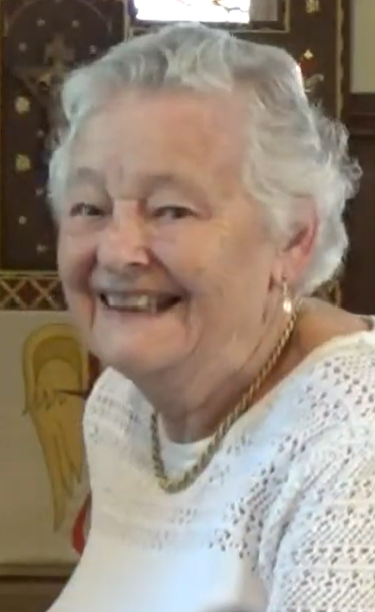
On 19th July we said farewell to Judith Phillips who is moving to Larkhall in Bath. She has worshipped in Hilperton for many years and will be greatly missed. Good Luck with the move Judith and we pray that you will be blessed in your new home with good health and happiness.











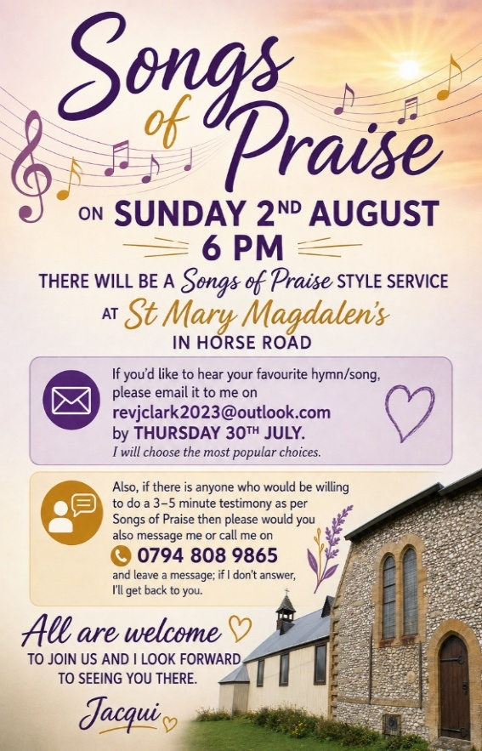



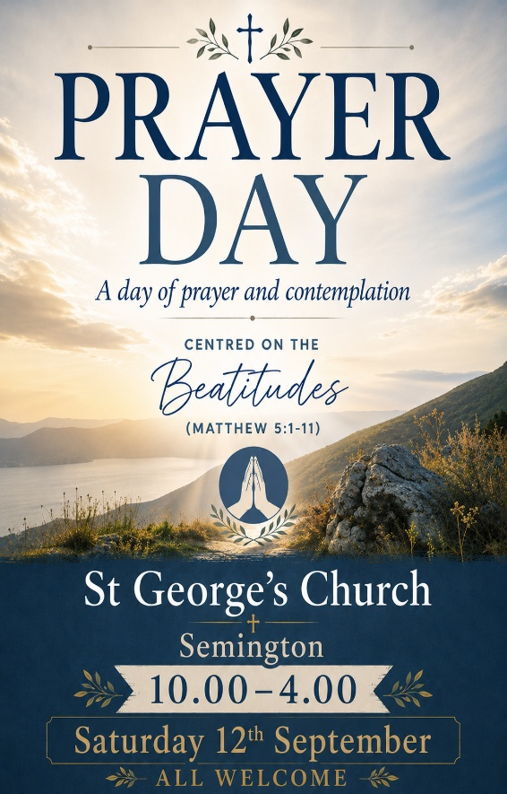



If you could help us with this event please contact Chris asap

