SUNDAY MORNING READING SHEET 20th September 16th Sunday after Trinity
A Reading from the Book of Jonah
When God saw what they did, how the people of Nineveh turned from their evil ways, God changed his mind about the calamity that he had said he would bring upon them; and he did not do it. But this was very displeasing to Jonah, and he became angry. He prayed to the Lord and said, ‘O Lord! Is not this what I said while I was still in my own country? That is why I fled to Tarshish at the beginning; for I knew that you are a gracious God and merciful, slow to anger, and abounding in steadfast love, and ready to relent from punishing. And now, O Lord, please take my life from me, for it is better for me to die than to live.’ And the Lord said, ‘Is it right for you to be angry?’ Then Jonah went out of the city and sat down east of the city, and made a booth for himself there. He sat under it in the shade, waiting to see what would become of the city. The Lord God appointed a bush, and made it come up over Jonah, to give shade over his head, to save him from his discomfort; so Jonah was very happy about the bush. But when dawn came up the next day, God appointed a worm that attacked the bush, so that it withered. When the sun rose, God prepared a sultry east wind, and the sun beat down on the head of Jonah so that he was faint and asked that he might die. He said, ‘It is better for me to die than to live.’ But God said to Jonah, ‘Is it right for you to be angry about the bush?’ And he said, ‘Yes, angry enough to die.’ Then the Lord said, ‘You are concerned about the bush, for which you did not labour and which you did not grow; it came into being in a night and perished in a night. And should I not be concerned about Nineveh, that great city, in which there are more than a hundred and twenty thousand people who do not know their right hand from their left, and also many animals?’ Jonah 3: 10, 4:1-11

GOSPEL
Jesus said:
‘For the kingdom of heaven is like a landowner who went out early in the morning to hire labourers for his vineyard. After agreeing with the labourers for the usual daily wage, he sent them into his vineyard. When he went out about nine o’clock, he saw others standing idle in the market-place; and he said to them, “You also go into the vineyard, and I will pay you whatever is right.” So they went. When he went out again about noon and about three o’clock, he did the same. And about five o’clock he went out and found others standing around; and he said to them, “Why are you standing here idle all day?” They said to him, “Because no one has hired us.” He said to them, “You also go into the vineyard.” When evening came, the owner of the vineyard said to his manager, “Call the labourers and give them their pay, beginning with the last and then going to the first.” When those hired about five o’clock came, each of them received the usual daily wage. Now when the first came, they thought they would receive more; but each of them also received the usual daily wage. And when they received it, they grumbled against the landowner, saying, “These last worked only one hour, and you have made them equal to us who have borne the burden of the day and the scorching heat.” But he replied to one of them, “Friend, I am doing you no wrong; did you not agree with me for the usual daily wage? Take what belongs to you and go; I choose to give to this last the same as I give to you. Am I not allowed to do what I choose with what belongs to me? Or are you envious because I am generous?” So the last will be first, and the first will be last.’ Matthew 20:1-16


If you wish to make a donation to the church, then please hold Your phone’s camera over this image then touch the link that appears:

Royston Parish Church
Where all are welcome and God’s love is shared
Sunday 20TH September 2026 – 16TH Sunday after Trinity

If you would like regular copies of the Notice Sheet emailed to you please email the
Parish Office at admin@roystonparishchurch.org.uk

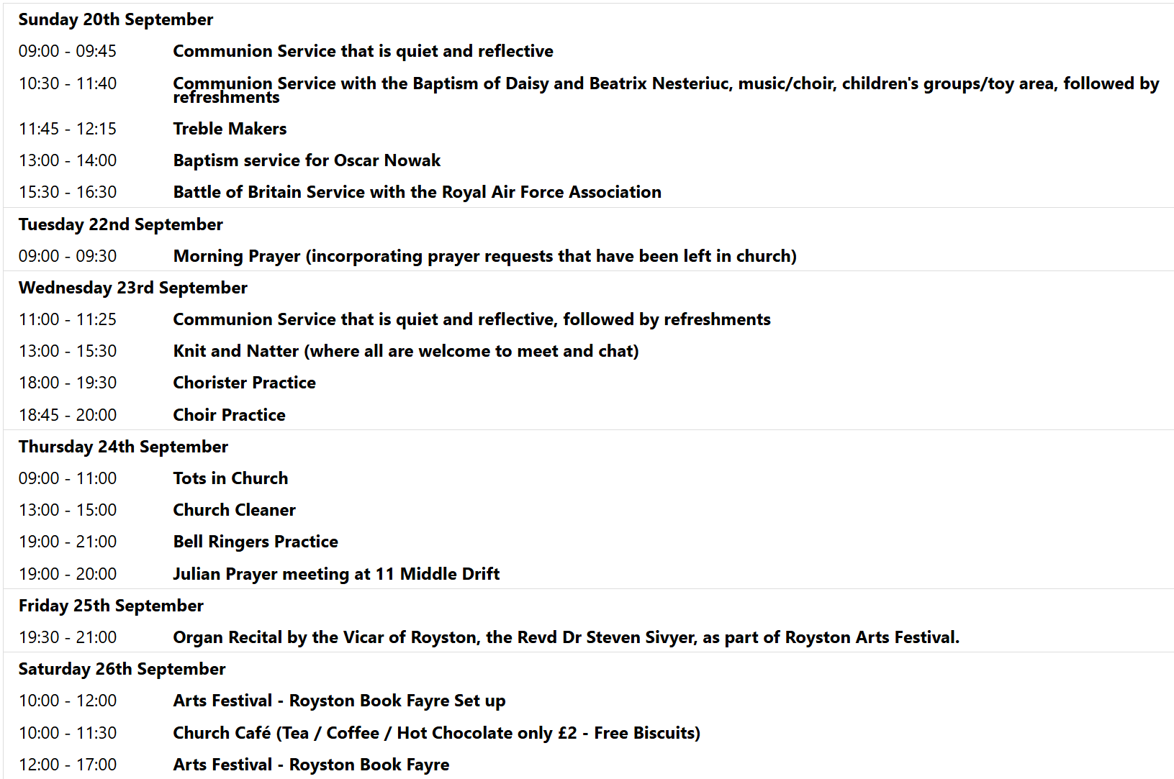
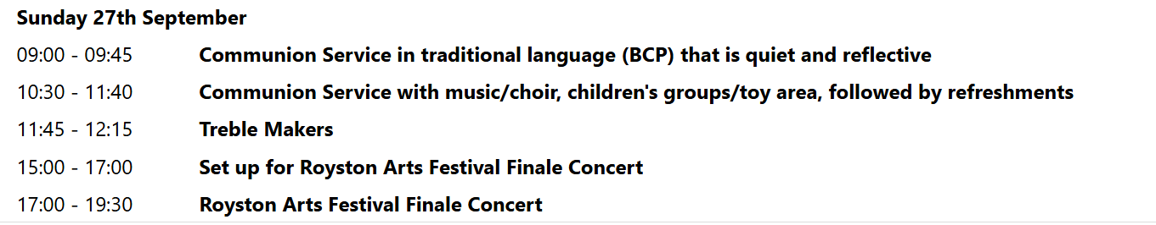

We pray for all Christians worldwide:
For all Christians in Argentina, Paraguay, Uruguay
For all who worship at Melbourn Baptist Church: Rob & Jenny Hughes
For the work of our mission partners: Church Mission Society (CMS)
Pray for the community of Royston:
For our local health centres
For all who volunteer and make use of Royston Community Transport
We pray for our world and ECO projects:
Fair Trade Fortnight 22nd September to 5th October

We pray for the Rt. Revd Andrew Rumsey installed on the 19th September as the 11th Bishop of St Albans
We pray for all who may be considering applying for our Minister of Music.

We pray for the sick and suffering:
6th September | 13th Sept | 20th Sept | 27th Sept
Emma Thompson | Pat Tidey | Val Brown | Peter Coates
Jackson Herbert | Mike Brown | Angie & Ken Rushall | Peggy Dawes
Marion | Clare Rice | Paula Walker | Peter Foster
Barbara Goy | Max Elliott | Sandra Landels  (nee Cornwell) | Keith & Elaine Edwards
Chris Stratton

We pray for those who have died in the faith of Christ:
Deceased Bereaved
Sylvia Penn Family and friends
We pray for those whose anniversaries fall at this time:
Sarah Milton, Maureen Pendrick

NOTICES

THE INSTALLATION OF THE RT REVD ANDREW RUMSEY AS THE 11TH BISHOP OF ST ALBANS tok place on Saturday 19th September at 2pm. If you would like to follow this, then you can watch it through this link: https://www.youtube.com/watch?v=A81P_yOK9vU

THANK YOU TO EVERYONE WHO HELPED LAST Saturday for the Heritage Open Day in so many ways. We had over 600 people come into church and it also raised over £650 for the church’

HELP WANTED TO HOST SOME PEOPLE: We have our town's twinning exchange coming up soon and I would to have some help please in hosting some people. They are due to arrive on the morning of Friday 9th October and will be leaving following the 10.30am service on Sunday 11th October. If you feel you could put up any of the following people for the two nights and host them whilst they are with us then please could you let me know (my email address is: vicar@roystonparishchurch.org.uk). If you are willing to do this but cannot commit to some of the time such as you are at work on the Friday or you have something on for part of the Saturday then please still let me know as I or others may be able to cover that. There are the people who need hosts:
Sivia is 62 and enjoys swimming, reading, gardening and travelling.
Regina Lui is 68 and enjoys singing, gardening and church life.
Please be aware that she requires her own room due to medical reasons.
Anja zur Nieden who is 60 and likes dogs, travelling, music and football
Anja & Regina could be hosted together if helpful.
Jurgen is 71 and enjoys sport, walking, music, dancing, travelling and politics.
Lara is 24 and enjoys walking, shopping, games and events.
Thank you Steven


HARVEST SUPPER: SATURDAY 3rd OCTOBER 6:00 pm: In Church, Tickets £12 individual / £30 family. Supper includes casserole, cottage pie or vegetarian alternative, with fruit crumble for dessert. Drinks available to buy. Entertainment included. To book please go to https://tickets.myiknowchurch.co.uk/gb/NzcwMi0zNw/t
or scan the QR code


FRIDAY 25TH SEPTEMBER 7.30 PM – 9 PM, ARTS FESTIVAL ORGAN RECITAL: in Church, with Steven Sivyer playing the Organ. Tickets in advance are £10 for adults or £3 for under 18s in advance at https://bit.ly/ArtsFestivalOrgan or scan the QR code
Doors open from 7 pm, refreshments will be served.
AND; SATURDAY 26TH SEPTEMBER 10 AM TO 4 PM, ARTS FESTIVAL BOOK FAYRE: in Church,

HELP WANTED! We have events coming up during September, for which we'd like donations of cakes, and help to serve refreshments. We have the Arts Festival running a book fayre in our church building on Saturday 26th, during which we'll be selling refreshments, the proceeds of which will go to church funds. If you're able to spare an hour or more to help, or can make a cake or batch of scones for either event, please can you sign up on the sheets at the back of church. Thank you from the Events Committee.

