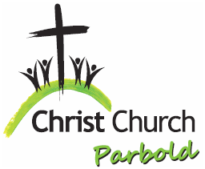
Christ Church Parbold September Services
Join us for our usual varied mix of services and activities.
Sunday’s (except 6th & 20th) 8:00am – Holy Communion
Quiet, reflective, said services.
Sunday’s, 10:30am – Worship Service
Friendly and uplifting worship services, with something for everyone.
Wednesday’s, 10:30am – Service of Holy Communion at Parbold WI (Resumes 16th) Light refreshments follows.
For Families & Children
Sundays, 10:30am – Worship Services
Children are warmly included with plenty to enjoy in our Tots’ Corner, Lending Library and Resource Areas.
Sunday 6th Sep, 9:30am – Family Service. Everyone is welcome to this fun, interactive service which is for all ages. Theme: Praise God.
Sunday 13th Sep 10:30am – Junior Church
Meeting in the Scout Hut with activities and learning for ages 4–13.
Sunday 20th 9:30am – Muddy Church at the Hut
An hour of outdoor fun and craft activities for all ages, whatever the weather! Theme: ‘Thank you God for the Harvest’.
Sunday 27th Jun, 10:30am – All Age Harvest Festival Service. Our traditional Harvest Festival service is for all ages.
Youth
Sunday’s, 13th & 27th Sep, 6:00pm – Soul Action Café at the Hut
A relaxed, faith-based group for ages 12+.
Special Evening Service
Sunday 20th Sept, 7:30pm – ‘Encounter’ Graham, the Praise Band along with guest speaker Peter Wood invites you to an evening of modern praise, worship and teaching. Light refreshments served. ■ Weekly Faith Moments available from Geoff: christchurchparbold.admn@gmail.com

