SUNDAY MORNING READING SHEET 6th September 14th CREATIONTIDE
The Reading of Prophecy of Jeremiah
The word of the Lord that came to Jeremiah concerning the drought:
Judah mourns and her gates languish; they lie in gloom on the ground, and the cry of Jerusalem goes up. Her nobles send their servants for water; they come to the cisterns,
they find no water, they return with their vessels empty. They are ashamed and dismayed and cover their heads, because the ground is cracked. Because there has been no rain on the land the farmers are dismayed; they cover their heads. Even the doe in the field forsakes her newborn fawn because there is no grass. The wild asses stand on the bare heights, they pant for air like jackals; their eyes fail because there is no herbage. Although our iniquities testify against us, act, O Lord, for your name's sake; our apostasies indeed are many, and we have sinned against you. O hope of Israel, its saviour in time of trouble, why should you be like a stranger in the land, like a traveller turning aside for the night? Why should you be like someone confused, like a mighty warrior who cannot give help? Yet you, O Lord, are in the midst of us, and we are called by your name; do not forsake us! Thus says the Lord concerning this people: Truly they have loved to wander, they have not restrained their feet; therefore the Lord does not accept them, now he will remember their iniquity and punish their sins. Jeremiah 14:1-10

GOSPEL
Jesus told the crowd a parable: 'The land of a rich man produced abundantly. And he thought to himself, "What should I do, for I have no place to store my crops?" Then he said, "I will do this: I will pull down my barns and build larger ones, and there I will store all my grain and my goods. And I will say to my soul, Soul, you have ample goods laid up for many years; relax, eat, drink, be merry." But God said to him, "You fool! This very night your life is being demanded of you. And the things you have prepared, whose will they be?" So it is with those who store up treasures for themselves but are not rich towards God.' He said to his disciples, 'Therefore I tell you, do not worry about your life, what you will eat, or about your body, what you will wear. For life is more than food, and the body more than clothing. Consider the ravens: they neither sow nor reap, they have neither storehouse nor barn, and yet God feeds them. Of how much more value are you than the birds! And can any of you by worrying add a single hour to your span of life? If then you are not able to do so small a thing as that, why do you worry about the rest? Consider the lilies, how they grow: they neither toil nor spin; yet I tell you, even Solomon in all his glory was not clothed like one of these. But if God so clothes the grass of the field, which is alive today and tomorrow is thrown into the oven, how much more will he clothe you—you of little faith! And do not keep striving for what you are to eat and what you are to drink, and do not keep worrying. For it is the nations of the world that strive after all these things, and your Father knows that you need them. Luke 12:16-30

BEDS & HERTS HISTORIC CHURCHES TRUST SPONSORED BIKE ‘N HIKE - SATURDAY 12TH SEPTEMBER 2026: Last year we in Royston we raised over £ 2,000 which was divided between BHHCT and our own parish funds. This earned us a Gold Certificate and we were one of only 11 churches that raised more than £ 2,000. We hope to do just as well or better this year. Select your own route for cycling or hiking between the churches – there are over 600 churches to choose from so make it as long or as short as you wish. Most churches will be open on the day. The Sponsorship Packs are now available and if you would like a sponsor form, please go online www.bedshertshct.org.uk or contact Mike Maze (245606 or mikefmaze@aol.com) There is always the easier option which is to sponsor one of the participants using their Sponsor form or if online giving suits you best, please visit:- Sponsor Rodney & Matt Dyer or Sponsor Mike Maze

Royston Parish Church
Where all are welcome and God’s love is shared
Sunday 6th September 2026 –14th Sunday after Trinity

If you would like regular copies of the Notice Sheet emailed to you please email the
Parish Office at admin@roystonparishchurch.org.uk

CREATIONTIDE BEGINS
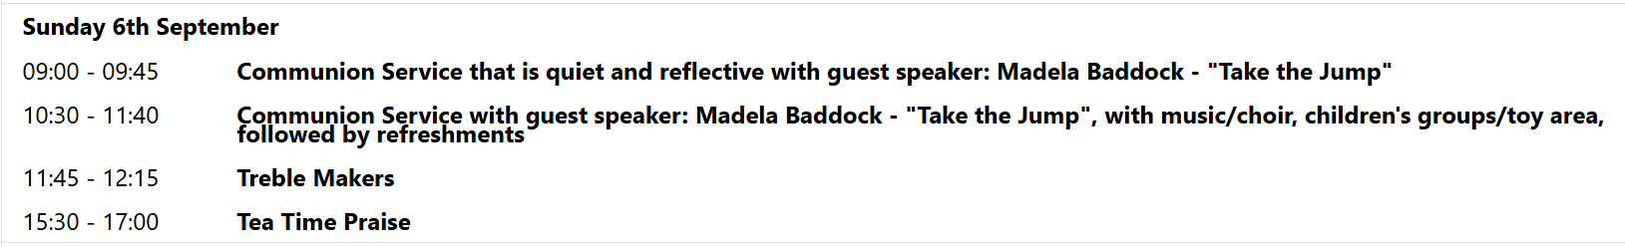
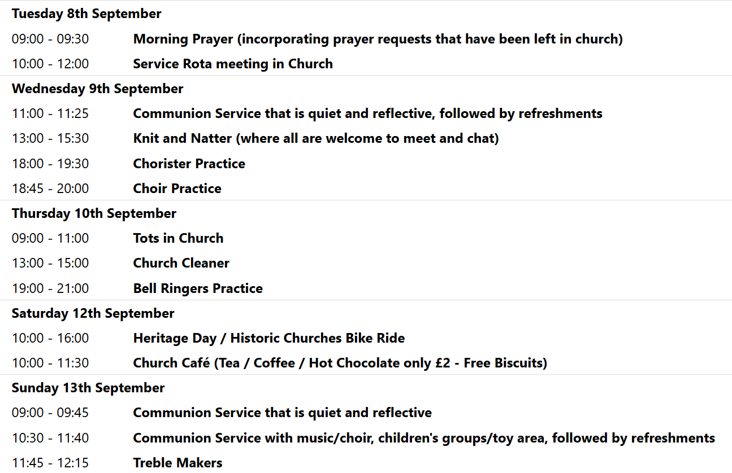

We pray for all Christians worldwide:
For all Christians in Benin, Ivory Coast, Togo
For all who worship at Trinity Life Church: Peter Chapman
For the work of our mission partners: Royston Home Start

Pray for the community of Royston:
For our local health centres
For all our local Road sweepers and those who empty our bins

We pray for our world and ECO projects:
The first week in September is "Zero Waste Week" (see zerowasteweek.co.uk) in which we are encourage to reduce our waste and set goals to reuse, recycle and repurpose.

We pray for the sick and suffering:
6th September | 13th Sept | 20th Sept | 27th Sept
Emma Thompson | Pat Tidey | Val Brown | Peter Coates
Jackson Herbert | Mike Brown | Angie & Ken Rushall | Peggy Dawes
Marion | Clare Rice | Paula Walker | Peter Foster
Barbara Goy | Max Elliott | Sandra Landels  (nee Cornwell) | Keith & Elaine Edwards

We pray for those who have died in the faith of Christ:
Deceased Bereaved
Sylvia Penn Family and friends
We pray for those whose anniversaries fall at this time:
John Salmon, Dorothy Priest, Herbert Williams, Revd. John Gardiner


If you wish to make a donation to the church, then please hold Your phone’s camera over this image then touch the link that appears:

NOTICES

ROYSTON PARISH CHURCH GAINS “ECO CHURCH SILVER AWARD”!
Royston Parish church has been participating in the A Rocha Eco Church scheme since 2021. This includes completing a survey to consider what actions our church is taking to care for creation and reduce our carbon footprint. The survey covers five categories: worship & teaching, buildings & energy, land & nature, community & global engagement, and lifestyle. We achieved the bronze award in 2022, and since then have been using the survey as a framework to inspire us to take further action. We are excited to announce that our church community has just been awarded “Eco Church Silver”. Our speaker for creationtide, Madela Baddock, will be presenting us with the plaque to celebrate this achievement on Sunday 6th September.

PLASTIC BOXES: Chris would be very pleased to receive any plastic boxes, that fruit come in, the size used for grapes. Please just leave on the Jam table. Thank you

SPEAKER FOR CREATIONTIDE: MADELA BADDOCK FROM "TAKE THE JUMP"
Our Creationtide speaker this year is Madela Baddock, an ambassador for "Take the Jump", a grass-roots climate-action movement that encourages people to adopt six practical shifts for a more sustainable lifestyle. She will be speaking to us at both the 9am and the 10:30am services on Sunday 6th September. Creationtide is the period in the church calendar from 1st September (the World Day of Prayer for Creation) to 4th October (the Feast of St Francis of Assisi, patron saint of ecology). Our previous guest speakers for this season have included Oliver Franklin-Wallis speaking about his book, "Wasteland", and Professor Rachel Warren who spoke on "Climate Change: Science and Solutions". We look forward to welcoming Madela on 6th September.
For more information about "Take the Jump", see their website: www.takethejump.org


HARVEST SUPPER: SATURDAY 3rd OCTOBER 6:00 pm: In Church, Tickets £12 individual / £30 family. Supper includes casserole, cottage pie or vegetarian alternative, with fruit crumble for dessert. Drinks available to buy. Entertainment included. To book please go to https://tickets.myiknowchurch.co.uk/gb/NzcwMi0zNw/t
or scan the QR code

SAVE THE DATES: We have a HERITAGE OPEN DAY in Church on Saturday 12th September 10 am – 4 pm. Free entry. Join us for a day of discovery about where we live. The Royston Tapestry on full display at the Parish Church, as well as demonstration of the organ and bells and tours of the church and refreshments. Donations welcome on the day.


ALSO : FRIDAY 25TH SEPTEMBER 7.30 PM – 9 PM, ARTS FESTIVAL ORGAN RECITAL: in Church, with Steven Sivyer playing the Organ. Tickets in advance are £10 for adults or £3 for under 18s in advance at https://bit.ly/ArtsFestivalOrgan or scan the QR code
Doors open from 7 pm, refreshments will be served.
AND; SATURDAY 26TH SEPTEMBER 10 AM TO 4 PM, ARTS FESTIVAL BOOK FAYRE: in Church,

HELP WANTED! We have 2 events coming up during September, for which we'd like donations of cakes, and help to serve refreshments. We have the Heritage Open Day on Saturday 12th, and the Arts Festival is running a book fayre in our church building on Saturday 26th, during which we'll be selling refreshments, the proceeds of which will go to church funds. If you're able to spare an hour or more to help, or can make a cake or batch of scones for either event, please can you sign up on the sheets at the back of church. Thank you from the Events Committee.

