

Holy Communion

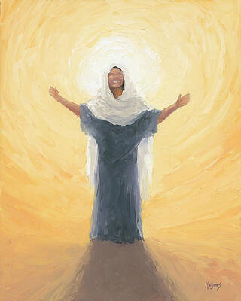

with the

Welcome of a New Deacon

Kingsbridge Estuary Churches Mission Community:
All Saints, West Alvington; St Edmund, King and Martyr, Kingsbridge;
St Thomas of Canterbury, Dodbrooke

THE GATHERING

Welcome, Notices and Banns of Marriage

Processional Hymn:
Christ Is The One Who Calls (487)

The Greeting

In the name of the Father, and of the Son, and of the Holy Spirit.
Amen.

The Lord be with you.
And also with you.

Words of Welcome
The Rural Dean welcomes the congregation and introduces the newly ordained Deacon.

Prayers of Penitence
The Deacon leads:

A deacon is called to serve the Church and the world, remembering our need for God’s grace. Let us confess our sins in penitence and faith.

We have not held out the word of life
In a dark and twisted world:
Lord have mercy.
Lord have mercy.

We have failed to share our bread with the hungry.
Christ have mercy.
Christ have mercy.

We have closed our hearts to the love of God.
Lord have mercy.
Lord have mercy.

The Absolution
The Rural Dean gives the Absolution:

Almighty God, who forgives all who truly repent,
have mercy upon you, pardon and deliver you from all your sins,
confirm and strengthen you in all goodness,
and keep you in life eternal; through Jesus Christ our Lord.
Amen.

The Collect Prayer for Newly Ordained Deacons
God our Father, Lord of all the world,
Through your Son you have called us
into the fellowship of your universal Church;
Hear our prayer for your faithful people,
That in their vocation and ministry
Each may be an instrument of your love,
And give to your servants, newly ordained Deacon,
The needful gifts of grace: Through our Lord and Saviour, Jesus Christ,
Who is alive and reigns with you, In the unity of the Holy Spirit,
One God, now and forever.
Amen.

THE LITURGY OF THE WORD

First Reading
1 John 4:7-17 read by ???

This is the word of the Lord.
Thanks be to God.

Gradual Hymn:
Christ Be Our Light (42)

The Gospel Reading
John 13: 1-17 read by the Deacon.

Alleluia, alleluia!
The words that I have spoken to you are spirit,
And they are life, says the Lord.
Alleluia!

Hear the Gospel of our Lord Jesus Christ according to St Matthew.
Glory to you, O Lord.

At the end:
This is the Gospel of the Lord.
Praise to you, O Christ.
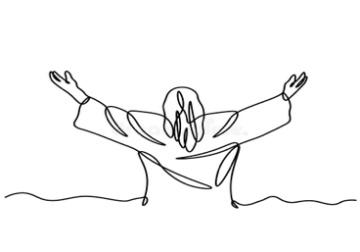
The Sermon
The Presentation of the Deacon
The Churchwardens and Rural Dean stand with the new Deacon before the congregation:

People of God, we welcome Amanda Sarjeant, who has been ordained Deacon to serve among us. Will you support and uphold her in this ministry?
We will.

Mandy, receive this Bible as a sign of your authority to proclaim the Gospel of Christ, and to serve His people; building them up in His truth.
Deacon: Amen. By God's grace, I will.

The Deacon speaks to the people:

We preach not ourselves but Christ Jesus as Lord,
And ourselves as your servants, for Jesus’ sake.
We welcome you as a fellow servant in the gospel.
May Christ dwell in your heart through faith,
That you may be rooted and grounded in love.

The congregation welcome Mandy.

The Prayers of Intercession
Given by the Deacon
The prayers conclude with:
Merciful Father,
Accept these prayers for the sake of your Son,
our Saviour Jesus Christ.
Amen.

THE LITURGY OF THE SACRAMENT

The Peace
We are all one in Christ Jesus.
We belong to him, and he belongs to us.
The peace of the Lord be always with you.
And also with you.

Deacon: Let us offer one another a sign of peace.
The congregation shares the Peace.


Offertory Hymn:
Take My Life and Let It Be. (787)

During this hymn, the Deacon assists with the preparation of the sets the altar table.

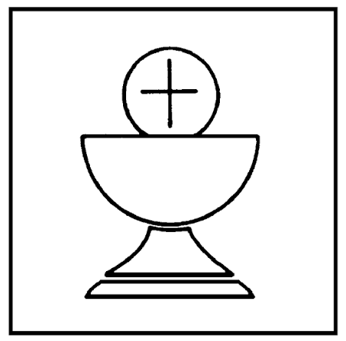
The Eucharistic Prayer

The Lord be with you.
And also with you.
Lift up your hearts.
We lift them to the Lord.

Let us give thanks to the Lord our God.
It is right to give thanks and praise.

It is right to praise you, Father, Lord of all creation;
in your love you made us for yourself.
When we turned away, you did not reject us
but came to meet us in your Son.
You embraced us as your children
and welcomed us to sit and eat with you.

In Christ you shared our life that we might live in him and he in us.
He opened his arms of love upon the cross
and made for all the perfect sacrifice for sin.

On the night he was betrayed, at supper with his friends,
he took bread and gave you thanks;
he broke it and gave it to them, saying:
Take, eat; this is my body which is given for you;
do this in remembrance of me.
Father, we do this in remembrance of him:
his body is the bread of life.

At the end of supper, taking the cup of wine, he gave you thanks,
and said: Drink this, all of you; this is my blood of the new covenant,
which is shed for you for the forgiveness of sins;
do this in remembrance of me.
Father, we do this in remembrance of him:
his blood is shed for all.

As we proclaim his death and celebrate his rising in glory,
send your Holy Spirit that this bread and this wine
may be to us the body and blood of your dear Son.
As we eat and drink these holy gifts
make us one in Christ, our risen Lord.
With your whole Church throughout the world
we offer you this sacrifice of praise
and lift our voice to join the eternal song of heaven:
Holy, holy, holy Lord, God of power and might,
heaven and earth are full of your glory.
Hosanna in the highest.
Blessed is he who comes in the name of the Lord.
Hosanna in the highest.

The Lord's Prayer

Deacon: Let us pray with confidence as our Saviour has taught us:
Our Father, who art in heaven, Hallowed be thy name;
Thy kingdom come; Thy will be done; On earth as it is in Heaven.
Give us this day our daily bread,
And forgive us our trespasses,
As we forgive those who trespass against us.
And lead us not into temptation; But deliver us from evil.
For thine is the kingdom, the power and the glory,
Forever and ever,
Amen.

Breaking of the Bread

We break this bread to share in the body of Christ.
Though we are many, we are one body,
because we all share in one bread.

Giving of Communion

Jesus is the Lamb of God
who takes away the sin of the world.
Blessed are those who are called to his supper.
Lord, I am not worthy to receive you,
but only say the word, and I shall be healed.

We receive Holy Communion. All are welcome to the Lord’s Table.
The new Deacon assists by administering the chalice.

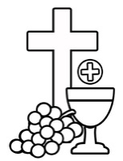
Prayer after Communion

Lord God, heavenly Father,
Grant to your church today
The faith of her apostles,
The hope of her martyrs
And the love of her Lord,
Our Saviour, Jesus Christ.
Amen

The Blessing

May the Father, whose glory fills the heavens,
Cleanse you by his holiness;
And send you to proclaim his word.
Amen.

May Christ, who has ascended to the heights,
Pour upon you the riches of his grace.
Amen.

May the Holy Spirit, the comforter,
Equip you and strengthen you in your ministry.
Amen.

+And the blessing of God almighty …
Amen.

The Dismissal
The Deacon dismisses the congregation, sending them out into the world to serve.

Go in the peace of Christ. Alleluia. Alleluia!
Thanks be to God. Alleluia. Alleluia!

Recessional Hymn: O Jesus I Have Promised (tune: Hatherop Castle) (748)



