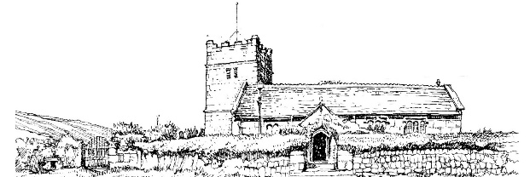
TOWEDNACK CHURCH NEWS
OCTOBER and NOVEMBER
In the June news we reported that we were delighted to see that the Towednack swallows had returned to build a new nest in our porch and that they were busy raising a family. We are pleased to report that they are still here in a new nest with a second family. During this year’s hot summer, it has been a great pleasure to be able to hear them chirping away during our Sunday services.
This photo was taken on 6th September by Ellen Carter.
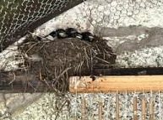
CHURCH GARDEN PARTY 15th August 2026
Once again, we held a Church Garden Party in the beautiful garden next door to the church by kind invitation of Mr and Mrs Bob and Steph Franklin. The weather was perfect, cream teas were served in the church, St Ives Bay Community Choir sang and the event was a great success with £175 raised to be shared between the Church and the Cornwall Air Ambulance charity. Thanks are extended to all who helped to make it a very special day.
Pictured: The St. Ives Bay Community Choir

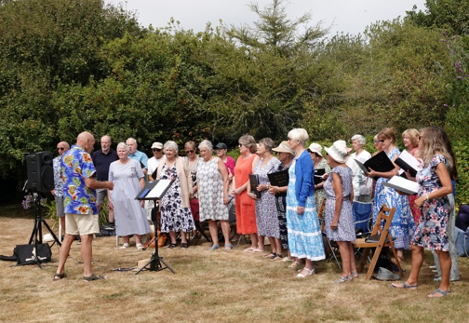
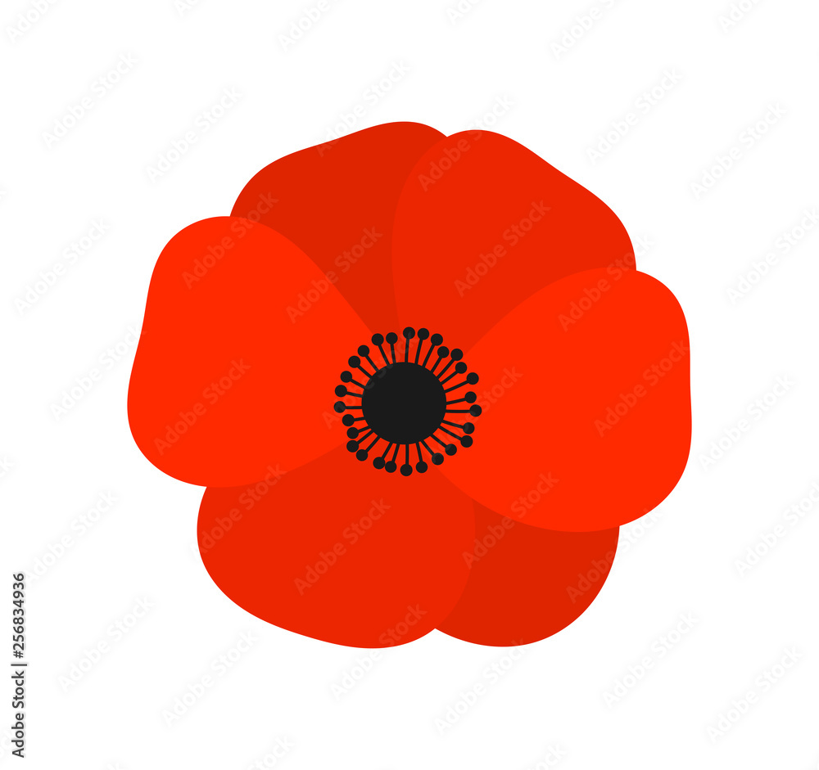
SATURDAY 7th NOVEMBER
10.30am to 4.30pm

POPPY DISPLAYS and
CHRISTMAS CRAFT FAIR

Refreshments
Stalls, Raffle, Tombola and more
ALL ARE WELCOME

ADVENT 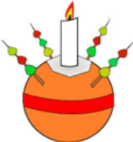SUNDAY 29th November at 4.00 pm
FAMILY SERVICE & CHRISTINGLE
With Rev Jo Thomas

PCC MEETING
Monday 2nd November at 2 pm in Church

CHRISTMAS CRAFT FAIR SATURDAY 7th NOVEMBER 10.30 am to 4.30 pm
Opening Ceremony by Councillor Andrew Mitchell
POPPY DISPLAYS STALLS RAFFLE REFRESHEMNTS

